Vladimir Putin meeting with: Ivan Glasenberg of ‘ Glencore ‘ ,,, to sign the Biggest Oil & Gas Business Deal in the WORLD ,,,
https://www.youtube.com/watch?v=aK77o4hamjU

The Cryptocurrencies - Artificial Intelligence Virus Sold as "Freedom" Money, Bitcoin AI
https://www.youtube.com/watch?v=OYYezaGa5DU

It's not a Concpiracy anymore! THIRD TEMPLE brings END TIMES-CHRISTIAN, ISLAMIC & JEWISH Prophecies
https://www.youtube.com/watch?v=zVYMDJq1oZM

RFID, Blockchain, AI, Bitcoin - The Truth Will Shock You!
https://www.youtube.com/watch?v=W7nt5FynDw8

Trump is the Last President! You are the Last Generation!
https://www.youtube.com/watch?v=zuNiJF-eumw

FREEMASONRY IN THE CHURCH?!?! Illuminati Agenda Exposed!!!
https://www.youtube.com/watch?v=AK6axOyCXcM

Trump Tells Rapture Starts AFTER NOVEMBER 28, 2018 New World Order & Jason A MOST WILL ΝOT SURVΙVE
https://www.youtube.com/watch?v=uWqQS8PYsgw

The Zionist Plan to Take Over the World

https://www.youtube.com/watch?v=ZHZPLvbhLh8

Barack Obama
QPOST BO's BIRTH CERT PLANE CRASH & CULT
https://www.youtube.com/watch?v=NTVU_QLSdyk

Anti-Christ UNVEILED: The Sun Rising in the West
https://www.youtube.com/watch?v=EFCQvvXSwx4

*AGE OF DECEIT* (FULL) Fallen Angels and the New World Order
https://www.youtube.com/watch?v=wjmFm8PIz8M

Hidden Evil Swiss DeceptionHidden Evil Swiss Deception
Hidden Evil Swiss Deception
NOTE: 28:31 Law Firm Appleby (same name as Paradise Papers largest firm for off-shore money, which GLENCORE was the largest beneficiary)

Paradise Papers: Who are Appleby, the lawyers at the centre of the leak?
- 5 November 2017
The operations of law firm Appleby are under the spotlight after millions of its documents were disclosed in the Paradise Papers leak.
Anyone who wants to set up an offshore enterprise, for any reason, must navigate the laws and regulations of the territory in question. And for that, they will need lawyers.
Enter Appleby - one of a handful of major international "offshore legal service providers".
Its business is to help clients, be they financial institutions, global corporations or high-net-worth individuals, to set up and register companies and trusts in overseas jurisdictions with low or zero tax rates and high financial confidentiality.
It's the kind of work which, inevitably, can lead to contact with those who have chequered backgrounds, controversial reputations or opaque motives. That's not to say the aims of such clients are not above board.
Appleby, like all legal firms in this field, uses a term for such clients and potential clients - politically exposed persons, or PEPs. A PEP is someone with a prominent profile - a celebrity of the political, diplomatic, military or judicial worlds - who, through their prominent position or influence, is more susceptible to being involved in bribery or corruption. By extension, any close family member of a PEP, is also a PEP.

ADVERTISEMENT

It is these PEPs, and how the have been handled by Appleby, that are the focus of much of the Paradise Papers. A "register of politically exposed persons", contained in the leak, lists more than 150 politicians and business leaders from across the world who are clients of Appleby.
Risky business
Legal guides name Appleby among the so-called "offshore magic circle" of law practices.
According to a database compiled by The Lawyer magazine, Appleby's corporate clients include Barclays Group, Citibank, Credit Suisse, Goldman Sachs, HSBC Bank, JPMorgan Chase, KPMG, Lloyds Banking Group, PwC, Royal Bank of Scotland Group, Santander UK and Standard Chartered.
Appleby's website highlights the awards it has won and the "Band 1" ranking given to it by legal directories, placing it among the top-rated offshore law firms.
Appleby was named offshore firm of the year by Legal 500 UK in 2015.
Such reputations are hard won. The first Appleby practice was established in Bermuda by Major Reginald Appleby in the 1890s. Some 120 years later, it has become one of the largest and best known legal groups in its specialist area.
Appleby has about 470 employees, including 60 partners, in 10 offices around the world. Its branches are in Bermuda, Isle of Man, Jersey, Guernsey, British Virgin Islands, Cayman Islands, Mauritius and the Seychelles, and it has a presence in Hong Kong and Shanghai.
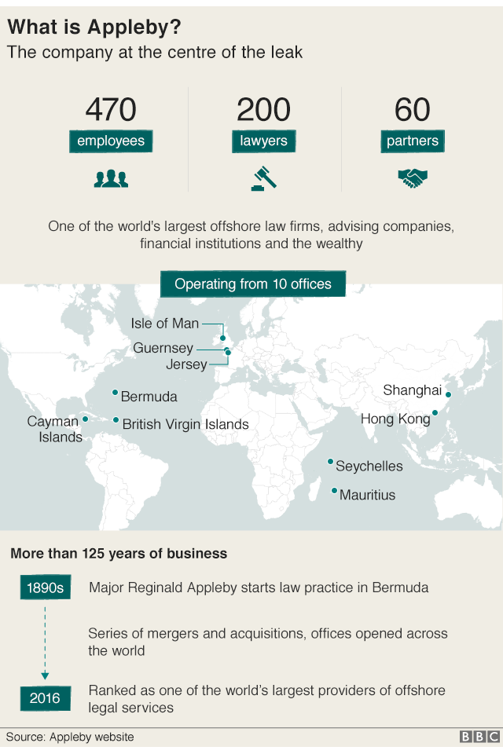
Its reputation partly rests on its rigour, and the Paradise Papers includes a lengthy Appleby document detailing the compliance procedure its officials are expected to follow when handling PEPs.
But even before this huge leak of documents exposing the law firm's business, Appleby appears to have had concerns about its standards. A presentation to its staff in Bermuda in 2012, itself found in the Paradise Papers leak, appears to acknowledge the company may have taken on risky business, referring to concerns around "non-compliance" with its regulatory obligations, including anti-money laundering policies.
A letter in the documents from the Bermuda Monetary Authority, the island's financial regulator, shows concerns were also raised in 2015 over Appleby's anti-money laundering and anti-terrorist financing checks and compliance with trust regulations.
In August 2014, Appleby was warned by the British Virgin Islands Financial Services Commission it was in breach of rules around client checks.
A month later a "high risk client register" features in documents from Appleby's British Virgin Islands office naming people with political or other public roles in countries including China, Russia and Greece. Their work was accepted and "enhanced due diligence" - the process of vetting a client - carried out.
London branch closure
Another register shows Appleby has declined business from potential clients facing allegations of wrongdoing or corruption.
In 2013 an industry group which included Appleby lobbied against then-UK Prime Minister David Cameron's push for the identity of the owners of offshore "shell" companies to be placed in public registers.
Appleby says it is "focused on the development of new products and the provision of effective service to its many international clients".
Recent years have seen a flurry of corporate change. In 2016, it announced the management buyout of its fiduciary business - which includes accounting and fund management services - renamed Estera.
It was involved in a series of mergers and acquisitions and some of the documents in the Paradise Papers relate to deals originally set up by other practices.
In 2015, it closed its London branch, telling The Lawyer magazine staff could easily do business in the UK capital by travelling from its offices in Guernsey, Jersey, and the Isle of Man. The firm also shut an office in Bahrain in recent years.
In fact, the leak shows the US dominates Appleby's client register. Documents list 31,180 US addresses for clients. There were 14,434 UK addresses and 12,017 in Bermuda. The next highest number were in the Cayman Islands, followed by Hong Kong, China, China, Canada, the Isle of Man, Switzerland and the British Virgin Islands.
In a statement on the Paradise Papers leak, Appleby said it has "thoroughly and vigorously investigated the allegations and we are satisfied that there is no evidence of any wrongdoing, either on the part of ourselves or our clients".
The company said it works in highly regulated jurisdictions and "advises clients on legitimate and lawful ways to conduct their business. We do not tolerate illegal behaviour".
It added: "It is true that we are not infallible. Where we find that mistakes have happened we act quickly to put things right and we make the necessary notifications to the relevant authorities."
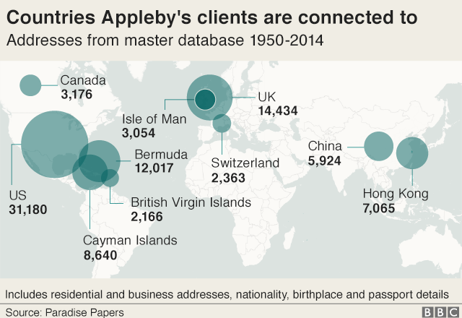
The papers are a huge batch of leaked documents mostly from offshore law firm Appleby, along with corporate registries in 19 tax jurisdictions, which reveal the financial dealings of politicians, celebrities, corporate giants and business leaders.
The 13.4 million records were passed to German newspaper Süddeutsche Zeitung and then shared with the International Consortium of Investigative Journalists (ICIJ). Panorama has led research for the BBC as part of a global investigation involving nearly 100 other media organisations, including the Guardian, in 67 countries. The BBC does not know the identity of the source.
Paradise Papers: Full coverage; follow reaction on Twitter using #ParadisePapers; in the BBC News app, follow the tag "Paradise Papers"

The Huns from the Alps
https://www.youtube.com/watch?v=a_rHraD_WpY

https://www.youtube.com/watch?v=dnbggL8pGgs

https://www.youtube.com/watch?v=94LtrmAhrjY
Pharaoh Oligarchy

MEET THE ROTHSCHILDS' BOSSES 1

https://www.youtube.com/watch?v=_RU893a1X_c

MEET THE ROTHSCHILDS' BOSSES 2
Doreen Dotan
Published on Jun 3, 2018
SUBSCRIBE 14K
https://www.youtube.com/watch?v=XRrjyS2-_Mc

Photo Shows Trump Beaming When Putin Joins World Leaders in Paris
President Donald Trump and Russia’s Vladimir Putin shared an oddly warm greeting Sundaywhen the two took part in a ceremony in Paris marking 100 years since the end of World War I. The two leaders arrived separately from the more than 60 heads of state who took part in the commemorations and when Putin showed up it seems clear Trump was happy to see him. A photo that quickly went viral and many said was surprisingly telling, shows Trump flashing a big smile when he sees Putin, whereas France’s Emmanuel Macron and Germany’s Angela Merkel look at him much more sternly.
It was the first time Putin and Trump saw each other since their now infamous Helsinki summit in July. And on Sunday, it was “the only moment” Trump “brightened up,” wrote the Guardian’s Julian Borger. “He flashed a goofy smile, all the more noticeable alongside Macron and Merkel who had switched their demeanour to steel resolve on spotting the Russian leader.”
https://slate.com/news-and-politics/2018/11/photo-shows-trump-beaming-when-putin-joins-world-leaders-at-paris-event.html
'Appalling' Khashoggi audio shocked Saudi intelligence – Erdoğan
Turkish president keeps up pressure on Saudi crown prince, as pro-government paper publishes x-rays of hit team’s luggage

Erdoğan said Turkey was “waiting patiently” for Prince Mohammed, Saudi Arabia’s de facto leader, to shed more light on the circumstances surrounding Khashoggi’s death.
Boyd Anderson had emailed his story to the Washington Post in May of 2017 ,,,

The respected Washington Post columnist and critic of Prince Mohammed was killed by a team of men who flew from Riyadh to ambush him during a marriage paperwork appointment at the Saudi consulate in Istanbul last month. His body, which investigators believe was cut up and dissolved in acid at the nearby consul general’s house, has not been found.
Turkey has maintained that the hit was ordered at the highest levels of the Saudi government, steadily leaking gruesome details from the criminal investigation which undermine the Saudi version of events.
It was clear the House of Saud was involved in Khashoggi’s killing, Erdoğan reiterated in comments to the tabloid Yeni Şafak on Tuesday, but he did not think King Salman, for whom he had “limitless respect”, could be behind such a crime.
“It must be revealed who gave them [the Saudi team] the order to murder,” Erdoğan said.
After two weeks of denying it had anything to do with Khashoggi’s disappearance, the kingdom said he had died in a fight, before changing its story again to say the Turkish investigation’s findings indicated his killing was premeditated.

https://www.theguardian.com/world/2018/nov/13/audio-of-khashoggi-killing-appalling-says-erdogan

https://www.youtube.com/watch?v=xRT9Us9qWd0

Benghazi Whistleblowers – The story behind the cover-up - CTM #670
https://www.youtube.com/watch?v=_vUJSvynuxw

The World Now Knows, 'It's the British Empire, Stupid!’
https://www.youtube.com/watch?v=NUTmsdussIo

Top Illuminati Grand Wizard: “We Control Islam and We'll Use It to Destroy the West.” (WW3)
https://www.youtube.com/watch?v=0dXD2H0m74g

David Icke - ‘ After they have Eaten Us “ !!!! , 2018 (MUST WATCH)

https://www.youtube.com/watch?v=EId1XgQwy5o

Saturn is not what you think it is , either.

https://www.youtube.com/watch?v=EKS2e3-z2js

Robert David Steele "Uncovering the Deep State, What's next?"

Feb. 14, 2018

17 killed in mass shooting at high school in Parkland, Florida

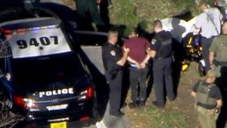

Another ‘ FALSE FLAG ‘ - NOTE IN PICTURE 9/11 (9/407)

Todays Headlines July 16th 2018

Former intel chiefs condemn Trump's news conference with Putin
Washington (CNN)Former US intelligence chiefs expressed astonishment and condemnation Monday in response to President Donald Trump's comments at Monday's news conference with Russian President Vladimir Putin, with former CIA Director John Brennan calling the US President's performance "nothing short of treasonous."

"a sad day for America" and "a sad day for the world."

UNDER THE RADAR 537-555

With one record-smashing night in his exploding hockey career, Boyd Anderson went from 'the best line in junior hockey' to an international playoff team of champions from Zug, Switzerland.

After creating a huge sale to Saudi Arabia, Boyd moves from Toronto to Budapest to Dubai and unknowingly finds himself at the 'Top of the Food Chain'. It is in Dubai, 2007 where he meets Thomas who introduces him into a world of deception and unimaginable Power Weilding Elite, hyper-competitive deal-makers and hungry profiteers, who trade entire lives just as easily as they swapped arena tickets and team contracts, behind the scenes of business , governments and politicians you've heard of ,,,,

But when CNN announced “Malaysian Airlines flight MH370 has disappeared” on a March morning in 2014, Boyd immediately blurted out, “I know who did this.” Horrified, he became an investigator, using his highly toned instincts and perception, along with his memory. Backed up with facts, he saw all the pieces coming together, realizing that hundreds of lives lost were just 'collateral damage' for a 55,500 Ton gold heist.

Even worse, using ancient numerology and researching the main players introduced to him from a nearly-forgotten contact who had described a plan for just how Bitcoin, political turmoil in Europe and the Middle East, and even the world's economy would play out -- drastically changing the world as we know it, in just a few years.

After spending 3 years investigating and researching, Boyd discovered 3 abandoned Boeing Jumbo 747's left on the tarmac at Kuala Lumpur airport, he finally figured things out. Unable to escape the feeling that all the signs were in place for a scandal that's bigger than Watergate, now everyone needs to know the truth regarding the origin of Bitcoin, Ethereum, Monero & ETC Classic, the Blockchain, Kraken, Brexit, ISIS, Interest Rate Hikes -- and the biggest gold heist-assassination in the history of the world!

TRUMPENCE SETS THE TONE FOR THE STORY

It appears that RUSSIA - Putin & “ the NEW WORLD ORDER “

Definition
TRUMPENCE (noun) --
The return on investment of a con, bribe, theft or fraud. This could include the direct financial benefit of a scam or plot, but also can be used to represent the emotional boost a narcissist or sociopath gets from feeling superior to those they have manipulated and tricked.
“You should always make sure the target of your scam isn't overly intelligent, then you can play on their fears to maximize your potential trumpence.”

During the 1972-73 season in Medicine Hat, Alberta, I was 18 years old and playing with the Medicine Hat Tigers. I had completed the best hockey season of my life, setting 3 records in the WHL (major junior league in western Canada),

Most goals in a 20 minute period -- 5 Goals
Fastest 4 Goals -- 2:35 (2 minutes & 35 seconds)
“Fastest 5 Goals -- 3:07 (3 minutes & 7 seconds)” ,,,,,,,,,,

NOBODY WILL EVER BREAK THIS RECORD !!!!!!
Yes, I scored 5 goals in 3:07 minutes… averaging out to 1 goal 37.4 seconds apart. In my mind,,,,,,,,,,, “5307” became my favorite number from that day forward!

“537” - 2012 Barak Obama re- election campaign advertisement
Referencing the 2000 election results, Obama’s campaign focused on inspiring people to get out and vote. The ad is titled “537, the number of votes that changed the course of American History”. In it, Obama mentions “537, the difference between ‘What was and what could have been.’ So this year if you're thinking that your vote doesn't count, that it won't matter, well, back then there were probably 537
people who felt the same way. Make your voice heard. VOTE.”
“537” - Bush beats Gore by 537 votes in the 2000 US presidential election
During the hotly-contested Florida election recount in the US, during the weeks after Election Day in the 2000 United States presidential election between George W. Bush and Al Gore, the Florida vote was ultimately settled in Bush's favor -- by a margin of 537 votes.
—————————————————————
“537” B.C. - Cyrus
After the overthrow of Babylonia by the Persians, Cyrus, who was married to Isis, gave the Jews permission to return to their native land in 537 BC, fifty thousand Jews are freed and allowed to practise their sacrifice religion and begin to rebuild the 2nd Temple in Jerusalem
—————————————————————
“537” A.D. - Phasis
The First Siege of Rome during the Gothic War lasted for a year and nine days, from March 537 to March 538. The city was besieged by the Ostrogothic army under their king Vitiges; the defending East Romans were commanded by Belisarius, one of the most famous and successful Byzantine generals. The siege was the first major encounter between the forces of the two opponents, and played a decisive role in the subsequent development of the war.
In a related ‘537’ connection, Pope Vigilius (died 7 June 555) was Pope from March 537 to his death in 555. He is considered the first pope of the Byzantine Papacy. While on the journey, he died at Syracuse.
—————————————————————
Shiva, the ‘Goddess of Destruction’ (whose sacred number is ‘5’), is portrayed in a commemorative statue at CERN, the CIA Headquarters in Geneva, Switzerland
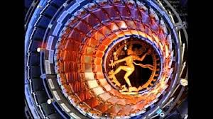
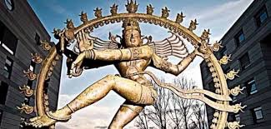
Shiva (or Siva) is considered the Supreme God within Shaivism, and is the creator and “destroyer” of all that is. On June 18, 2004, a 2-meter tall statue of Shiva was unveiled at CERN, donated by India.

—————————————————————
The occultist believe "5" to be the Number of Death, and the greatest intensification of any number to be a triplicate, a "555" literally means "Highest Death".
—————————————————————
The Bible in Basic English
1 Kings 10:14 (BBE) Now the weight of gold which came to King Solomon in one year was six hundred and sixty-six talents; 666 divided by 12 Tribes of Israel = “55.5” Talents
—————————————————————

STORY BEGINS:

Carl Anderson, my father, was born in 1920 in Wynyard, Saskatchewan of Icelandic heritage, and had eight siblings. From 1939, he served four years in England and helped liberate Holland.
Bill Anderson, my uncle, was born in 1919, and died of pneumonia in England 1943. His death was caused by the chemical gas poisoning he was exposed to while training in British Columbia, Canada in 1939, before they went overseas. His respiratory system never recovered.

Their commander was a Rothschild.

During the 1972-73 season in Medicine Hat, Alberta, I was 18 years old and playing with the Medicine Hat Tigers. I had completed the best hockey season of my life, setting 3 records in the WHL (major junior league in western Canada), including:
Most goals in a 20 minute period -- 5 Goals
Fastest 4 Goals -- 2:35 (2 minutes & 35 seconds)

Fastest 5 Goals -- 3:07 (3 minutes & 7 seconds)
Yes, I scored 5 goals in 3:07 minutes… averaging out to 1 goal 37.4 seconds apart. In my mind, 5307 became my favorite number from that day forward!

WHL Record Book
FASTEST FOUR GOALS:

2 mins, 35 secs – Boyd Anderson, Medicine Hat Tigers, October 7, 1972, at Medicine Hat, against Flin Flon Bombers, third period. Anderson scored at 10:08, 10:17. 11:50 and 12:47. Tigers won 10-1.

FASTEST FIVE GOALS:

3 mins, 7 secs – Boyd Anderson, Medicine Hat Tigers, October 7, 1972, against Flin Flon Bombers, third period. Anderson scored at 10:08, 10:17, 11:50, 12:47 and 13:15. Tigers won 10-1.

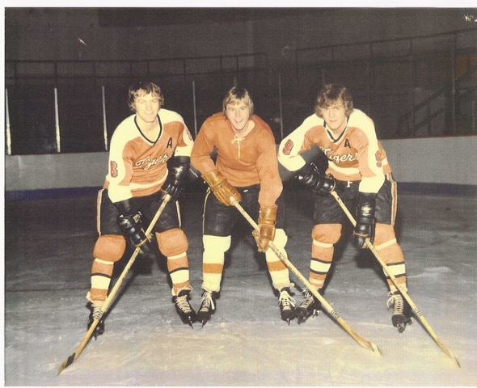

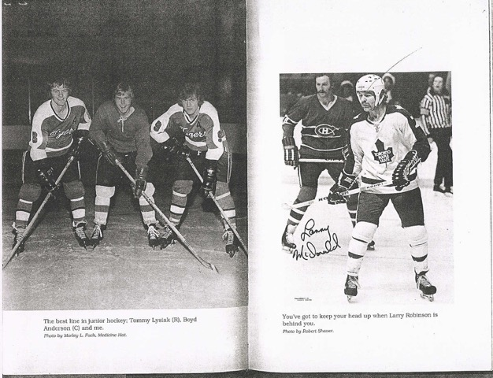

Pictures taken from the book “Lanny”, “The BEST LINE IN JUNIOR HOCKEY”

Boyd Anderson
Left Wing -- shoots L
Born Mar 15 1954 -- Carrot River, SASK
[64 yrs. ago]
Height 5.11 -- Weight 180 [180 cm/82 kg]

Drafted by New York Rangers
- round 4 #68 overall 1974 NHL Amateur Draft

Drafted by Winnipeg Jets
- round 4 #52 overall 1974 WHA Amateur Draft

Agent ‘Duped Clients’

The Spectacular Rise and Ignoble Fall of Richard Sorkin, Pros' Agent
By PAUL L. MONTGOMERYOCT. 9, 1977
October 9, 1977, Page 1
The New York Times Archives
Three weeks ago, in the babble of a Nassau County courtroom in Mineola, a wheyfaced 37‐year‐old agent for professional athletes stepped forward to plead guilty to seven counts of grand larceny. The man, Richard Sorkin, admitted he had stolen money he was supposed to have been keeping in trust for his clients, including some of the stars of the Islanders, the Rangers and the Nets. More than 50 professional hockey and basketba41 players were the victims, and authorities have put the losses at about $1.2 million.

Sorkin told the judge he had “utilized” the money in unwise stock market investments. He spoke sorrowfully of his life, the plummet from his $415,000‐a‐year business two years ago to a harried existence now in obscure boarding houses, trying to find work as a house painter.

Sorkin was in Saskatchewan discovering what proved to be his gold mine—the Western Canada Hockey League. The 10‐team junior circuit, one of the three top “amateur” leagues, is the last stop for promising players before they enter the professional draft at 19. In this system, players start at 14 in rundown rinks, sometimes away from home and susceptible to trade, earning perhaps $75 a week and lodging, and honing the skills that might take them to the glitter of the N.H.L. 10 years later.
The beginning of 1972 was a heady time for hockey agents, unheard of in the sport a few years before. The competition between the N.H.L. and the W.H.A. created a shortage of players and brought about big salaries—a true seller's market. Virtually any player in the first 150 drafted was assured of a contract; in a sport where the average salary had been $15,000, salaries of $50,000 or more were suddenly commonplace.

Sorkin and another agent, Dave Schatia of Montreal, increased their chances by dividing the Western League teams between them and devising a system of kickbacks of as much as $5,000 to management if players signed with them, Of 20 players from the league who were signers with Sorkin, 18 were from five teams: New Westminster, Medicine Hat, Saskatoon, Calgary and Flin Flon.

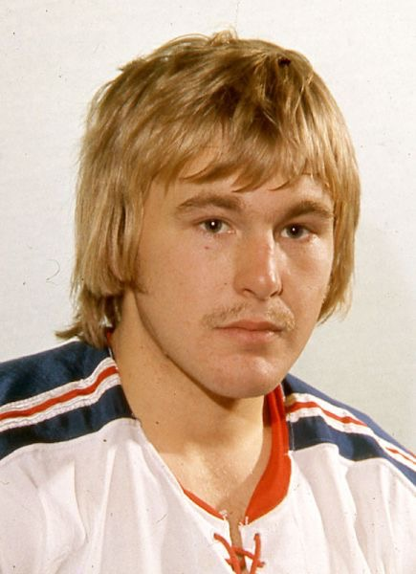

Around the World Trip July 3rd, 2007 Beijing Wedding

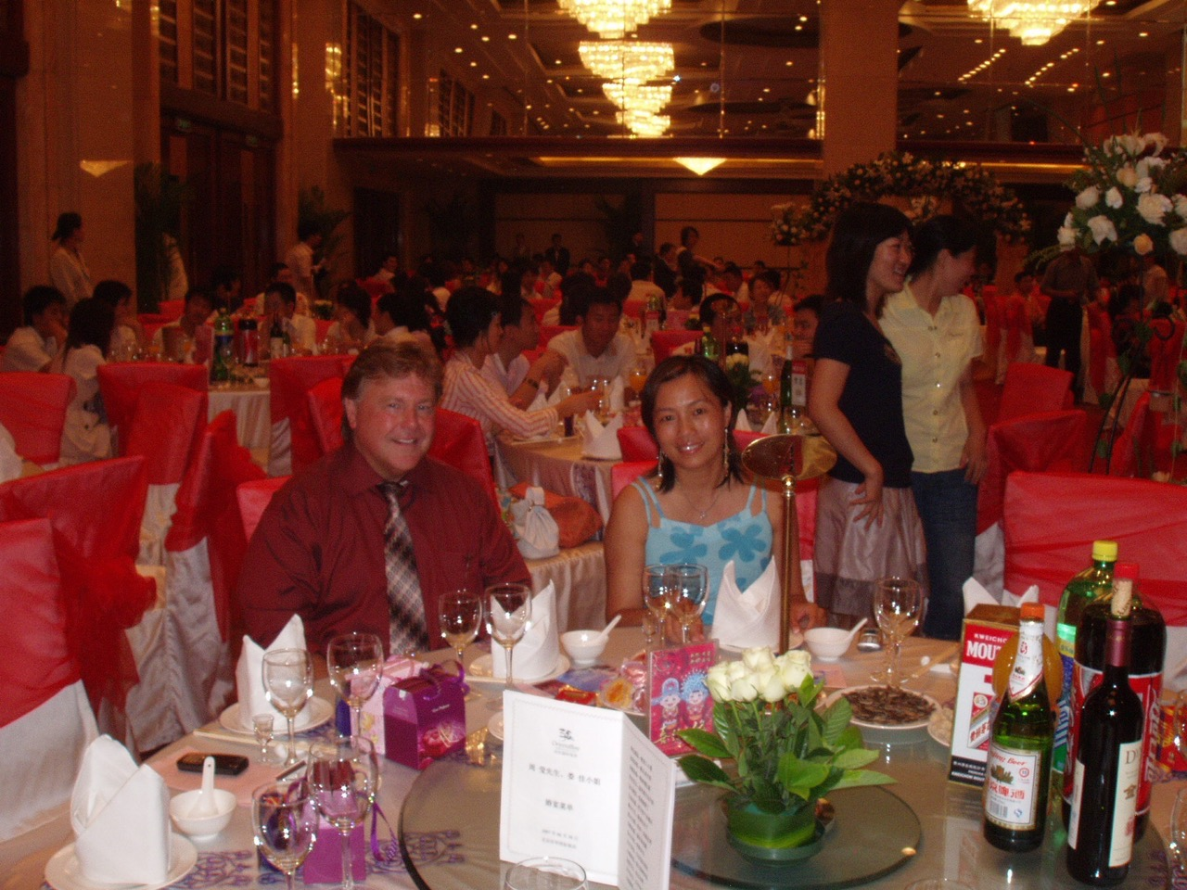

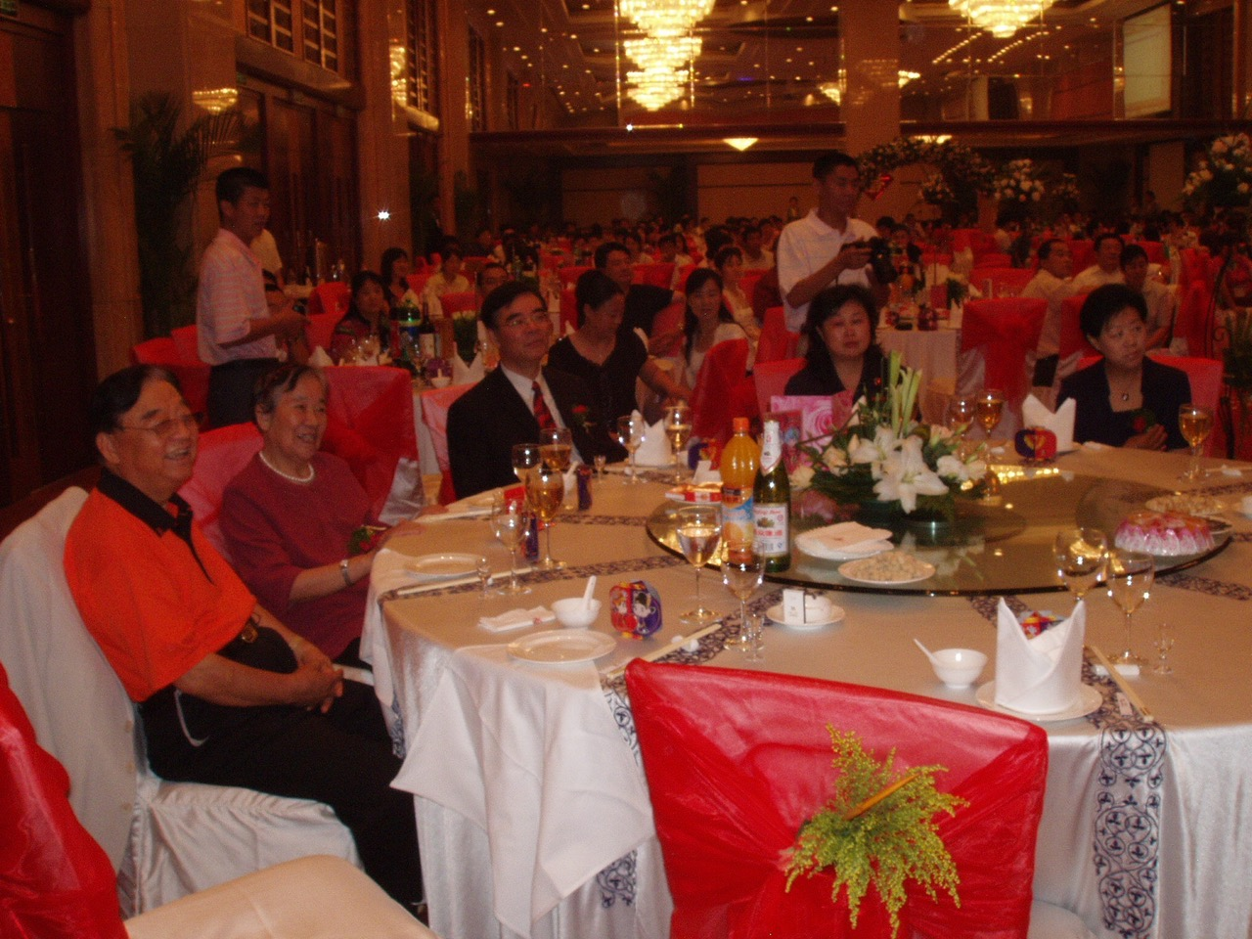

Chinese General in Red Shirt

Our Distributor in Zenchen, China Lisa

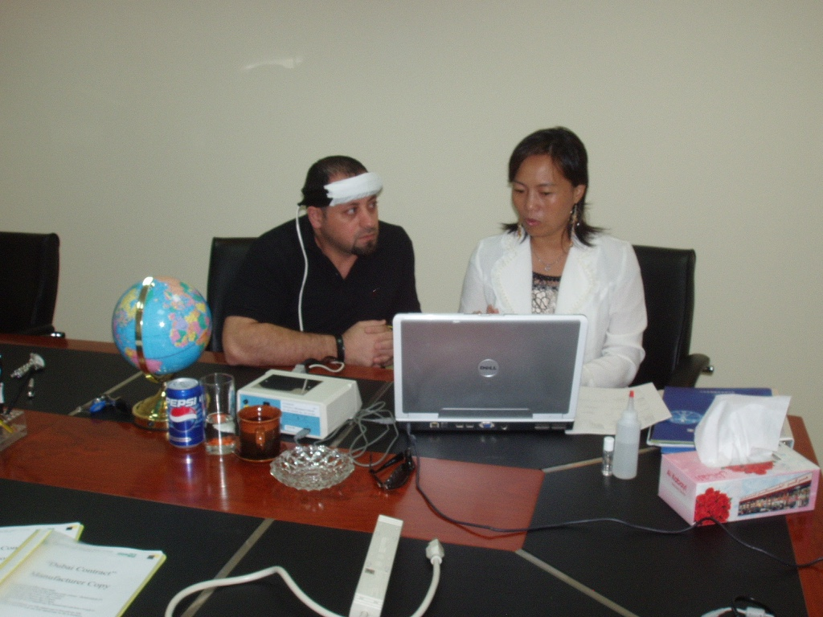

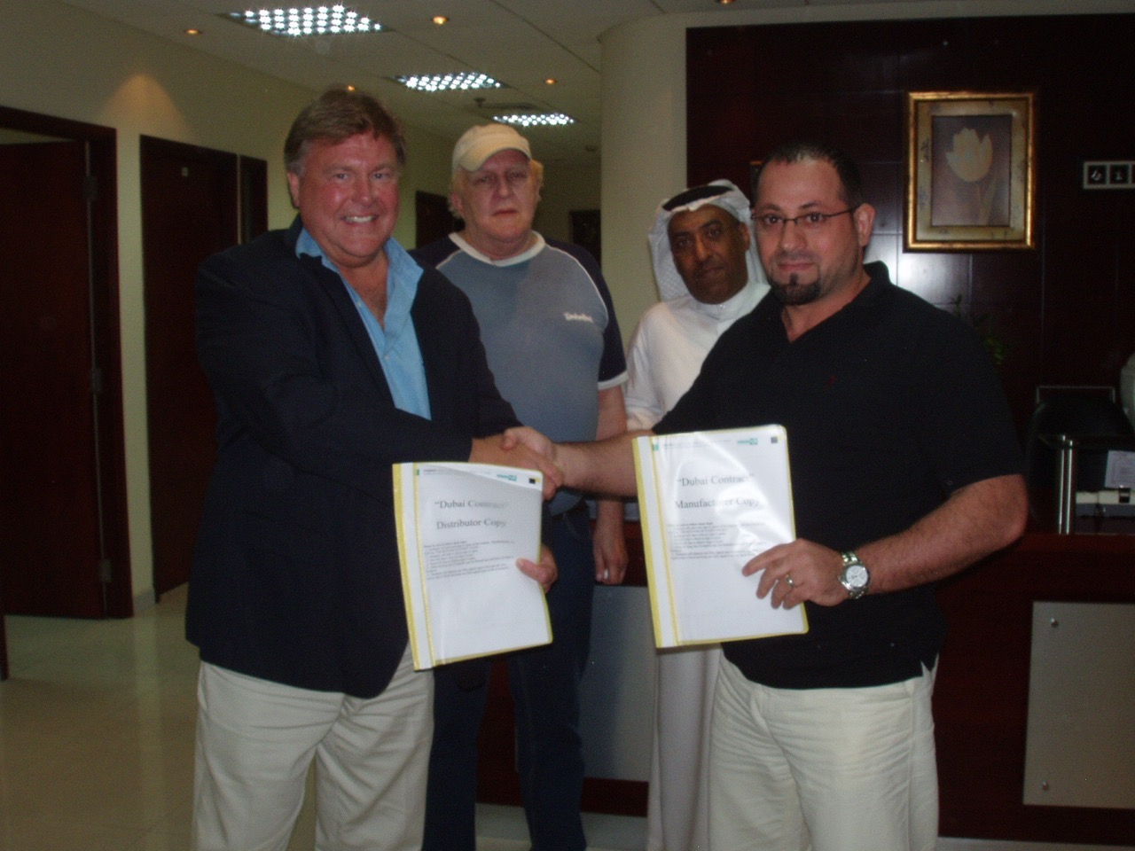

(L-R) Boyd, Thomas, Obeid and Jihad signing the contract for 1,000 EPFX machines in 2007
The Arab, Obeid, was directly and closely connected to the Saudi sheik who wanted to start 1,000 wellness centers in the Middle East, as he was in charge of all the food supply and wellness (health) for Saudi Arabia.This is the same Saudi group that bought the Canadian Wheat Board in 2015.
For the record, THIS AGREEMENT WAS MADE AT MAITREYA KFT ON JUNE 24th, 2007 IN BUDAPEST, HUNGARY, BETWEEN: MAITREYA KFT - MANUFACTURER, THE QUANTUM ALLIANCE INC - BROKER, QUANTUM POWER CENTER (BOYD) -

AGENT, and AL HAMMOUDI GENERAL TRADING LLC - DISTRIBUTOR.
After signing the contract, Jihad mentioned that the sheik had a cheque for $16MM USD ready to hand over. All he wanted was authenticated proof that the EPFX was a Class II medical device in Canada, as Quantum Alliance had promised.

Thomas was intrigued with my hockey stories. We traded stories day after day. We spent many evenings in the Bavarian pub in the Marriott, just down the street from his office. We drank a lot of Glen Fiddich, and I always paid. He was cheap, he was Jewish. I thought maybe he didn’t have much money. He boasted how he could live on $15.00 per day.
Thomas mentioned that Jihad had called me a “Dump Truck.” I wasn’t sure what that meant. Then Thomas said, “Boyd, you are here for a reason. I believe in Fate.”
Thomas would tell me about Vietnam, and being shot down in the Strait of Malacca in the bay of Thailand. He told me of his mother, a Russian doctor who had emigrated to the USA from St. Petersburg. Thomas said, “ I work for the Swiss Jews, Boyd.”

He called himself a banker, saying that for many years throughout the 70’s and 80’s, he
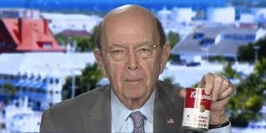
helped bankrupt many companies in the USA. He mentioned working with Wilbur Ross,,,
Trump’s Secretary of Commerce

Basically Thomas was a ‘money launderer’ for ‘the Swiss Jews’. His passport was being held by the UAE authorities, so he was trapped or committed to living in Dubai. I think he’d gotten into some trouble with the mob, and he was on a mission. He never stopped talking about the gold in Thailand.
It seemed Thomas was always talking to Richard Leibel in Bangkok. I overheard many conversations about “getting rid of the damn fiat currency”. He used to say bankers were the biggest crooks in the world, as they could simply print money whenever they needed it.
Thomas mentioned how he and Richard were working on a new money system that would eliminate the paper dollar, because the paper dollar wasn’t backed by anything -- and because the leaders of the UAE, Saudi Arabia, Iran, Turkey, Israel and Qatar were all brothers. All of them had their ancestry in the Persian Empire.
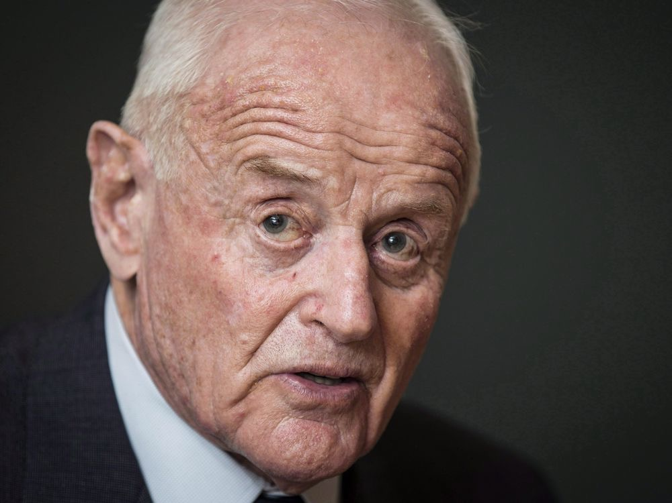
Thomas mentioned his banker Marc quite often, saying he was going to have Marc set up a Swiss Bank account for me and that we would be very wealthy soon. Thomas often tried to educate me on “spot oil” and “spot gold”. He often mentioned the Canadian mining company Barrick Gold, which was the largest gold mining company in the world, owned by another Jewish guy by the name of Peter Munk.
Thomas had about 5 visits from a German banker from Deutche Bank throughout 2007-08.
DECEMBER 5th, 2017
Trump-Russia probe: Mueller 'demands Deutsche Bank data'
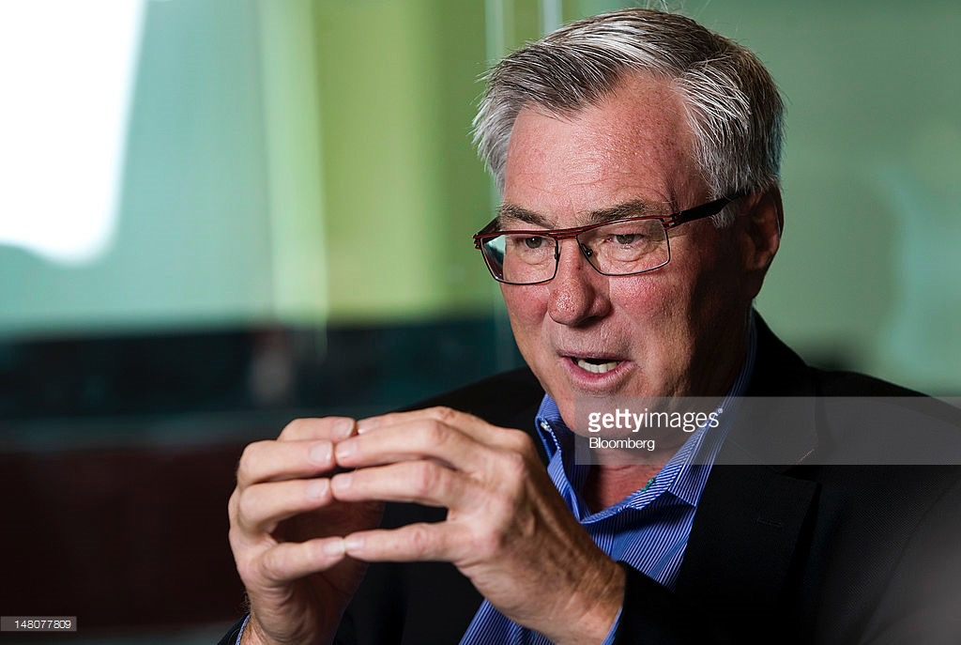
US special counsel Robert Mueller has ordered Germany's Deutsche Bank to provide records of accounts held by Donald Trump, according to reports. He also mentioned Eric Sprott, a renowned Canadian gold guru. Sprott had set up Sprott University at Carlton University in Ottawa, Canada. Surprisingly (to me, at least),

Surprisingly (to me, at least), Thomas knew a lot of people in Saskatchewan, of all places.
I couldn’t believe it! Saskatchewan had less than a million people. Yet here I was in Dubai, on the other side of the world, and he’s naming people in Saskatoon who grew pot and had big grow operations.
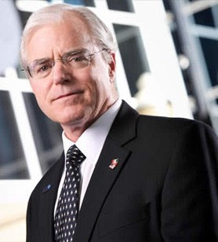
He’d say, ‘Do you know Harvey Schmidt in Saskatoon? He used to have a grow operation and trucked all the pot to Vancouver, then he set up in Vancouver in the 70s and 80’s and 90’s, where he had six or seven houses in neighbourhoods set up as grow operations. He also talked about the “Hill family from Regina.”
When I was growing up, I never knew any of these people. I had left home when I was fifteen to play hockey, and never spent much time in Regina or Saskatchewan.

But Thomas would always say that he had a main contact in Yorkton, Saskatchewan who he still kept in touch with.
Why Yorkton, Saskatchewan??? Thomas mentioned many times, back in 2007-08 that he had a close contact in Yorkton Saskatchewan,, and for two years immediately after MH370 went missing, when Thomas first called me, I had left an

old laptop of mine unsecured on-line and found out later, by a technical company that I was being hacked and spied on by someone in North Carolina and YORKTON.
Samuel Bronfman's booze empire began with bootlegging in Yorkton, Saskatchewan
His surname means “liquor man” in Yiddish — was a legendary figure in the liquor business.
Once the world’s largest distilling firm, Seagram had many links with Saskatchewan. Over the years, the Bronfman family owned businesses in Yorkton and Regina.
Al Capone and Chicago relationship with Samuel Bronfman and Saskatchewan has only gotten stronger over the years. This is why the Saskatchewan Potash company Agrium has all executives living in Chicago and why Bitcoin is sold on the Chicago Stock Exchange.
In later years, Bronfman is said to have blended 600 samples of whiskey before creating the prestigious Crown Royal brand in honour of King George VI and Queen Elizabeth’s visit to Canada in 1939.
The philanthropist established arts centres and museums in Canada, the U.S. and Israel. In recognition for Bronfman’s community works, he was inducted into the Order of Canada in 1967.
Bronfman served as president of the Canadian Jewish Congress from 1938 to 1962 and was honourary vice-president of the World Jewish Congress at the time of his death in Montreal on July 10, 1971.
According to the Toronto Star and CBC/Radio Canada, the records suggest that the grandson of Samuel Bronfman, Stephen Bronfman and his family's Montreal-based investment company, Claridge Inc., were linked to an offshore trust in the Cayman Islands that may have used questionable means to avoid paying millions in taxes.
Bronfman is a close friend of Prime Minister Justin Trudeau, who tapped him in 2013 to fill the role of revenue chair - effectively, the chief fundraiser - for the federal Liberal party.
The offshore trust also involved former chief Liberal fundraiser and senator Leo Kolber and his son, Jonathan Kolber.
Bronfman E.L. Rothschild L.P. Acquires 236 Shares of Boeing Company (The) (BA) - Dispatch Tribunal 82

Thomas mentioned a guy by the name of Skip Boyce, who was into selling aircraft. He talked about Pakistan and India, Lebanon and Syria. Thomas was a military guy who worked with the CIA and Israeli Mossad but he never told me who was connected to his other cell phone. He would ask me for money whenever he was in need, but I was getting low on funds and he knew it. Still, I kept giving Thomas $500 or so every once in awhile.
I remember one night after both Thomas and I consumed a lot of Scotch, Thomas was staggering a little too much. So I walked him back to his office, where he would crash for the night. Thomas was a big guy, around 6’1”and 250 lbs. When I put my arm around his shoulders to support his weight, he immediately said, “Get your arm off me.”

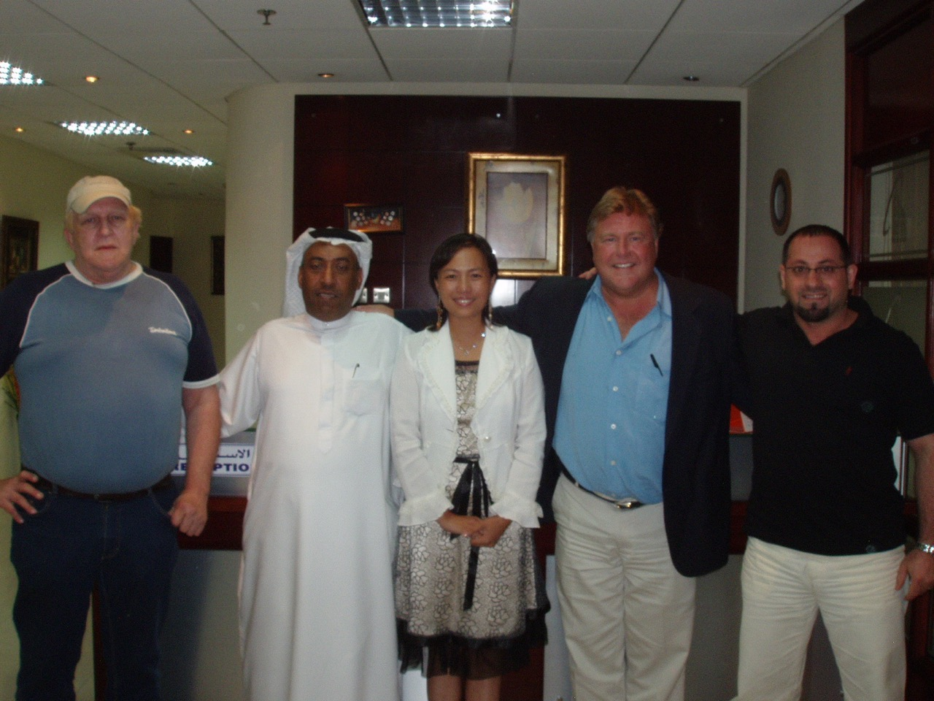

Dubai was exciting, with the huge growth and development of real estate in full swing. I absolutely loved the fabulous architecture I saw. For example, the Palm “Trump “ International Hotel & Tower had been announced a couple of years earlier, and construction of the hotel’s dramatically-designed towers was already underway on 63

Palm Island, a man-made island enclave in the Arabian Gulf.

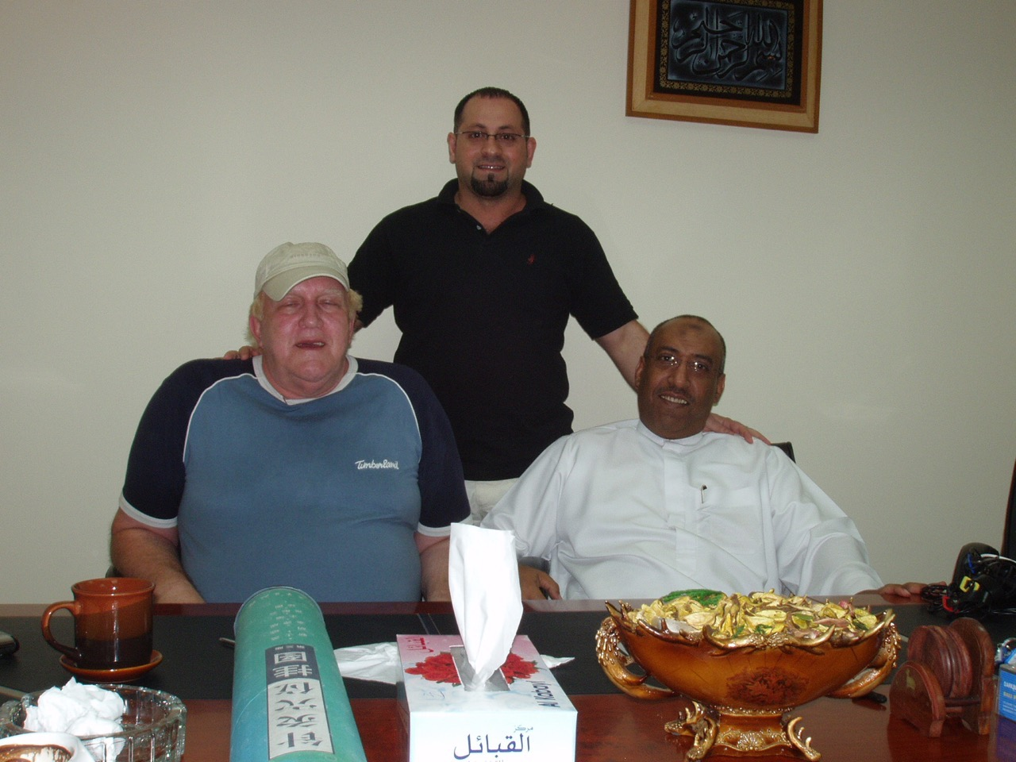

One day in October, Hussain Sajwani, a wealthy Dubai real estate developer, entered Thomas’ office. Thomas had mentioned Sajwani often, as someone who was interested in buying a large amount of the gold. In one conversation after another, Thomas was always trying to convince Sajwani to commit. He told Sajwani that once the gold was re-melted in Perth, nobody could prove whose gold it was.
Between October 2007 and February 2008, both Grace and I had hooked Sajwani up to the EPFX Bio-Feedback device and the Life System for various demo sessions, as I was also trying to find an investor for the devices.

Many religious preachers would come to visit Thomas, I think mostly from the USA. Thomas always kept himself well groomed, walking down the street to the barber every couple of days to get the works (shave, a haircut and hot towel). He also had regular manicures and got his nails polished.
Thomas’ partner Richard was working on a new type of currency, and he frequently called Thomas for his opinion while Richard was writing the software for this new money system. At the time, I had no idea that it was Bitcoin he was working on.
On many of his phone conversations, while I was playing backgammon on my laptop in his office, Thomas would mention “flying the first 2-ton tranche out of the military base on a passenger plane. The pilot could take the plane up to 45000 feet and cut off the oxygen to the cabin.” He said passengers would die of asphyxiation (lack of oxygen) within 15-20 minutes, then the plane could then make a landing on Diego Garcia, a naval and military base in the Indian Ocean.
From Sept. 2007 till August 2008, I spent every day with Thomas except for my trips to Budapest, Hungary (where Bill Nelson lived) or when Grace and I flew to China or Istanbul to hook up Erdogan. During this time, I did have the use of Obeid the Arab middleman’s car, so Thomas and I would go out for dinner (ribs) at Billy Blues/Cactus Cantina.

During October of 2007, Thomas received daily calls from Nick in Greece and Fuat (close friend of Erdogan and had strong ties in Germany) in Turkey, wondering when something new was coming down the pipe. Obviously they had worked together with Thomas for a long time. Thomas kept talking about how they wanted to get rid of the fiat currency, paper money that is not backed by anything.
Thomas said, "People want convenience, in the future, everyone will be using their cell phones to do their banking. Richard and I are working on a new digital currency..." He explained how the International Monetary Fund worked, saying the Fed could just print money.
Thomas’ friend Fuat from Turkey was very impatient, and wanted to come to Dubai to see the bio-feedback device he’d described. Grace had come back to Dubai, so one day Fuat came to visit, to get more info on the EPFX. Grace hooked him up to the device, and he was impressed.
Fuat was a nice guy, always asking “You understand?” after anything he said because of his heavy Turkish accent. He was in Dubai for only a couple of days, and then returned back to Istanbul. A couple of days later, after

another call from Fuat, Thomas asked if we wanted to go to Istanbul and hook up a politician and a surgeon. Without thinking, off we went.
Jihad had mentioned that the Vice President of Turkey was their good ally. When we arrived, we were picked up by Fuat in a black Mercedes. He had a driver and we were driven directly to Recep Erdogan’s office. Erdogan was Vice President of Turkey at the time, but I, being naïve, didn’t pay much attention to his rank.

His office was on the second story of an old house that had been renovated. We shook hands, and Grace hooked him up to the device for about an hour while Fuat and I stayed in the lobby. Fuat briefly mentioned that Erdogan was an ex-football player for Istanbul (football in Turkey is huge!!), then he was elected mayor of Istanbul.
So after Grace had finished the bio-feedback session with Erdogan, we shook hands and left for the main hospital in Istanbul, where we hooked up the top surgeon in Turkey for a demo. Because the device is quite subtle, we didn’t get much of a reaction from either Erdogan or the surgeon very quickly. After staying only three nights in Istanbul, Grace flew back to Toronto and I flew back to Dubai.

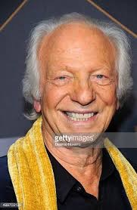
In January 2008, Dubai played host to the World’s biggest Health Congress, featuring the world’s most comprehensive conference programme at the Dubai International Exhibition Centre. The show was huge, and I set up a booth for people to have 15-minute sessions. During the conference, I talked and hooked up tens of people from all over the Mid-East. Everyone was fascinated with the Life System, but nobody purchased.
One day in 2008, a man I’d never seen before brought a box of Sketcher running shoes to Thomas’ office. I went out canvassing in Dubai, but had no success in selling them. It was only during my research for this book that I recognized the man as Robert Greenberg, although at the time I had no idea who he was and was never properly introduced to him.

At the same time, Thomas had a servant from Sri Lanka named Abu. He’d yell “ABUUU!! Get me some tea!” He used to take out his false teeth every day, both upper and lower, sitting behind his desk cleaning them. He prayed a couple times a day, where he’d take off his baseball hat and kneel behind his desk wearing a Kippah. Thomas would sleep in his office a lot, and I never saw his apartment. 97

Aloub Aloub was a huge 450 lb. Sudanese guy who came into Thomas’ office every month or so with a different scam. For example, he mentioned 20 million USD in cash sitting in a locker at the Sierra Lyon airport, diamonds from Africa, or gold bars in wooden cases in Nigeria.

Dimitri was around 35 years old, the son of a Greek ocean salvager. He came in a lot to talk about how they salvaged old freighters and ships. His wife was much younger, a 19-year-old beauty from Egypt. She left for six months to learn Flamenco dancing and live in Seville, Spain.
In June of 2008 I was sitting in Thomas’ office when he asked me to leave for a few minutes. He needed to have a private meeting.
As I was walking out, Al Baghdadi was entering with three other Arabs (obviously, I did not know who he was at the time). We acknowledged each other with nods, rubbing shoulders as we passed each other.
I later asked Thomas who that was and he shrugged it off. “Just some extremists,” he said.

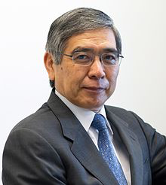
I also saw Bank of Japan’s CEO, Haruhiko Kuroda, come to Thomas’ office two or three times in 2008. I did not know who he was at the time, but I recognize him on TV now. I thought he was a retired banker looking for some kind of investment. I spoke to his wife while she awaited her husband, and she mentioned that they owned a house in Vancouver. (which is where the first Bitcoin ATM was installed in 2013)

Occasionally Rahim, the nephew of Kazakhstan’s president, would come to Thomas’ office almost every day, looking for money. Thomas called the boy his son, and treated him that way. Rahim was about 15 years old in 2007, and lived with his mother in Dubai. It was like he was safer in Dubai, I think there were risks of kidnapping if he stayed in Kazakhstan. Thomas had a real soft spot for Rahim and treated him special and always giving him money. When he turned 16 in 2008, he kept asking Thomas for a car.

Hours would go by, and I would watch and listen as I sat in Thomas’ office playing backgammon on my laptop. His phones would ring every hour or so. I’d frequently hear Thomas talk about how they could get this gold out on a passenger plane. “Well, the pilot could take it up to 45,000 ft and cut off the oxygen to the cabin, and every one would die within 5 minutes.” 99

After all, it’s a chilling fact to realize the brain can survive for up to about 6 minutes after the heart stops.
After 1 minute - brain cells begin to die
After 3 minutes - serious brain damage likely
After 10 minutes - many brain cells have died; the person is unlikely to recover
After 15 minutes - recovery is virtually impossible
Thomas spoke on the phone about landing the plane in Diego Garcia, Banda Aceh, or Butterworth Military base in Malaysia. He also mentioned using the Cosmodrome in Kazakhstan, saying:
“Maybe we could get the Mossad or the Russians to get involved.”
We can possibly get to Putin through Medvedev.
“We gotta get that gold to Perth, Australia because it’s old gold, and we have to re-melt it to get certified and back onto the market…”
“We gotta have that 99.99% purity stamped on it.”
“We need a new gold refinery in Dubai so we can do it all here”
“We need to find a pilot who will agree to go on a simulator.”
We have the use of the Cosmodrome in Kazakhstan, if needed.

Thomas called Richard, and said, “We can offer the pilot a villa in Bali and $10 million dollars.” He would go on and on, day after day, trying to put together a plan on getting this gold out of Thailand.
By that point, there were so many scams and unbelievable stories flying around Thomas’ office and a lot of sketchy people around, I did not know what to believe.
But it seemed like, while I was in Dubai with Thomas during 2007-08, if there was any kind of International Charitable Funding or Foreign Aid of any kind being given to anyone (like the WHO or any organization who was promoting the betterment of humanity on the planet), Thomas and the Swiss Jews tried to steal it.
The strange thing was, while Thomas always spoke on his cell phones mentioning millions and even billions of dollars that he offered to launder, he was always borrowing money from me. And he loved going to movies, we’d go every week. He seemed to get more out of the movies than me.
He kept calling a Dr. Gupta in India, trying to sell him something like 10 tons of gold. This went on at least 4-5 times a week, he’d be yelling and very blunt. 101

In the Spring of 2008, I remember he went out to see some ‘extremists’, and he later told me that he helped bleach a $10,000.00 USD sample from a larger amount of 20 million US dollars. These bills were marked, and these extremists had loads more in their possession. Thomas said he was an alchemist, and explained that he knew the proper chemicals and knew the procedure to clean the money.
In July of 2008, Thomas’ banker from Zurich, Marc, came to Dubai to see him. This was after Thomas’ meeting with Al Baghdadi (alias Simon Elliot, aka Al-Baghdadi, son of Jewish parents, Mossad agent). Obviously, I had no idea who he was at the time, but recognized him during my recent research for this book.
Again, as Thomas was very secretive and I did not ask any questions, I had no idea what was going on. I had no idea who these people were.
Thomas kept borrowing money from me, which I believe was a joke for him. Looking back, I’d guess he was misleading me, so I wouldn’t really know whether to believe him or not. I mean he worked directly with Marc Reich, who was one of the richest men in the world. I was very naive.

You see, when I met Mark Rich, he introduced himself as “Marc Reich”, speaking with a German accent. He stayed at the Marriott and seemed rather melancholy, so I sat and listened.
Thomas, Dimitri and I met Marc for a drink in the sports bar in the lower level of the Marriott. Marc lit up a big Cuban cigar and never said much. During the meeting, the only thing I said was “Are you going to get the gold out of Thailand?” His reply was “Yes.”
So the next day, Marc Reich set up Swiss bank accounts for both Dimitri and me. That’s the only time I ever met Marc Reich, and I had no idea who he was. I thought he was a Swiss banker who had just been demoted in his job.
I mentioned to Marc that I played hockey in Zug, Switzerland, but absolutely did not put it together that he had been the team’s owner, because he told me he was from Zurich. It wasn’t until after MH370 went missing that I eventually found out who Marc Reich was, long after he died in 2013.

Anyway, back to Dubai, altogether from what my mother, myself & Tina had lent Thomas, he was into us for around $50,000.

So I decided it was time to go back to Canada via Bangkok, to have a chat with this Richard Leibel (his partner).
My flight to Bangkok was around 17th of July, 2008. I’d stay for 5 days, then head back to Saskatoon, Saskatchewan, where my mother lives.
The day before I left Dubai, Thomas handed me an envelope with about 15 printed pages all about Bitcoin, blockchain, Release the Kraken, Monero, Ethereum, ETC Classic, Brexit, Bitgold/Goldmoney, Interest rate hikes, and the 2016 USA Election. It was the Bilderberg’s 14-year plan (double SHEMITAH) for the New World Order (NWO).
It also had information about the Vatican, DHS Homeland Security, but I had no idea! I thought it was just another scam. But in surprising detail, the 14-year plan (double SHEMITAH) that Thomas handed me in 2008 described:
Blockchain technology - they have the code
Bitcoin
Release the Kraken
Monero
Ethereum
ETC Classic
Brexit
BitGold / Gold Money -
2016 USA Election
Interest Rate Hikes 2017 and 2018, when “7” Hikes will occur

I asked Thomas “Who wrote this?”
“Richard”, he answered.
Just before I left Dubai, Thomas mentioned that Richard had just found a Malaysian Airlines pilot who accepted to go on simulator. This meant they’d be training him for the gold heist, and to learn the asphyxiation-flight plans and escape routes I’d heard Thomas describe so often. They offered the pilot $10 million and a villa in Bali for his part.
I left two bio-feedback Life Systems and some clothes with Thomas, and the next day I flew to Bangkok to meet with Richard Leibel, who I discovered was suffering from Parkinson’s disease.
Richard said he had been working on the 14-year plan (double SHEMITAH) for 7 years, and that they were going to get the gold out one day on a passenger plane. He said I’d definitely hear about it when it happened. 105

Finally, he confirmed that they’d recruited a Malaysian Airline pilot to go on a simulator, possibly landing the plane in Diego Garcia in the Indian Ocean or Banda Aceh in Indonesia.

I called Thomas once in a while trying to get paid back. On one call, he said, “So they wanna put a nigger in the Whitehouse!” Like all of his promised millions while I was in Dubai, he kept putting me off. It was always next week.

Then in June 2010, I received an email from a lady who said she owned a health store called ‘Sparkles’, in the Dubai Mall. A ‘Marli Thomas’ (Bloombergs anchor Caroline Hyde, as I recognized her on TV) emailed that she wanted to buy a Life System, so I let Thomas know I was coming back to Dubai to sell a device. Since I had left some clothes and two bio-feedback devices (1 new & 1 used) with Thomas, I expected they’d still be there when I arrived. 107

When I got to Dubai, I booked a room downtown. Prostitution is legal in Dubai and there were women everywhere.

Thomas was “Johny-on the spot”… he delivered my gear and the two devices, and asked me if I would have dinner with him later, at Billy Blues. I agreed, then took a cab over to the Dubai Mall, which is 7 stories high at the bottom of the Burj Khalifa, the tallest building in the world.
Fortunately, I sold the new Life System to “Marli Thomas,” and received $5,000 cash.
Strangely, while I was selling the device to Marli Thomas, she started showing me pictures of her boyfriend who was living in Ft Lauderdale, Florida. The photos showed her boyfriend standing beside a red Ferrari. I could not understand why she brought him up and showed me these photos at the time, but now I know. (After my recent research, I believe this was a relative of Abdol Moabery)

Later that night, Thomas and I went out for ribs at Billy Blues. While we talked, he started flipping a Bitcoin in the air.

Apparently, he’d had some physical Bitcoins made and said “They’re worth 30 cents now Boyd, do you want to get involved?”
He confirmed that Hussain Sajwani had agreed to buy $600 Million dollars worth of the gold. At that moment, I felt a huge rush of wealth go through my entire body, a feeling of extreme wealth like I’d never experienced before. (Note: this is the same Hussain Sajwani that attended US President Trump’s 2016 New Years Eve party, where Trump boasted to the world that Sajwani was his partner!)
Then a very cold feeling went through my body, as I remembered how Jihad had told me “Thomas will chew you up and spit you out” back in 2007.
Turning to Thomas, I replied, “Listen, you’re the money launderer and I’m a salesman. I’m going back to Canada to sell. Pay me back when you can.”
Back in Saskatoon, I tried to forget about Thomas and focused on making a living. I deleted his number from my phone, but I still had his email in my records. However, I did not communicate with Thomas for the next 4 years.
And I returned to selling security systems. I bought a house in 2012. During this period, I just happened to knock on the door of Reg Schafer, who was Richard Leibel’s former partner in fraud, back in 1999. I mentioned the gold, and found out Reg was still communicating with Richard. He knew about the gold, but thought it is was in Hong Kong. Apparently, Richard had given him the wrong info. I was so eager to put those memories behind me.

In July of 2012, I introduced Ron Greschner, my old hockey buddy in New York, to LED lighting. “ Gresch,” I said, “let’s light up New York.”
Ron and I started our hockey career together in Estevan, Saskatchewan when we were both 15 years old. We both got drafted to the New York Rangers in 1974, and played in Providence, Rhode Island together. After playing only 5 games in Providence, Ron was brought up to the NY Rangers, where he stayed and played for the next 16 years.
On my first visit to NYC in late June 2012, I had not seen or talked to Ron in 35 years. We drank beer all afternoon and Ron told me how he’d moved to Boca Raton (near the head office of Homeland Security) about 8 years earlier, after his divorce from Carol Alt, and it had just about ruined him financially. He said he did a lot of golfing with the boys.
Ron was the only person that I ever talked to about the gold, and that it was probably bullshit. I also explained the LED Lighting opportunity, since I had become part owner of Pristine LED’s assembly plant in Windsor. Ron got excited about LED lighting and was eager to get involved, quickly forming a company called “4 Beginnings” with his new partner Kathy P., the sister of Gresch’s lawyer and best friend, Kenny.
Kathy P. was CEO of QCCH (Quality Choice Correctional Healthcare), who supplied all the medical staffing to the Department of Homeland Security. DHS controls all the prisons in the US.
Leveraging our new partnership, I began doing “LED Lighting Audits” for Jamaica Queens Prison in New York City, and for the 26 buildings of the Indiana State Prison for Women. While I
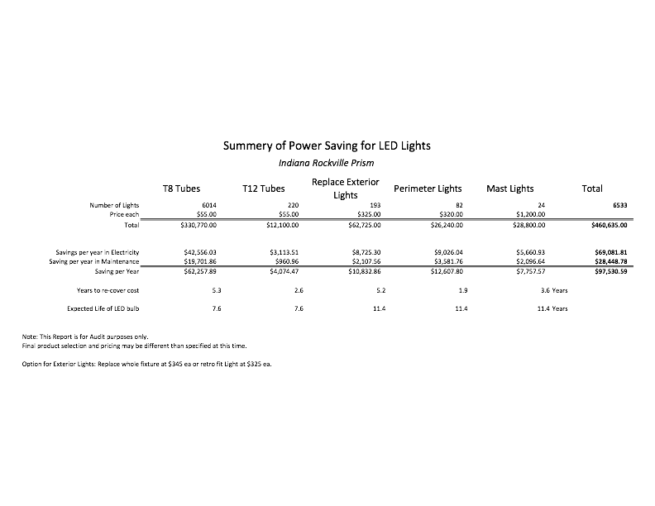was doing the audit with Cindy (Kathy’s associate from Kentucky), Ron and Kathy were having dinner with Indiana’s governor, Mike Pence (before he became Donald Trump’s current Vice President in the US).
It was a busy time. They had me flying to Houston, Grand Rapids, New York City, and Indiana, attending prison trade shows and doing lighting audits for pricing quotes. On one flight to Houston, I remember sitting beside CNN reporter Phil Mudd, who whispered to me that the Jewish people who 115

worked at the twin towers stayed home on the morning of 9/11.
I could not believe the Prison business. Each prison is like a factory, with dairies, fish farms, and all types of manufacturing within their walls. Prisoners being paid a dollar a day for their work… what a business! Why would they do this? It takes so many jobs away from the local communities.
And these prisoners were treated with the best of medical care, with both doctors and dentists fully provided. No wonder the US & Canadian prisons are full. I thought it was insanity… the amount of money it costs the tax payers every year for one prisoner, WOW!
I think I was the only guy ever allowed into these prisons to do audit counts on all the lights. I met with Governor of NY, the Mayor of Yonkers, and the retired guy who was in charge of all municipal buildings in Nassau County.

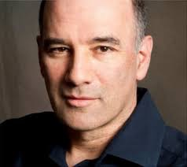

Ron set Bruce and I up with Harry Epstein from Chicago-based McDonalds Quadrant Management Consulting, to meet with us at the Ritz Carlton in Manhattan. It was a strange meeting, as Bruce and I were there to discuss LED lighting for 100 McDonalds locations. Harry said “There’s too many people in the world…we will be seeing things in the future that will be very scary and unusual.”
Recently doing research, I find out that when Gresch was married to Carol Alt and playing with the Rangers, he was good friends with Donald Trump and would invite Trump to the Rangers games as his guest. Trump owned Miss Universe for two decades and Gresch was a judge for the contest in the ’90’s,, I’d remembered seeing him on T.V. as a Miss Universe judge in Viet Nam.
Now this brings up another interesting connection with Saskatchewan, as Ron is from Saskatchewan. Recently, in February 2017 , I noticed that Miss Universe Canada is from Moose Jaw, Saskatchewan, the one and only contestant ever from Saskatchewan to make the finals.

Fast forward
On the morning of March 8th, 2014, I was having breakfast at the Willows golf course in Saskatoon, Saskatchewan, Canada. Ironically, this is the same golf course that led to Thomas Lilly’s partner, Richard Leibel, getting deported from Canada 15 years earlier.
Still, I was watching the news on TV when CNN announced “Malaysian Airlines flight MH370 has disappeared.” I immediately blurted out, “I know who did this,” knowing this was the gold heist I’d heard so much about several years earlier. A few people looked at me in surprise.

I remembered back to July 2008, the day before I left Dubai, Thomas Lilly handed me an envelope with about 15 printed pages. It was the Bilderberg’s NWO (New World Order) 14-year plan. It also had information about the Vatican and Homeland Security, but I had no idea! I thought it was just another scam.
The 14-year plan (double SHEMITAH) that Thomas handed me back in 2008 described:

Bitcoin
Blockchain technology - they have the code
Release the Kraken
Monero
Ethereum
ETC Classic
Brexit - this was planned in 2008
Bit Gold / Gold Money
USA Election
Interest Rate Hikes 2017 and 2018

When I’d asked Thomas “Who wrote this?” he answered simply, “Richard”.
Just before I left Dubai, Thomas mentioned that Richard had just found a Malaysian Airlines pilot who agreed to go on a simulator, to train for the passenger plane’s in-flight destruction. They offered the pilot $10 million and a villa in Bali.
My mother and I are born on the same day March 15th, so while we were celebrating our birthdays at my girlfriend’s restaurant, I mentioned to my mother that I believed Thomas was behind the disappearance of MH370. She knew who I was talking about, since she had spoken to him back in 2007-08, and had lent him $4,000 that he’d never returned.
I had long since erased Thomas’ phone number from my phone in 2010, but I did have his email address. I was totally positive that Thomas was behind the plane’s disappearance, even though I had not communicated with him for 4 years. I had no

idea what had happened with Bitcoin, Block Chain, Release the Kraken, Monero, Ethereum, ETC Classic, BREXIT, etc.
But I was about to find out.
When I began doing research, I started by Googling “Bitcoin” and discovered that, just a few short weeks earlier in January 2014, one Bitcoin was worth $1,100.00 USD ea.
I also read that, in February 2014, Mt. GOX in Japan - the world’s largest Bitcoin exchange - and Silk Road in the USA had been robbed. I remembered reading in the NWO 14-year plan (double SHEMITAH) how Thomas and the Swiss Jews have the code for the blockchain.
Mt. Gox, known for trading guns, nuclear weapons, and military equipment, immediately collapsed into bankruptcy, reeling from the disappearance of $460 million so soon after another $27.4 million went missing from its bank accounts, in two separate heists. That’s almost half a billion dollars stolen! Mt.Gox CEO Mark Karpeles was blamed and sent to prison.
At roughly the same time, Silk Road, a major Bitcoin exchange in the USA, known for doing drug cartel trades, was robbed of $850 million. Founder Ross Ulbricht was sentenced to life in prison.
These were just two of the six biggest Bitcoin heists in the short 3-year history of the blockchain technology’s use as a currency at the time. Hundreds of millions of dollars worth of the crypto-currency kept getting taken, apparently through anonymous hacks that were supposed to be impossible. Yet they kept happening… and growing.
From the Pony Botnet’s theft of $220,000 in missing crypto-currency in February 2014, to Mt. Gox’s loss of half a million dollars’ worth in 2011 (supposedly by an unknown user account, which managed to hack into Mt. Gox and make off with about 25,000 Bitcoin), the security of blockchain technology was hugely suspect. Then Silk Road 2, which was cleaned out by a hacker who broke in and swiped over $2.7 million dollars in February 2014, lost its entire balance as the sequel to the deep web’s most famous black market.
Rounding out the Top 6, another 96,000 Bitcoins (worth about $56.4 million) disappeared from the Sheep Marketplace in December 2013. But one of the most unusual heists in the top 6 was the original Silk Road marketplace, which was shut down by the FBI in October 2013.

In short, that means that the Feds took over the biggest Bitcoin wallet in the world, valued at roughly $127.4 million at the time.
Bitcoin’s Turbulent History
Bitcoin was created by Satoshi Nakamoto (Richard Leibel), who published the invention on 31 October 2008 as a peer-to-peer electronic cash system. One of the first supporters, and the receiver of the first bitcoin transaction, was programmer Hal Finney (Thomas Lilly), who received 10 bitcoins from Nakamoto on the day it was released. Other early supporters were Wei Dai, creator of Bitcoin predecessor B-money, and Nick Szabo, creator of Bitcoin predecessor Bit Gold.
Eventually, between the years 2012-2013, mainstream websites began accepting Bitcoins, including WordPress and OKCupid. More sites began accepting blockchain currency for payments in 2014, including TigerDirect and Overstock.com, Expedia, Newegg, Dell and even Microsoft in December of that year.
In May 2013, the U.S. Department of Homeland Security seized millions of dollars in assets belonging to the Mt. Gox exchange. The same year, the U.S. Federal Bureau of Investigation (FBI) shut down the Silk Road ‘dark web’ website in October 2013.
On 19 November 2013, the value of a Bitcoin on the Mt. Gox exchange soared to a peak of US$900 after the FBI told a United States Senate committee hearing that virtual currencies are a legitimate financial service. Bitcoin actually traded for over RMB¥6780 (US$1,100) in China that same day.
The first Bitcoin ATM was installed in Vancouver, British Columbia, Canada during October 2013. Soon after, in early February 2014, Mt. Gox (one of the world’s largest Bitcoin exchanges, in Japan) suspended withdrawals, citing technical issues. By the end of the month, Mt. Gox had filed for bankruptcy protection in Japan, amid reports that 744,000 Bitcoins had been stolen.

$500,000 Bali villa was biggest Bitcoin purchase ever
As I continued digging, I was shocked to discover one of the largest Bitcoin purchases ever completed. “This is where they put the pilot of MH370”, I thought.

According to the article, a villa in the Delmango Villa Estate, on the Indonesian island of Bali, was sold on March 12th for more than $500,000 worth of Bitcoin, making it the single largest crypto-currency purchase ever.
Although the exact purchase price and identity of the buyer involved remain unknown, BitPremier founder Alan Silbert described the purchaser of the property in Bali as an early Bitcoin adopter from the US. The sale represented "by far the largest" sale to date on the luxury BitPremier marketplace, which handled the transaction.

Around this time, I was trying to create a web-site for my LED lighting business. I wanted to create a web page about my company, Lofty Technologies, and how it was started. I always thought that if I included my hockey records, it may draw some business in Western Canada, and maybe I could retrofit the hockey rinks that still used the metal halide lights.

I thought back to October 7th, 1972, the night I scored 5 goals in 3:07 minutes, while playing for the Medicine Hat Tigers in Canada’s top junior league called the W.H.L. “The 5th goal was the “Best”. I’ll never forget it. 5 Goals in 3:07, 5307 became my favourite number.

I wanted to use the number “5307” so I purchased the following domain names:
led5307
ledlights5307
ledlightsupply5307
ledlighting5307
ledlightenergy5307
ledlightenergyLLC5307
ledlumens5307
In all, I had about 7 different domains, and for my logo I used the Hemihelix - community of Scholars.
But then I Googled 5307, and found a foreboding reference for the number.
According to Strong’s Concordance at BibleHub.com, their entry #5307 refers to the Greek/Hebrew definition for na phal:
1) To fall, lie, be cast down, and fail
2) “to fall (of violent death)”

This is where I began to uncover more devious connections, after searching for added info regarding Bitcoin. As it turned out, within days of the MH370 plane crash, the CEO of a Bitcoin startup in Singapore had fallen to her death under suspicious circumstances.

On February 28, 2014, Autumn Radtke, the 28-year-old CEO of Singapore-based Bitcoin startup First Meta, died from multiple injuries sustained after falling from her 16th floor apartment building.
In a flash of inspiration, I googled “autumn” in the Hebrew – Greek dictionary, where it’s known as the “falling of the leaves”. At the time of her death, Autumn Radtke must have owned 50,000 -100,000 Bitcoins or more and probably brought in many investors, which were all robbed.

By this time, I knew that all the stolen Bitcoins went to either the Feds or DHS, (Department of Homeland Securities). And who became the Global Regulator? KRAKEN

“Release the Kraken”
Kraken, formed in April 2014 (just after MH370 disappeared), is a Bitcoin exchange located in San Francisco, USA and is now the regulator of Bitcoin and other crypto-currencies.
To this day (May 27th, 2017 as I write this), whenever the Crypto Currencies make a huge correction, it is the Kraken being released automatically to either steal or buy up Bitcoins that are on sell orders, by the Bitcoin Mines answering difficult equations. This is a self perpetuating “ beast ” that will destroy people and the financial systems of countries, as foretold in the NWO 14-year plan (double SHEMITAH) I’d read as “Release the Kraken”.
Not only can they steal your Bitcoins, they are also the regulators!
Up until MH 370 went missing, I had no idea this was going on. During the previous 4 years, I had totally lost contact with Thomas. Now I really wanted to find out what was happening, and who was actually involved with the heist.
So, even though I had not communicated with Thomas Lilly since June 2010, I dug up his email address and sent him a short message…

“You did it.”
I never got a reply. So I googled “Thomas Lilly Bitcoin Dubai” and sure enough, he had a Forex website online. There was no phone number, but there was a contact form to leave typed comments.

So I typed in this message:
“Have Thomas Lilly Kazansky call Boyd Anderson immediately” and added my phone number. (I later figured out who passed the message along to Thomas, it was Nigel Farage).
Within 5 minutes the phone rang. It was Thomas Lilly, calling me for the first time in over four years. Without hesitating, I said, “I’ve been reading about Bitcoin and MH370. You’ve been a busy guy!”

Then I shut up.

After about 5 seconds of silence, Thomas said very calmly, “Yes, we got $200 million for MH370.”
Then he added, “Boyd, you are smart… very smart.’ I think he was telling me that I did the right thing by not getting involved in 2010.
Thomas continued, “I told you, I work for the Swiss Jews, Boyd.” Then he said, “Boyd, I don’t mind giving you, say, $500,000.00 for helping me back in 2007-08.”
Without skipping a beat, he joked “Remember the doctor, ha, ha, ha! That was quite a time. I used to see Lutchy once in a while walking down the street, and always would joke with her about you.”
“Do you still have your big gut?”
Thomas finished with another one of his wry observations, “So they wanna put a nigger in the Whitehouse, hmm?”
Over the following weeks, we started a series of conversations by phone and email. Below, 3 of the many emails from Thomas:
#1.
From: Thomas Liley <usherliley@yahoo.com>
Date: June 25, 2014 at 10:00:31 PM CST
To: Boyd Anderson <boydanderson.email@gmail.com>
Subject: Re: $300.00
Reply-To: Thomas Liley <usherliley@yahoo.com>
BOYD I AM NOT TAKING ADVANTAGE OF YOU RICHARD AND I ARE GOING TO MAKE A LOT OF MONEY AND SO WILL YOU I WILL KEEP MY WORD WE ARE THE ONLY ONES WHO ARE ALLOWED TO SELL THIS GOLD IT BELONGS TO THE KING OF THAILAND VENTURES ARE FROM CHICAGO HEIGHT LOOK UP WHO SIGNED THE CONTRACT LOOK AT HIS CREDENTIALS OF T. Paul S. Chawla INDIAN ATTORNEY AND YOU WILL SEE WHO HE IS A CHICAGO ATTORNEY WITH A BIG STAFF. BOYD THEY HAVE PUT $600,000,000 I N STANDARD CHARTER BANK TO BUY GOLD IT 15

IS NOT A EASY TASK TO FIND BUYERS LIKE THIS AGAIN BOYD THANK YOU FOR YOUR HELP
REGARDS, THOMAS
Mr. Liley:
Thank you for your continued communications and cooperation. From a procedural perspective, kindly direct all communications to both Mr. Srivastava and the undersigned, as we are the ONLY MEMBERS AND MANAGERS OF IVP.
Thank you for your understanding and cooperation.
Please also note our new address:
T. Paul S. Chawla
International Venture Partners, LLC
Member & General Counsel
3908 N. Cass Avenue
Westmont, Illinois 60559
630-325-5557 tel
630-325-6666 fax
630-214-4888 efax
Reply, Rep
BOYD I AM NOT TAKING ADVANTAGE OF YOU RICHARD AND I ARE GOING TO MAKE A LOT OF MONEY AND SO WILL YOU I WILL KEEP MY WORD WE ARE THE ONLY ONES WHO ARE 16

ALLOWED TO SELL THIS GOLD IT BELONGS TO THE KING OF THAILAND VENTURES ARE FROM CHICAGO HEIGHT SEE ATTACHMENT
#2
From: Thomas Liley <usherliley@yahoo.com>
Date: June 14, 2014 at 9:14:26 AM CST
To: boyd anderson <boydanderson.email@gmail.com>
Subject: Re lighting company
Reply-To: Thomas Liley <usherliley@yahoo.com>
Shalom Dr. Boyd my phone ran out of credit
1- Bulk sale purchase on inventory
2- Right to use the company name and he must change the name of his company
3- Provide list of clients interested in his products
4- Copies of all correspondence between the client and his company
5- Provide all E- Mails, address phone numbers of potential clients
6- Provide all of the above plus list of clients he has already sold along with all paid and un paid balances
7- Assignment of all receivables to new company with right of collection
8- A no compete radius close
9- Boyd we will have our money by the 3rd or 4th of July we should be in Hong Kong by the 17

2nd of July I have $35,000 USD coming by the 27th of June and in July we will be Farting In Silk. I will Buy Round trip business class tickets and make hotel reservation's in Hong Kong
11- My passport was Sent to the States for renewal foe all the new Biometric in new Passport my new passport will be here by the 20th of June if you can send me $250.00 Canadian Today I will be fine until I Receive my money.
12- Please call
Regards,
Dr. Thomas
#3
From: Thomas Liley <usherliley@yahoo.com>
Date: May 15, 2014 at 9:49:22 AM CST
To: Boyd Anderson <boydanderson.email@gmail.com>
Subject: Re: Brookdale Hospital Lights
Reply-To: Thomas Liley <usherliley@yahoo.com>
BOYD, I SENT YOU A LIST OF COMPANIES TO TAKE A LOOK AT AND SEE WHICH ONE YOU WANT THAN YOU CAN OPEN BANK ACCOUNT AT STANDARD CHARTER OR CHECK AND SEE WHICH COMPANY MAY HAVE BANK ACCOUNT AT STANDARD CHARTER. BOYD I 18

WILL DO A PROFORMA INVOICE FOR YOU TO TAKE WITH YOU TO HONG KONG I WILL SEND IT IN THE NEXT HOUR. RAHIM IS OKAY

In one conversation with Thomas, he mistakenly said “We pulled a Wally last night”. I made a quick assessment that they used to call “pulling a wally” meaning hacking into someone’s Bitcoin ‘wallet’ and stealing their Bitcoins. Remember, Thomas and the Swiss Jews have the code for the blockchain… which is the platform that Bitcoin runs on.
So they have total control of the blockchain and any transactions that run on it. In other words, they can steal Bitcoins from anyone’s wallet whenever they want!

Also, keep in mind that the crypto-currency capital of the world in Zug, Switzerland is home to Ivan G. and the headquarters for Glencore, which has connections to this conspiracy that we’ll talk about later.
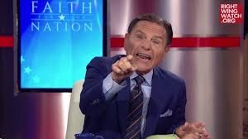
On one call Thomas mentioned that Ken Copeland was visiting with him in his office.
Kenneth Max Copeland (born December 6, 1936) is an American author, musician, public speaker, and televangelist associated with the Charismatic Movement.

Copeland has been identified with preaching a prosperity and abundance message, commonly referred to as the prosperity gospel, which has been criticized by various denominations.2013 vaccination controversy:
"Some people think I am against immunizations, but that is not true," the statement said. "Vaccinations help cut the mortality rate enormously. I believe it is wrong to be against vaccinations."
Overall, Thomas sent me about a dozen emails from March - July, 2014, mostly pictures and jokes about Obama. He would repeatedly say,

“So, they wanna put a nigger in the Whitehouse, hmmm!”

After another awkward telephone conversation, I told him that I’d gotten into the LED lighting business in 2012.
I sent him emails with my quotations for Jamaica Queens Prison in New York City, and Indiana State Prison for Women. I also showed him my quotations for Brookdale University Hospital and Medical Center, and for the Brooklyn Hospital Center.
I think I shocked him, as he called me back immediately to say,

“Those are all my main contacts, Boyd.”
The warden at Jamaica Queens Prison was Bill Z. In 2013, when I was doing the audit count for their lights, I’d heard that Hollywood had made a movie about his real life experience as a U.S. marshal, telling how he had captured approximately 20 escaped convicts at one time.
Back when we’d hung out together in Dubai in 2007-08, I remembered Thomas always carried two cell phones. He told me the one in his left pocket was connected to the “the Swiss Jews”, but at the time I had no idea who the other cell phone was connected to. 21

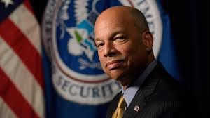
As it turns out, Thomas’s other phone was connected to the DHS. Jeh Johnson, Secretary of the Department of Homeland Security, was his friend. Thomas knew Jeh’s father.

If you ask me, DHS (Homeland Security) created ISIS by constructing a prison in Iraq in 2002, so that all the extremists could get together under one roof and do their planning. And in August 2014, experts were saying that ISIS was using Bitcoins to fund criminal activities.
At this point, I expected Thomas was thinking I must be with the CIA or some group that was involved. He told me he had the co-pilot from MH370 in Dubai. Prior to the call, I’d read about the largest Bitcoin purchase ever, a villa in Bali which sold for $500,000.00 USD on March 12th, 2014.
I thought, “That’s where the pilot went with his family.”
Soon afterwards, Thomas sent me a contract for $575,000 US to pay me for helping him back in 2007-08. He said, “We use the Standard Chartered Bank in Hong Kong”. Then he invited me to Hong Kong at the end of June, 2014 to attend a Bilderberg meeting 22

at the Marriott, as they were giving recognition to ‘their fine work.’
I knew he was lying again. He even had the nerve to ask me to send him more money through Western Union. They own Western Union, as well as Brinks and ADT.
On a couple of occasions when I called Thomas in September 2014, I could hear laughing in the background. When I asked him where he was living, he told me “I’m with some guys, we have a house in the suburbs of Dubai.”
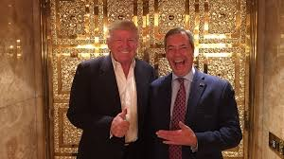
Thomas and I had probably 10 conversations throughout the first half of 2014, from late March to the end of June.

He even had an investment advisor by the name of ‘Nigel’ from England call me, to see if I wanted to invest with him. He said he was a FX Forex trader, recommended by Thomas. I still did not trust Thomas, and I never had any money to invest anyway, so I declined.
I believe this ‘Nigel’ was Nigel Farage, as he spoke with the very same ‘whiskey-voiced English accent’ as the British politician. 23

The last conversation I had with Thomas was around mid-September 2014, when he said, “Now that we have the gold we need to sell it.” He added, “The people on MH370 are never coming back. You need to know where money originates from, that’s the key.”
Quickly researching “the origin of money”, I discovered it is Turkey and Greece!
Then around the 17th of September, 2014, I got a call from someone I didn’t recognize.

Speaking with a South African accent, the voice said “Hi Boyd, this is Ivan. I’m Thomas’ friend from South Africa.”
“Thomas had a stroke last night,” Ivan continued, “and it doesn’t appear he will recover. He’s talking like a baby.”
It was as if Thomas was guiding him through the conversation. I could remember Thomas often used that expression “talking like a baby” back in 2008.
I never heard from Thomas again.

I began to do more research, prompted by my misgivings about Thomas, contacts I remembered from our days in Dubai, and by the details I recalled from the NWO 14-year plan (double SHEMITAH) that still weighed heavily on my mind. To begin, I Googled:

Marc Reich
Ivan Glasenberg
Rothschilds, including Boeing, MH, Freescale semi-conductors
George Soros - Quantum Fund
Peter Munk - Barrick Gold
Haruhiko Kuroda - Bank of Japan
Eric Sprott - Sprott University
DHS - Jeh Johnson
John Baird - Canada’s former minister of foreign affairs
BITCOIN, Blockchain, Ethereum, ETC Classic, Monero
Release the Kraken
Interest Rate Hikes 2017-2018

The list goes on, as the rabbit-hole deepened with each web search. But the further I dug, the more I was convinced of the incredible conspiracy that was being revealed right before my eyes,

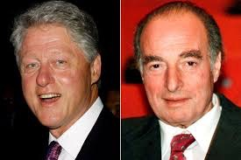
Let’s start with Marc Reich (alias Mark Rich), who fled the U.S. in 1983 after being charged with tax evasion and illegal dealings with Iran. In fact, on his last day in office on January 20, 2001, US President Bill Clinton issued a pardon for the international fugitive, who had used his special relationship with Ayatollah Khomeini to buy oil from Iran -- despite the American embargo at the time.
In what would become perhaps the most condemned official act of Clinton’s political career, Marc Rich got a reprieve on a list of charges going back decades. Born Marcell David Reich on December 18, 1934, he was an international commodities trader, hedge fund manager, financier and businessman who was known for trading illegally with America’s enemies, including Ayatollah Khomeini’s Iran.
During the notorious Iran hostage crisis at the US Embassy in Tehran, Rich had bought about $200 million worth of oil from Iran while revolutionaries allied with Khomeini were holding 53 Americans hostages in 1979.
Digging further, I also discovered that, after a failed attempt to corner the Zinc market a decade later, Rich sold his interests in the Marc Rich Group (his commodities company in Zug, Switzerland) to some of his executives, who changed its name to Glencore. (Incidentally, Glencore’s North American headquarters are located in Regina, Saskatchewan).

One of the new partners in Glencore was Ivan Glasenberg, who speaks in a

“clipped South African accent “.

Apparently, Ivan constantly interrupts himself, as if his mouth can’t keep up with his brain… which sounded exactly like the guy who’d told me about Thomas’ stroke during our short phone conversation only weeks earlier!
Glasenberg, who joined Rich’s firm in South Africa in 1984, was appointed CEO of commodities behemoth Glencore, with his reputation as the shrewdest, boldest leader in the entire world of copper,coal,oil,aluminum, and wheat. While he’s known throughout the commodity mining industry simply as Ivan. Glasenberg’s wife is from Toronto, Canada.6

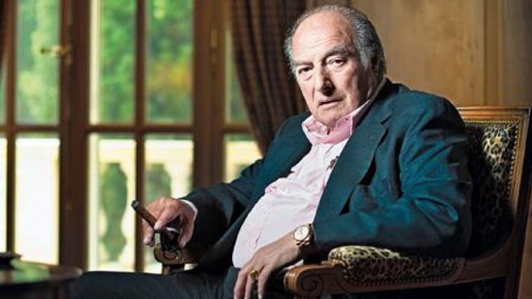

More on Marc Rich and Glencore
Rich expanded his investments in the 1980s to additional sectors, purchasing 20th Century Fox studios along with industrialist Marvin Davis in 1981. But in 1984, after Rich fled from the United States, Davis sold his share to Rupert Murdoch for $250 million.
Read more: http://www.haaretz.com/israel-news/business/.premium-1.532365
I believe the 2016 movie, “Assassins Creed”, was dedicated to Marc Rich & Thomas Germain Lilly, who were both Mossad agents, regarding MH370, MH17, ISIS projects, and their successful elimination of 125 top scientists, 75 bankers, 4 journalists, and Autumn Radke, the CEO of Bitcoin in S.E. Asia.

Forbes reported Rich had a net worth of US$1.0 billion as of 2010, a few years before he died of a stroke on June 26, 2013, at a Lucerne hospital. He was 78.
On January 20, 2001, hours before leaving office, U.S. President Bill Clinton granted Rich a highly controversial presidential pardon. Several of Clinton's strongest supporters distanced themselves from the decision. Former President Jimmy Carter, a fellow Democrat, said, "I don't think there is any doubt that some of the factors in his pardon were attributable to his large gifts. In my opinion, that was disgraceful." Clinton himself later expressed regret for issuing the pardon, saying that "it wasn't worth the damage to my reputation."
Clinton's critics alleged that Rich's pardon had been bought, as Denise Rich had given more than $1 million to Clinton's political party (the Democratic Party), including more than $100,000 to the Senate campaign of the president's wife, Hillary Rodham Clinton, and $450,000 to the Clinton Library foundation during Clinton's time in office.
In a February 18, 2001 op-ed essay in The New York Times, Clinton (by then out of office) explained why he had pardoned Rich, noting that U.S. tax professors Bernard 126

Wolfman of the Harvard Law School and Martin Ginsburg of Georgetown University Law Center had concluded that no crime had been committed, and that Rich's companies' tax-reporting position had been reasonable. In the same essay, Clinton listed Lewis "Scooter" Libby as one of three "distinguished Republican lawyers" who supported a pardon for Rich.
Glencore International AG was a corporate successor to "Marc Rich + Co AG." Glencore merged in 2013 with Xstrata to become Glencore Xstrata, headquartered in Baar, ZUG, Switzerland. Today, Ivan Glasenberg and his colleagues are eager to play down the Marc Rich connection. Glencore's website says the company was founded in 1974, but there is no credit given to the actual founder, Marc Rich.
With my cache of information on the people involved growing by the minute, I was beginning to understand how they all seemed to point back to one person… the very same guy I’d heard describing his wicked plan countless times, back in Dubai.
I do remember receiving a phone call from a Swiss Bank around the end of June, 2013 asking if I wanted to keep my bank account open. I answered “NO” because I had not communicated with Thomas for 3 years. Coincidently, from my recent research, Marc Rich died on June 26th, 2013.
Now it was time to figure out just who Thomas Lilly was, and try to decipher his connection to the fateful Malaysian Airlines disappearance that I was certain he was involved in.

CHAPTER #6 – Will the REAL Thomas Lilly please stand up?
It took me months to track down Richard Leibel, but in 2015 I finally got in touch with Reg Schafer, his old partner in Saskatoon, and asked him for Richard’s email.
As soon as I emailed Richard, he sent a reply denying that he knew anything about anything. We exchanged a few emails, but it was useless trying to get Richard to admit he was “Satoshi Nakamoto” -- the infamous, so- called Japanese programmer who wrote the whole Bitcoin software program.
However, he did say that Thomas’ real name was
“Thomas Germain Lilly”, so I searched Google with my new-found information – and just about fell off my chair at what appeared onscreen.

The “Assassin’s Creed” web page was full of pictures, and as I scrolled down, there he was. Included in the biography that followed for “Germain Grisez” was a picture of Thomas that was dated July 28th, 2014. I gasped, then clicked on his picture

-- he’d lost some weight, but that was him.

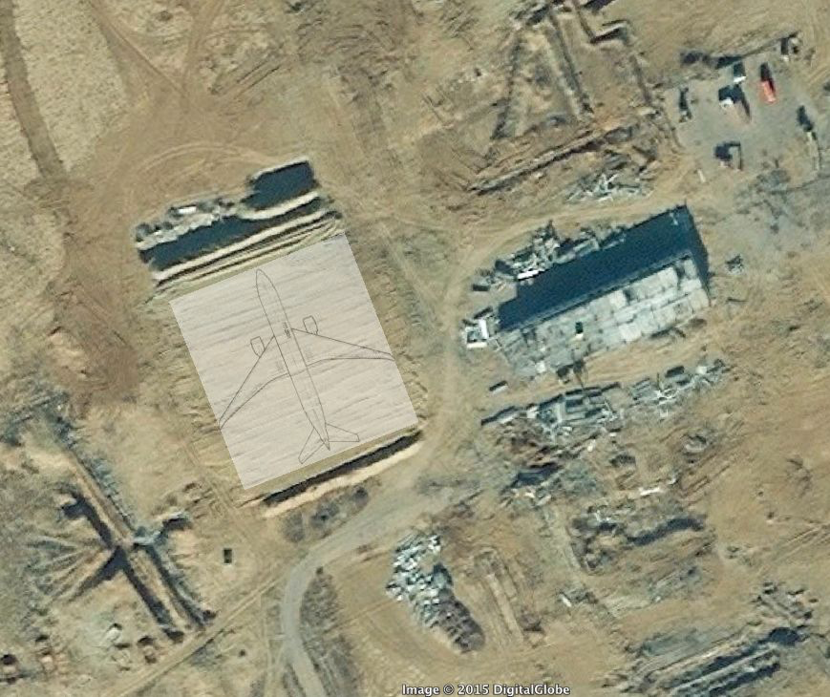
Apparently, for thirty years (from 1 July 1979 to June 2009), Germain Grisez was the Most Reverend Harry J. Flynn Professor of Christian ETHICS at Mount Saint Mary’s University in Emmitsburg, Maryland. Founded in 1808, the Mount is a unique combination of a seminary that trains men for the Catholic priesthood and a four-year, co-education undergraduate college. The college is the second oldest Catholic college in the United States and the seminary is the second oldest Catholic seminary. It’s widely regarded as one of the best.
During his long tenure at Mount Saint Mary’s, Grisez’s main work had been researching and writing “The Way of the Lord Jesus”.
When Germain Grisez resigned from the college in Georgetown, Maryland in 1972, he had accepted an invitation to become a professor of philosophy at
Campion College, a Catholic college that’s also an integral part of the mostly secular university in Regina, Saskatchewan in Canada. Campion was striving to carry on collegially an apostolate along the lines Grisez had hoped to undertake individually. Grisez was at Campion Catholic College in Regina, Saskatchewan for 7 years - 1972-79.
I’m from Saskatchewan, and so is Richard Leibel, a man my father knew of. He’d actually married my friend’s cousin, and Thomas (alias “Germain Grisez”) knew lots of drug dealers and powerful people in Saskatchewan. For example, Thomas had mentioned a Harvey Schmidt, living in Saskatoon, saying Harvey had a bunch of houses in Saskatoon and Vancouver neighbourhoods that were grow operations. He told me Harvey’s operation grew lots of pot, before transporting it out to British Columbia.
Thomas also talked about the Hill family from Regina, who own half the city and were instrumental in getting Sun Life’s headquarters moved from Montreal to Regina. The Hill family is an Air Force family, and was educated at Georgetown. Plus, they started Campion College in Regina, so they have a strong connection with Georgetown (the largest Catholic school in North America), as well as the US Air Force base in Maryland.
Finally, Thomas Lilly used to mention Russia and the Mossad quite often. His mother had emigrated to the US from St. Petersburg, Russia and started a pharmaceutical company.

NOVEMBER 5th, 2017
Paradise papers
These were all part of Thomas’ group ,,,,, with trillions of dollars being reported in offshore accounts up until 2007 and have now been invested into BITCOIN and other cryptocurrencies.
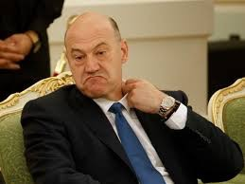
'Paradise Papers' Disclosures Of TRUMP-Administration-RUSSIA Ties Warrant Congressional Hearings
Apart from those Russian ties, the Paradise Papers also show that a number of other Trump administration figures, including chief economic adviser Gary D. Cohn

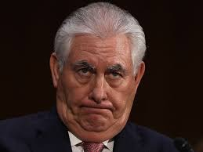

and Secretary of State Rex W. Tillerson, have participated in the offshore tax haven network.
U.S. Commerce Secretary Wilbur Ross has kept investments in a shipping firm with significant business ties to Russian President Vladimir Putin’s inner circle, U.S.

media reported on Sunday, citing leaked documents from an offshore law firm.
Wilbur Ross and Thomas were old friends.
The Paradise Papers: Massive New Leak Links Russia and Trump Cabinet Member Wilbur Ross
The Paradise Papers: Haaretz Reveals Some of the Israeli Businessmen and Firms Registered in Offshore Tax Havens
The term 'Israel' appears in more than 20,000 documents leaked from the Bermudan law firm Appleby, including Idan Ofer and Jonathan Kolber
Uri Blau Nov 05, 2017 10:53 PM
read more: https://www.haaretz.com/israel-news/1.821229
Jewish investors believed to be buying up Greek Patriarchate land
Purchases by foreign-registered companies have infuriated some in the church amid claims they will change status quo.

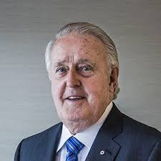
OTTAWA - The Canada Revenue Agency says it won't hesitate to investigate new evidence of offshore tax evasion in the wake of a second massive leak of tax haven financial records.
The leak of some 13.4 million records, dubbed the Paradise Papers, lifts another veil on the often murky ways in which the wealthy - including more than 3,000 Canadian individuals and entities - stash their money in offshore accounts to avoid paying taxes.
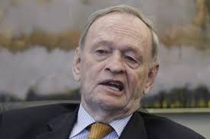
Among the names that pop up in the records with some connection to offshore accounts are former Canadian prime ministers Brian Mulroney, Paul Martin and Jean Chretien, the

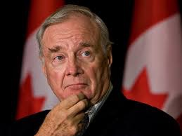
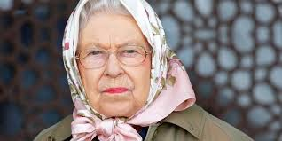
Queen, U.S. commerce secretary Wilbur Ross, and the past and current chief fundraisers for the federal Liberal party.
Queen Elizabeth has investments in offshore havens: reports
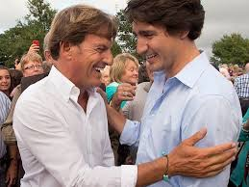
Stephen Bronfman and his family's Montreal-based investment company, Claridge Inc., were linked to an offshore trust in the Cayman Islands that may have used questionable means to avoid paying millions in taxes.

6 NOVEMBER 2017 • 3:21PM
Glencore, the FTSE 100 mining giant, is among Appleby's top clients worldwide. The company has subsidiaries based in Australia, Switzerland, Bermuda and Canada, where it owns Katanga Mining Limited, which operates in Congo but is listed on the TSX.
is facing fresh questions about the way it conducts its business following a massive data leak called the ‘Paradise Papers’.
More than 120,000 people and companies have been named in 13.4 million files, many of them leaked from offshore law firm Appleby. The documents have been reviewed by the German newspaper Süddeutsche Zeitung and the International Consortium of Investigative Journalists.
Glencore, the mining giant, which employs more than 7,000 Canadians, was one of Appleby’s biggest clients: the firm reportedly had a “Glencore Room” in its offices dedicated to handling transactions and management duties for the miner. But what do the leaks reveal?
What is Glencore?
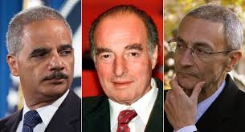
Glencore is the global successor to the trading firm founded by Marc Rich, the financier who spent years as a fugitive on the FBI’s most wanted list for sanctions-busting, fraud and tax evasion, before being pardoned by Bill Clinton in the final hours of his presidency.

Glencore, and its forerunner company, have been accused of sanctions-busting in Saddam Hussein’s Iraq, apartheid South Africa and Iran. In 2004, Glencore was cited by the CIA as having paid $3.2m in illegal kickbacks in violation of sanctions to Iraq’s state-run oil monopoly. It has also been accused of environmental pollution, poisoning rivers, and allowing child labour in its African mines. Glencore denies the allegations.
While hardly a household name, Glencore is one of the biggest miners in the world, with a turnover of $152bn (£116bn). It mines copper, zinc and coal and trades commodities such as oil and wheat all around the globe.
Based in Switzerland, the firm has a reputation for secrecy. But it has had to adapt to greater public scrutiny since listing on the London Stock Exchange in 2011. The float raised $10bn and generated a massive windfall for senior management, including chief executive Ivan Glasenberg, who now owns 8pc of the stock.
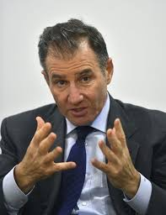
Ivan Glasenberg

Glasenberg is feted as a canny deal maker, unafraid to operate in jurisdictions where others fear to tread. For example, Glencore is one of the biggest foreign firms in the 137

Democratic Republic of Congo, one of the world’s poorest countries, where it runs the Katanga copper mine. This mine is at the centre of some of the documents in the Paradise Papers.
What do the Paradise Papers reveal about Glencore in the DRC?
The leaked documents shed more light on Glencore’s dependence on Israeli businessman Dan Gertler, who was a minority shareholder in Katanga and is accused of using his closeness to the DRC president and bribes to win mining permits – allegations Gertler has denied.
The documents purportedly show that a number of Glencore subsidiaries in Australia engaged in cross-currency swaps worth up to $25bn. These deals, while legal, have come under scrutiny from the Australian tax office amid concerns they could be used to avoid tax.
Glencore offices
Glencore is based in Switzerland
Other documents purport to show that Glencore kept secret a 47pc stake in a shipping company called SwissMarine, leading to claims it is operating a “ghost fleet” of 167 cargo ships. 138

In 2013, around the time Glencore was finalising its $46bn merger with Xstrata, its fellow founding shareholder SwissMarine was arrested on charges relating to fraud, which were later dismissed, according to the Australian Financial Review.

Paradise Papers show world’s biggest miner lent millions to Israeli billionaire on condition authorities agreed to a deal.
Trump says U.S. now recognizes Jerusalem as capital of Israel
Trump will also direct State Department to move U.S. Embassy from Tel Aviv to Jerusalem
Trump also said he would direct the State Department to begin the process of moving the U.S. Embassy from Tel Aviv to Jerusalem.

Former Economy Minister Among 23 On Trial In Kazakhstan
November 07, 2017 11:12 GMT
ASTANA -- Former Kazakh Economy Minister Quandyq Bishimbaev went on trial along with 22 other defendants charged with bribery and embezzlement on November 7. 11

Meanwhile, as these thoughts and conversations were coming back to me, the list of mysterious and suspicious deaths I was able to discover surrounding scientists,
bankers and journalists from 2011 to 2015 was astounding.

For example, the death tolls included:
75 High-level bankers, including a Denver banker who supposedly shot himself 8 times in his head and torso with a nail gun
125 Scientists, including an infectious disease scientist who was stabbed 196 times
3 investigative journalists, who all worked in an explosive area, died within 24 hours of each other. The list goes on and on
And of course, there was sudden ‘falling’ death of Autumn Radtke, the American CEO of Bitcoin in southeast Asia, that seemed more suspicious and ‘co-incidental’ than any Jason Bourne movie ever was.

So in 2015 September, I called Ivan Glasenberg and spoke to his secretary to say,
“It’s been about a year since Ivan called me to let me know Thomas had a stroke. I’m calling to see how Thomas’ health is.”
Obviously, I never heard back. Ivan did not want to talk to me.
But that didn’t stop my investigations.

And finally, in January 2016, I discovered the last piece of the puzzle to MH370’s disappearance, the gold heist and a long list of assassinations.
Up until then, I couldn’t figure out how they could get 55,500 tons of gold down to Perth, Australia for re-melting and re-certification, until I read about three Boeing Jumbo 747s that had been abandoned at the Kuala Lumpur airport -- the same airport where the fateful MH370 flight originated from.
But after sitting unused for over a year, the three jumbo Boeing 747s were finally auctioned off in December 2015.
Cha Ching!!! BINGO! I had now put 99% of the MH370 gold heist/assassinations together.
Here’s how the last key piece played out…

Kuala Lumpur International Airport (KLIA) authorities placed an advertisement in local newspapers, trying to track down the owner of three double-decker passenger aircraft that had been parked and left abandoned on its tarmac for more than a year.

Now some days I have a hard time finding my car in the shopping-mall parking lot, but who forgets where they left their Boeing 747-200F for a whole year? Or, you know, three of them?
According to CNN, the airport’s operator, Malaysia Airports Holding Bhd, placed a notice during the first week of December 2015 in Malaysia's The Star and Sin Chew Daily newspapers, announcing “If the Boeing 747-200F planes are not collected within two weeks, we reserve the right to sell or otherwise dispose of the aircraft”. They said the money raised would be used to offset expenses and due debts to the airport for housing the jumbo jets for all that time.
Malaysia Airports general manager Zainol Mohd Isa, the contact person listed in the advertisement, told Bloomberg news agency the planes had been sitting on the tarmac for more than a year. Although the planes were left at KLIA at different times, and the last registered owner was known, they had not been in contact over the removal of the planes.
Further details surfaced here…
“We’ve been in communication with the so-called owner, but they have not been responding to take away the aircraft,” Zainol said. “That’s why we go through this process to legalize whatever actions we want to take.”
Apparently, two of the three abandoned planes had previously been leased to Malaysia Airlines from Air Atlantic Icelandic, but that company says it sold them in 2008. Since then, the aircraft appear to have changed hands several times.
With the final clues in place, I could piece together the timeline of the biggest gold heist and mass murder in history.
5 PLANES INVOLVED WITH MH370, GOLD HEIST - ASSASSINATION
2 x 777’s (MH370 & MH17) + 3 x Jumbo 747’s
THERE’S THAT NUMBER "537"

CHAPTER #7 – Project Prophecy by the numbers: The murderous timeline fulfilled
Here is the sequence of events (and supporting evidence) behind the disappearance of Malaysian Airlines flight MH370 – the biggest gold heist and mass assassination in the history of the world.
This timeline of events -- a play-by-play description of what happened in various, seemingly unrelated incidents – along with numerological references and supporting facts that I can’t believe are merely coincidences.
March 6th, 2014 Freescale Semiconductors holds a seminar in Kuala Lumpur, with at least 20 company officers, engineers and senior technicians in attendance.
March 8, 2014 (Kuala Lumpur time)
(actually March 7, 2014 in the Western World) Numerology: 3/7/2014 (2014=2+1+4=7, making 3/7/7 – “377”)
Just after midnight UTC, Malaysian Airlines flight MH370 with 239 passengers and crew took off from Kuala Lumpur’s airport on a scheduled direct flight to Beijing, China.
Boeing constructs planes two at a time, working from the same spec sheet to create ‘identical twins’ during manufacture. According to published Boeing specifications, the two ‘paired’ planes MH370 and MH17 had wireless explosives on board, and were armed with stealth cloaking technology and wireless auto-pilot technology.
The Malaysian airliner’s twin was MH17, according to The Boeing Corporation -- a Rothschild company, based in Seattle. Boeing is the manufacturer of the twin model Boeing 777-2H6(ER), and the home of Flight MH370’s demise agents of darkness.
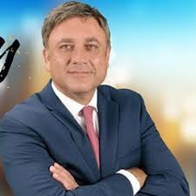
GA Telesis, a privately-owned aircraft leasing and servicing company based in Fort Lauderdale, Florida, owns a fleet of 26 airplanes. Only one of those planes is a Boeing 777, a used Malaysian airliner that was being stored in Israel.
The owner of GA Telesis is Abdol Moabery, the son of Iranian immigrants, who lives in the posh Woodlawn Hills suburb of Los Angeles. George Soros is a friend of Moabery.

MH370’s CARGO Manifest states there were two tons of MangoSteen on board. However, it was really two tons of gold, which had been smuggled in from the US military base in Thailand.
The New York Times reported that radar signals recorded by the Malaysian military appear to show the plane ascending to 45,000 feet, making a sharp turn to the left not long after it disappeared from civilian radar.
This indicates that, over the Bay of Thailand, the MH370 pilot ascended quickly to 45,000 feet and cut off the oxygen to the cabin. He maintained that altitude for 23 minutes, killing all 239 passengers and crew members on board by asphyxiation (lack of oxygen) before descending (“falling downward”) and dropping “under the radar” over the Strait of Malacca.

At the same time, the Israeli Mossad came flying by in the ‘twin’ MH17 plane, picking up the radar signal and heading in the direction of the Indian Ocean. This was done to misdirect and fool the public into thinking MH370 landed somewhere in the vast, watery wasteland, making it extremely difficult to trace.
An immediate lock-down of Thailand and Malaysia was enforced. The Thai air force says its radar spotted MH370 heading towards the Strait of Malacca minutes after it vanished. But they didn't say anything, suggesting a military cover-up over the missing jet.
1:28 AM
MH370 spotted in the air, eight minutes after it stopped communicating. The plane turned towards Butterworth, a Malaysian city along the Strait of Malacca.
2:14 AM
Malaysia detect MH370 on their military radar, heading into the Strait of Malacca.
The Thai air force later said they did not report the contact because 'it did not look like a threat’. This meant precious time was being wasted searching in the wrong area, as Malaysia ceded control to other countries in the ongoing search operation across a wide search area, consisting of 14 sections covering an area the size of Australia
The communication systems aboard MH370 are powered up, as evidenced by the login sequence of the satellite data unit (SDU). Prior to power up, the transponder and ACARS were switched off so that the plane remained undetected.
2:29 AM
MH370 begins a descent into Banda Aceh Airport, turning from a northwest heading to a southwest heading. New WITN waypoints were entered into the flight computers, corresponding to the Maimun Saleh Airport in Sabang, Weh Island, Indonesia, which is just north of Banda Aceh.
4:46 AM
When it reached WITN, the plane turned towards the Sultan Iskandar Muda International Airport (formerly called Blangbintang Airport) at Banda Aceh, aligning with and landing on runway 17. With this approach path over the sea, the plane may have landed automatically, facilitating a night landing even by an inexperienced pilot. Since that runway has an operational instrument landing system (ILS), a B777 may be auto-landed.

As soon as it was on the ground at Banda Aceh, the precious cargo was quickly unloaded from MH370. It takes approximately 30 minutes to unload the 2 tons of gold, and to pick up medical equipment required to drain the blood from all the dead bodies onboard.
5:06 AM
MH370 takes off from runway 35, heading towards the sea, and follows the standard departure pattern towards waypoint BEDAX.
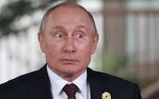
Since Putin had ordered the plane to be flown to Kazakhstan space port 13 , MH370 flies north to the Yubileyniy Aerodrome within the Baikonur Cosmodrome, Kazakhstan, where it is stored until July 17th, 2014.
The blood draining will be completed in-flight by the time MH370 arrives in Kazakhstan.
The blood was divided into 3 batches of “79”and to be used for sacrificial rituals.

Numerology: 3x79=237 passengers + 2 (pilot & co-pilot) = 239
Meanwhile, MH17 continues its ‘decoy’ flight towards the Indian Ocean for a while before veering off, turning off its radar communications and circling back to Banda Aceh airport.
Timing is precise: As MH370 departs for Kazakhstan, MH17 arrives. After landing, it takes another 30 minutes to load the 2 tons of gold onto MH17, which then departs for the World Gold Mint in Perth, Australia.
The 2 tons of gold, to be used for negotiation purposes with the Prime Minister of Australia, are deposited and an account is set up at the World Gold Mint.
The remaining gold to be delivered by the three ‘abandoned’ Jumbo 747s, at Kuala Lumpur International Airport. Each 747 will make 50 trips, carrying 370 tons of gold each time, over the next 5 months. At that point, the transaction is complete.
Numerology: 50x370 = 18500 x 3 = 55500 (symbolizing ‘555’, the number they worship)

How could all of this airplane activity proceed undetected?
Pine Gap, the Earth station in the centre of Australia which is operated by both Australia and the United States, has the ability to control radar in the Southern Hemisphere. With inside help, all arrangements had now been made for the three Jumbo 747s to commence transportation of the gold.
Two of the 747s are already on the tarmac at Kuala Lumpur’s airport.
The third 747 was flying in from Iran or Israel over the Maldives Islands, as witnessed by the locals. It headed to Diego Garcia, where it refuelled and proceeded to the Thai military base, where the gold was stored.
6:15am Malaysia time
Witnesses on the Maldives island of Huvadhoo report seeing a 'low-flying jumbo jet' at sunrise. They described the plane as white with red stripes, looking like a Malaysia Airlines jet. The residents stated that they sometimes see small seaplanes around the island, but this was the first time they ever saw a jumbo jet.

MH370 Flies to Kazakhstan, where a surprising flurry of preparations had been
taking place at the formerly-deserted site of the Yubileyniy Aerodrome, within the Baikonur Cosmodrome.

As evidenced by freely-available Google Earth and privately-obtained satellite photos viewable online at http://jeffwise.net/2015/02/23/what-went-on-at-yubileyniy, you can see :
A number of trucks are lined up in the parking lot of the long-abandoned site
The six-story building on the former ‘space port’ is being disassembled
A large rectangular pile of dirt to the left of the building has recently been bulldozed (in several of the photos, the image resolution is so good that you can actually make out the stripes left by the bulldozer blade, as it worked back and forth horizontally)
At the northern end of the rectangle, you can see a berm casting a shadow to the north, indicating remnants from digging on the site
At the far northeastern corner of the area lies what appears to be a trench, with a well-defined corner on the upper right of the photo. Tread marks are leading out of the trench and heading toward the southeast.

Looking at the pictures, I’m not sure what this dirt rectangle represents — are they building a pile of dirt, or a big hole? Either way, what really gets my attention is the size of the excavation. To give you a sense of scale, the author has superimposed a photo of an equivalently-proportioned 777 silhouette, which fits perfectly into the image of the bulldozed area.

This struck me as interesting, to say the least. Naturally, I wondered what happened next. Fortunately, Terraserver had one more image that I could browse for free. This next one was taken on April 26, 2014:
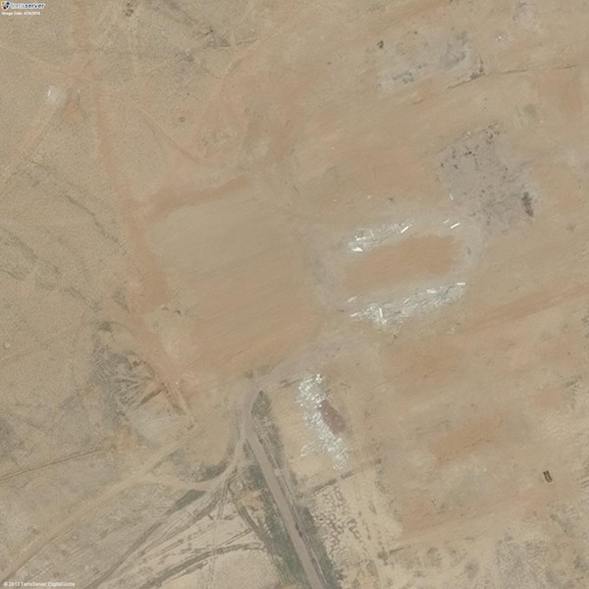
Holy cow. All traces of both the building and the dirt rectangle have been erased. Various debris piles have been swept away, too. At first I thought that maybe the image had been digitally scrubbed, but if you look closely you can easily make out individual pieces of junk in between the cleared areas. So my interpretation is that the site was actually cleared and swept up.
So here’s the situation: nothing happens at Yubileyniy for decades; then, four months before MH370 disappears, the Russians start building a 777-sized something-or-other a mile and a half from a giant disused airstrip. Then, a month after the plane disappears, the area looks like it’s been erased.

Another fact that makes this all seem particularly strange is that these ‘cleanup’ and excavation activities happened in the span of a couple of short winter months -- on a deserted site, in an area of Khazakstan that had sat unused, untouched and ignored for more than a decade. Plus, the flurry of preparations were completed within just two days of MH370’s disappearance!

If you ask me, MH370 was flown to the space-port site and buried before the sun came up. Then it stayed buried until three weeks before July 17th, 2014, when it was resurrected to play an important role in another notorious airline international incident over Ukrainian territory.

Meanwhile, the MH370 pilot was given $10 million USD and a $500,000 villa in Bali, paid for with Bitcoin. The plane’s co-pilot was flown to Dubai and looked after by Thomas and Ivan G.
For the time being, MH17 remains in Perth until the first 747 shipment arrives, which happens within 24 hours. At that point, MH17 departs for Diego Garcia, and then on to Israel or Iran.

Once MH370 and its ‘ghosted twin’ MH17 had caused a diversion, military leaders immediately locked down both countries in Malaysia and Thailand. That allowed the Bilderberg’s henchmen to fly the three Boeing Jumbo 747s onto the military base where the gold was kept, loading up the 55,500 tons of gold and flying the gold down to Perth, where it would be re-melted at the World Gold Mint.

Numerology:
The three Jumbo 747s made 50 trips carrying 370 tons of gold each time,
for a total of 18,500 x 3 = 55,500 tons. It took 5 months to get all the gold to Perth. And mid-September 2014 was the last time I spoke to Thomas, with our conversations lasting just over 5 months in total. The number 5 keeps repeating!

While the public thought there was a ‘search’ going on for MH370 in the Indian Ocean, Thomas and the Swiss Jews were flying back and forth from Thailand to Perth with the gold – right in front of the world’s eyes, as if they were part of the search!
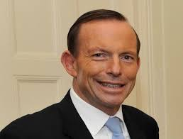
This is why the Australian Prime Minister and others were constantly on TV when MH370 went missing, trying to encourage the search in the Indian Ocean. Thomas and “Swiss Jews” planned everything! It is truly amazing how they accomplished so many different goals with one massive, co-ordinated effort.

Tony Abbott - Australian Prime Minister

The Cost of the Hunt: MH370 Search by the Numbers
The disappearance of Malaysia Airlines Flight MH370 in March 2014 sparked a search mission that has spanned thousands of square kilometers of seabed, simultaneously absorbing millions of dollars. But the team hunting for the missing aircraft and its 239 passengers and crew has come up with few real clues as to what happened.
$130 million was the total estimated cost to search 120,000 sq km -- the size of the search zone in the southern Indian Ocean. The total area, roughly 46,330 square miles, is half the size of the U.K.
And who paid for the transportation of 55,500 tons of gold for Thomas and the Swiss Jews?
The tax-payers of the countries involved! Incredible ,,,
Even the Chinese sent their largest military ship into the area to enforce the search, but to no avail -- because MH370 was sitting in the grounds of the Cosmodrome in Kazakhstan.
Now, for the conclusion of the mass-murderous activities, let’s look at everything that happened three months later. On July 17th, 2014, Malaysian Airlines Flight MH17 was shot down over Ukrainian airspace, with no survivors.

Again, a reminder of significant numbers here, from Strong’s Concordance at BibleHub.com
July 17th ,, #717 - Greek/Hebrew Definitions
Armageddon (pronounced ar-mag-ed-dohn') of Hebrew origin; Armageddon = "the hill or city of Megiddo”

Notice the numerology of the MH17 crash, with Flight MH17, a Boeing 777, first flew on 7-17-97 and crashed on 7-17-14 -- MH17’s 17th Birthday!
On July 17th, 2014, both MH17 and MH370 airliners went down together in Eastern Ukraine, with a total of 537 passengers and crew on board.
When MH17 enters Ukraine airspace, the radar records show it changes course slightly, a few degrees to the north. This is when the resurrected MH370, flying by “wireless auto-pilot” in parallel with its twin, takes over the radar screen. In reality, both MH370 and MH17 are flying in parallel (‘all together’), with a Ukraine SU-25 fighter jet directly under MH370 to hide its presence from radar detection.
On cue, the Ukraine SU-25 fighter jet shoots a huge hole into the cockpit of MH17, killing the pilot. MH17 begins to fall, while the SU-25 fighter jet follows, continuing to fire rounds of ammo into MH17’s fuselage as it drops. Finally, on-board wireless explosives are detonated, and MH17 explodes about 100 meters from the ground.
With closely co-ordinated timing, MH370 is also exploded, through the use of wireless 159 explosives onboard. In a huge blue flash, it spews 4-month-old body parts and plane parts, scattering the debris over 33 kilometres as it “falls to the ground”.
To witnesses of the strike, as well as to first responders at the crash site, this would have appeared like a missile had hit the plane.
The people who picked up the body parts told reporters that the body parts were already rotting and had a distinct stench. They also mentioned that the blood had been drained from the body parts they’d found.
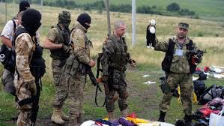
According to news reports found on USNews and elsewhere, "A top pro-Russia rebel commander in eastern Ukraine has given a bizarre version of events surrounding the Malaysian jetliner crash -- suggesting many of the victims may have died days before the plane took off.”

A top pro-Russia rebel commander, Igor Girkin, described the crash site, saying “A significant number of the bodies were not fresh,” adding that he was told “They were drained of blood and reeked of decomposition." Remarkably, he also claimed that a large amount of blood serum and medications were found in the wreckage.
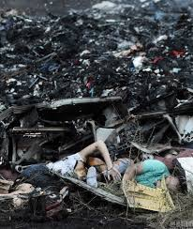
Numerology:
MH370 had 239 passengers and crew members
MH17 - had 298 passengers and crew members
TOTAL = 537 passengers and crew members

I added it up and again almost fell out of my chair… there’s that number “537” again!
Keep these references in the back of your mind, from Strong’s Concordance at BibleHub.com

#537- Hebrew-Greek definition - “all together”
#5307- Hebrew-Greek definition - “fall to a violent death”

After the crash, the Dutch authorities never started clean-up operations for 4 weeks, which allowed first responders from the Ukrainian military plenty of time to collect all the pieces of MH370 that were scattered over a 33-kilometre area.
Triggered by wireless explosives onboard, MH370 was approximately 7500 meters above the ground when it came apart, looking like a missile hit it. This caused the plane’s fuselage to break into pieces, all of them “falling” heavily to the ground. Some of the larger pieces caused craters 3 feet deep, which were later found to contain decomposed and rotting human body parts, drained of blood.
Mixed in with the scattered remains of both people and MH370, the twin MH17 airliner was also destroyed when it was gunned down after the Ukrainian fighter jet first shot a huge hole into the cockpit, then kept firing at MH17 until it was approximately 100 meters above the ground. At that point, wireless technology detonated the on-board explosives to finish the job.
Kiev and Western countries immediately blamed “pro-Russian” separatists and Moscow for shooting down flight MH17 with a BUK missile.
A year later, after intensive searches across miles of the Indian Ocean and other points along MH370’s estimated flight path, rescue teams and world leaders seemed to be no closer to solving the plane’s disappearance. To add insult to injury, and multiply the confusion, while it seemed the world knew that MH17 was shot out of the sky, no-one claimed responsibility or discovered who deserved the blame.

However, quotes from security and diplomatic personnel, first responders and the victims’ families present a mysterious and suspicious picture of events.
Quotes from victims’ families
The mother of one victim said, “He severed all ties in Holland, it was his last flight. A flight to a new life.”
“He was 53”.
Another from a sibling, “We believed our older brother was the best of us. We feel so sorry for him.”
“The authorities never showed the bodies – only pictures of their findings. Photos were full length and he wasn’t damaged, just slightly burnt. I was able to identify him.”
The person who cleaned the bodies told us, “Our brother’s body was in the best condition, with nothing missing. Everything was in place.”
“We were not allowed to open the casket. We were told by the government, ‘Nobody must see.’”

“All caskets with corpses that came back to Malaysia were not allowed to be opened.”
“The Government is not telling us anything,” said one victim’s mother. “We just wait and hope somebody will come up with something, especially from the Black Box.”
Quotes from Malaysian authorities
A Malaysian diplomat said,”Shooting the Boeing MH17 is like shooting our Country.”
“We want the Facts, you know, we do not want Propaganda.”
“Malaysian people blame Russia. Russia gave BUKs to separatists to shoot down MH17 because local media says so.”
Malaysia’s local media follows the Western media:
“The family of MH17’s pilot, Captain Wan Amran, will not speak to anyone, claiming mental problems after the trauma of Wan’s death.”

Remarkably, no forensics analysis was ever done on the bodies! As an excuse, the CIA said that the Ukraine, being a 3rd World country, did not have the capabilities.
And from the very beginning, only one version of what happened was considered by the West… that MH17 was shot down by separatists, using a BUK surface-to-air missile launcher. The trouble with that theory is that a single air missile fired on a plane the size of a 777 Boeing would just switch off the engine. Surface-to-air missiles have just 3-5 Kilograms of high explosives.
There is evidence that MH17 was rigged with explosives. But the Russians are blaming a Ukraine fighter jet seen leaving the scene by many locals, who witnessed the crash from a distance.
Eyewitness accounts at the MH17 crash site
“I heard 2 explosions, POP! Then another POP!”“There were two places where planes came down. I ran into the yard… I ran into the street to see a plane very far away.“The jet fired a rocket, and then from behind the clouds, I saw a plane “falling” to the ground.

One part “fell”, while the other part flew off towards another village.”
“You did not see a BUK missile vapour trail?” asked the reporter on the scene. “No I did not see a BUK trail. Not from either side”
“It’s not only my opinion, many have seen military jets flying below civilian planes.
“There were many planes.”
“I go outside and there’s a plane, a military jet was flying from over there, just above the forest. About 50 meters above, I saw a passenger plane approaching from there… then the military jet flew towards the passenger plane and SHOT towards the front of the plane.”
“There was a Blue Flash which turned Black. The altitude of the plane was about 100 meters above the henhouse, not high.”
“I could see the engines fans and this is where the fighter jet finished it off.”

“So the plane was shot several times…then it exploded.”
When more news about the crash started to surface on the following day, the gory details defied belief… except that they seemed to be coming from some pretty highly-ranked sources!
July 18 2014
Military Commander: Passengers dead long before plane took off
The bodies were dead for days before the flight, smelling of rot and drained of blood, according to a top military commander at the scene.
Dutchman comments:
“When I look at my country, the Netherlands, as an official Head of the investigation, we are part of NATO. We are part of Anti-Russian Alliance, so we are not Independent investigators.
This is something the United Nations should have investigated, and not a biased government, like the Netherlands.”
“How can you do an investigation if the Ukraine, one of the possible murderers, is part of the investigation, and delivered evidence that the Ukraine collected? Ridiculous!”
“Well, what it proved is that the Ukraine fired at the crash site with heavy mortars, with rockets that left craters 3 meters deep.” (This was caused by MH370 Fuselage hitting the ground)
Really, you have to ask yourself, who benefits? Who gains the most, from hiding evidence and from trying to distort the investigation? It’s the party who did it! Many facts have been established, but they aren’t being shared with the public or the victims’ relatives. The investigation remains classified.

But conflicting reports added to the horror and confusion of the families. From an MH17 crash report you can read at Independent.co.uk and elsewhere:
MH17’s passengers and crew may have been conscious for the one-and-a-half minutes it took the plane to crash, investigators have said.
In its final report into the crash, the Dutch Safety Board (DSB), some were killed by 168 serious injuries, while others are believed to have lost consciousness, but the DSB could not confirm when they died.
“It cannot be ruled out that some of the occupants remained consciousness for some time during the one to one-and-a-half minutes for which the crash lasted,” a spokesperson said.
“The Dutch Safety Board deems it likely that the occupants were barely able to comprehend the situation in which they found themselves.”
And yet, we hear of bodies falling down, as witnesses described “It was raining bodies.” Bodies were landing in gardens, in fields, on roofs of houses. One body crashed through the roof of an old house, landing in the bed of one of the bedrooms.

As the drama of the plane crash grabbed headlines and the world’s attention, there was still the matter of transporting all of that gold without getting caught. Once the gold was re-melted and certified on the market, it was transported by those same three Jumbo 747s into seven vaults around the world.
The vaults, located in Singapore, Hong Kong, Dubai, Zurich, London, Toronto and New York, received 7900 tons of gold each, for a total of 55,300 tons. Add the two-ton shipment that was originally transferred on MH370, and you get 55,500 tons of gold in this heist.

Numerology:
The atomic number of gold is 79. According to medieval magicians of Europe, gold is male and silver is female. The word ‘power’ is used 79 times in the New Testament, and the verb ‘to curse’ appears 79 times in the Old Testament.

Have you ever heard the idea that ‘there are no co-incidences, and everything happens for a reason’? Okay then, since we’re talking about ‘significant numbers’, check this out:
The Magic Number ‘ 7 ‘
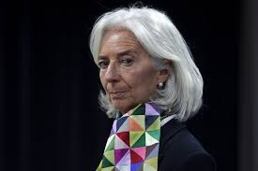
Brexit collapse falls exactly on Shemitah date23
In 2014, Christine Lagarde, Managing Director of the International Monetary Fund since July 5th, 2011, gave a speech on “the magic number 7”.

It, along with work by Jonathan Cahn, led us to the Shemitah seven-year cycle and the Jubilee year, which the globalist elites are well aware of.
What we’ve discovered since is that there is even more to the “magic number 7” than just years… it appears to correlate right down to months, weeks and days.
The last major market crash occurred on September 29, 2008. On that day, the Dow Jones fell 777 points, of all numbers…. its biggest one day point drop ever.
On Friday, in the aftermath of Brexit, the Dow fell over 600 points. What’s interesting about Friday’s date?

It was 7 years, 7 months, 7 weeks and 7 days since September 29, 2008.

The Bible is structured on “ 7’s “
The number ‘7’ is the Foundation of GOD’s word and means:
'COMPLETION OR PERFECTION'
GOD made ‘ 7 ‘ days in a week.
Ivan Panin’s work display how the Bible is structured on ‘ 7 ‘ and could not be mathematically be duplicated and impossible to be made by just a man.
DONALD TRUMP was born June 14th, 1946 , exactly 700 Days before the establishment of Israel as a nation May14th, 1948.
It just so happens that on January 21st, 2017, the 1st Day of DONALD TRUMP’s Presidency, he was 70 Yrs, 7 Months, 7 Days old.
Netanyahu’s 7th Year, 7th Month, 7th Day in office as Prime Minister of Israel on US Election Day, Nov. 8th, 2016
"777"
Inaugurated in the JEWISH Year of 5777
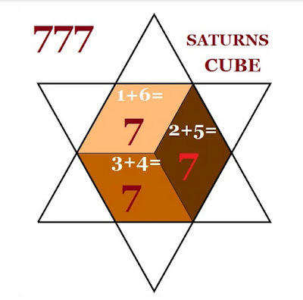

And now, in my mind, the most important number to consider… the significance of “537”. Let’s begin with several references from Strong’s Concordance at BibleHub.com

“537” - HEBREW - GREEK Definition:
Strong's #537: hapas (pronounced hap’-as)
Meaning: “ ALL TOGETHER “

“5307” - HEBREW - GREEK Definition: 171
Strong s #5307: na phal
Meaning: “ TO FALL TO A VIOLENT DEATH “

5 PLANES INVOLVED IN THIS MH370 HEIST - ASSASSINATION “ 537 “

A few more significant references to “537” throughout history, from ancient to modern times…
“537” B.C. - Cyrus
After the overthrow of Babylonia by the Persians, Cyrus, who was married to Isis, gave the Jews permission to return to their native land in 537 BC), and more than forty thousand Jews are freed and allowed to practise their sacrifice religion and begin to rebuild the 2nd Temple in Jerusalem
—————————————————————
“537” A.D. - Phasis
The First Siege of Rome during the Gothic War lasted for a year and nine days, from 2 March 537 to 12 March 538. The city was besieged by the Ostrogothic army under their king Vitiges; the defending East Romans were commanded by Belisarius, one of the most famous and successful Byzantine generals. The siege was the first major encounter between the forces of the two opponents, and played a decisive role in the subsequent development of the war.
In a related ‘537’ connection, Pope Vigilius (died 7 June 555) was Pope from 29 March 537 to his death in 555. He is considered the first pope of the Byzantine Papacy. While on the journey, he died at Syracuse.
—————————————————————
“537” - Bush beats Gore by 537 votes in the 2000 US presidential election
During the hotly-contested Florida election recount in the US, during the weeks after Election Day in the 2000 United States presidential election between George W. Bush and Al Gore, the Florida vote was ultimately settled in Bush's favor -- by a margin of 537 votes.
—————————————————————
“537” - 2012 Barak Obama re- election campaign advertisement
Referencing the 2000 election results mentioned above, Obama’s campaign focused on inspiring people to get out and vote. The ad is titled “537, the number of votes that changed the course of American History”. In it, Obama mentions “537, the difference between ‘What was and what could have been.’ So this year if you're thinking that your vote doesn't count, that it won't matter, well, back then there were probably 537 173
people who felt the same way. Make your voice heard. VOTE.”
—————————————————————
Shiva, the ‘Goddess of Destruction’ (whose sacred number is ‘5’), is portrayed in a commemorative statue at CERN, the CIA Headquarters in Switzerland
Shiva (or Siva) is considered the Supreme God within Shaivism, and is the creator and “destroyer” of all that is. On June 18, 2004, a 2-meter tall statue of Shiva was unveiled at CERN, donated by India.
—————————————————————
The occultist believes "5" to be the Number of Death, and the greatest intensification of any number to be a triplicate, a "555" literally means "Highest Death".
—————————————————————

The Bible in Basic English
1 Kings 10:14 (BBE) Now the weight of gold which came to King Solomon in one year was six hundred and sixty-six talents; 666 divided by 12 Tribes of Israel = “55.5” Talents
—————————————————————
Finally, going back to Strong’s Concordance for a numerical reference I cannot ignore, here’s another ‘coincidence’ that is the reason I wrote this book. 174

“5307” - DICTIONARY OF BIBLE THEMES – 5307 ENVOY
“An official representative sent on behalf of a king or government to other kings or nations. Believers are God’s envoys to his world, bearing the good news of salvation on his behalf.”
Incidentally, I’ve had a 5-foot steel statue of ‘Hermes the messenger’ in my home since 2000, and my nickname from my hockey days is ‘Herby’. As details about some of the people I met in Thomas Lilley’s circle of friends and beyond are becoming clearer, I believe that I escaped death, and that I am now ‘the messenger’ to bring these facts to light.

CHAPTER #8 – “Now that we have the gold, we need to sell it”
The last conversation I had with Thomas was in mid-September 2014, just over five months after MH370 went missing. This was also not long after the 5-month timeframe it took to deliver the gold to Perth.
Thomas told me, “Now that we have the gold, we need to sell it”
And who would do the selling? The only game in town – BitGold/GoldMoney, the one and only distributor that has access to all seven of these vaults!
It operates under SHARIA LAW.
As soon as the gold was transported to the seven vaults, BitGold/GoldMoney was created, providing delivery service through Brinks (which Thomas told me that the Swiss Jew bankers also own, as mentioned during our conversations back in 2007-8).
In May 2015, GoldMoney is listed on the TSE (Toronto Stock Exchange), formed as a holding company following the acquisition by publicly listed BitGold Corp. of the Goldmoney business in 2015. The company subsequently changed its name to Goldmoney Inc., and had over 1,400,000 clients as of late 2016.

As a global full reserved gold-based financial services company founded by James Turk, Roy Sebag,and Josh Crumb, GoldMoney Inc offers full reserve precious metal focused financial services, and is headquartered in Toronto, Canada and in Saint Helier, Jersey (UK). GoldMoney Inc. investors and backers include Eric Sprott, Albert D. Friedberg, George Soros, Adam Fleming, and Canadian Banks Canaccord Genuity (the Rothschilds!
Now things were starting to pick up speed on the gold front, right in line with the predictions I’d read in the NWO 7-year plan. Just before Brexit happened on June 23, 2016, China purchased 90B worth of gold, storing it in the London vault. Meanwhile, Ivan Glasenberg and Glencore started selling assets in 2016, including 40% of their agricultural business based in Regina. The agri-business stock was sold to the Canadian Pension Plan Fund for almost $3 Billion dollars.

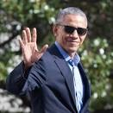
Remember When Obama Released 6,000 Federal Prisoners in October 2015.

Crashing the stock market in 2016
Think about it... Thomas had said, “Now that we have the gold we need to sell it.”
But in order to sell the gold, given that its stock price had been sliding since its peak in 2011, they had to crash the stock market in January 2016, to bounce the gold price back up. After all, gold has traditionally been the safe hedge from inflation and economic uncertainty, so its price usually inflates in uncertain times.
By November 2015, gold had slid to $1080 per ounce. Barrick Gold, a Canadian mining company (the largest in the world) hit a low

of $8.00 per share. Canada’s Minister of Foreign Affairs, John Baird, quit the government, and went to work for Barrick Gold and Hatch in November 2015.

So in January 2016 the market crashed… obviously China, Bilderbergs or the Dragons were involved. The elites simply sold their devalued stocks, and started buying gold & silver stocks instead.
"Nobody here knows quite what to make of the latest stock market sell-off, and that, indeed, is part of the problem, for uncertainty breeds fear of loss"
January got off to a terrible start, probably the worst start to a year ever. Panic about the slowdown in China and crashing oil prices sent the Dow to its worst 10-day start to a year on record (and the records go back to 1897).
With extreme fear about the meltdown in oil prices and plunging stock prices in China, investors sold off stocks in virtually all sectors. "Clearly this was an awful month. The selling was more about sentiment than a change in the actual fundamentals," said Russ Koestrich, global chief investment strategist at BlackRock.

How to profit from a stock market crash
So, in this atmosphere of fear and uncertainty they’d created, the elite started buying gold and silver stocks that had recently bottomed (gold had already slid to $1,080 an ounce)… and waited patiently for them to rise, as they surely would.
In fact, it looked like they’d soon have a little extra help in controlling gold’s value in the markets.

Because in early March 2015, John Baird (Canada’s foreign affairs minister) quit his high-profile government job in Stephen Harper’s cabinet, to join Barrick Gold Corporation as an international adviser!
Although his appointment to the precious-metals giant raised questions (as did his subsequent hiring as a strategic adviser to Hatch, the engineering and consulting firm for resource companies, Baird assured reporters that his sudden move from the public sector to private firms, in the same industries he used to oversee as a government minister, didn’t breach any ethical guidelines.
In an unprecedented $250 million deal, a U.S. agrifood company and a Saudi Arabian investment fund took over the former Canadian Wheat Board, formed by Parliament in 1935 to guarantee Canada’s western farmers would get fair prices for their wheat and barley in markets around the world.
And during the following year, the pace of massive wealth transfers between governments and a few select private companies continued to pick up speed.

In early 2016, Ivan Glasenberg offloaded a 40% stake of his Glencore Agricultural Products business to the Canadian Pension Plan Fund, selling US$2.5 billion of stocks when the share price bottomed in January at $71 per share.

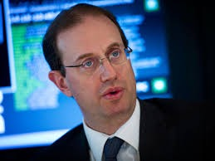
Apr 06, 2016News release
Canada Pension Plan Investment Board Signs Agreement to Acquire a Significant Strategic Stake in Glencore Agricultural Products

In a massive policy shift that would surely drive up gold prices even further, Bank of Japan’s Governor Haruhiko Kuroda, who had visited Thomas 3 times in 2007-08, announced his readiness to ease monetary policy further in September 2015. He seemed to shrug off growing market concerns that the bank was reaching its limits after an already massive stimulus program.

While Trump was distracting the West’s attention, Turkish president Recep Tayyip Erdogan survived an attempt to overthrow his government. The July 2016 attempted coup, set up by Erdogan and the CIA, supposedly reinforced his supporters, but was in reality a ‘false flag’ event that tightened Erdogan’s grip on power even further.
Erdogan would need that tight-fisted grip on his country’s reactions within months, when a Russian SU-24 warplane was shot down over Turkey. All this was created to DRIVE UP THE PRICE OF GOLD.

By 2016, it was becoming obvious to me that one of the reasons they created ISIS, had Turkey’s President Erdogan shoot down the Russian SU-24 fighter jet at the end of November 2015, and had not raised interest rates for 70 months, was in order to drive the price of gold back up!
So many of the world’s ‘disasters’ and terrorist events had the same purpose at their core. During 2015, a relentless series of attacks in France grabbed headlines around the world again and again, including:
the January 2015 attacks on Charlie Hebdo offices and a Jewish supermarket in Paris that killed 17 people and wounded a series of coordinated terrorist attacks in November 2015, with three suicide bombers who struck outside the Stade de France in Saint-Denis, several mass shootings (plus a suicide bombing) at cafés and restaurants, followed by
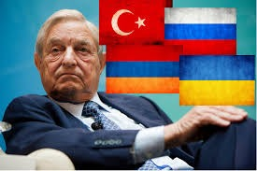
another mass shooting at the Bataclan theatre. Not surprisingly, the Paris attacks had the subsequent effect of driving up the price of gold too, as did international incidents like the 2016 Brussels bombings and the previously-mentioned Turkish Air Force F-16 shoot-down of a Russian Sukhoi Su-24M attack aircraft near the Syria–Turkey border on 24 November 2015.

As an added boost to global gold prices, the plotters were ready to support their positions to grow their profits. On May 17, 2016, George Soros bought a US$263.7 million stake in Barrick Gold Corp, the world’s largest gold miner, after its stock had bottomed out the previous October at a share price below $8.
Needless to say, huge amounts of money were being made on Gold, Silver and the British pound as a result of Brexit. I’d say it’s pretty easy to make billions when your buddies control the voting results!
Check out this news item as reported by Bloomberg’s Nariman Gizitdinov from July 2016, and you’ll see what I mean…

Brexit Bet Makes Kazakhstan Better Than Soros
Move over George Soros, Kazakhstan is claiming the title as the most prescient speculator in the pound.
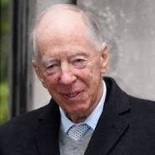
The former Soviet republic’s central bank bet against the currency before Britain’s surprise decision to leave the European Union last month, Governor Daniyar Akishev said in an interview Friday. Soros, who famously broke the Bank of England in 1992, netting a profit of $1 billion, didn’t repeat that wager in the historic Brexit referendum, according to a spokesman.
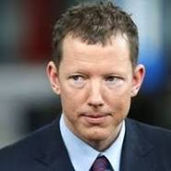
Not to be outdone, the Rothschilds, Jacob and Nathaniel, announced in August, 2016 that they’d be selling all their US dollars and buying physical gold, silver and Bitcoin, calling it “The Biggest Monetary Experiment in the History of the World.

But in this tumble of dramatic changes on the world stage, the best was yet to come. I laughed out loud when, for his New Year’s party for 2017, US President Donald Trump announced that Hussain Sajwani, his new billionaire buddy and business partner from

Dubai, would be a featured guest at the festivities at Trump’s Mar-a-Lago estate and golf course in Palm Beach, Florida.
This is the same guy Thomas had mentioned many times, as he continued trying to convince Sajwani, the founder and Chairman of global property development company DAMAC Properties, to invest in his shipment of gold. And I’d met the man three times in Thomas’ office back in 2007-08, including the first time Grace hooked him up to the EPFX Bio-feedback Medical Device in 2007. From there, I was his bio-feedback practitioner on his return visits, and he had another 1-hour session on the bio-feedback device with me in early 2008.
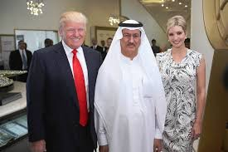

And yes, this is the same Hussain Sajwani who Thomas confirmed had committed to buy over $600 million dollars of the gold, when he spoke with me in June 2010. So, Trump’s newfound affection for the Saudi billionaire was an attention-getter for me, to say the least.
A few short months later, Sajwani partnered with Trump on a golf course at a luxury development called the Akoya, not far from the heart of Dubai in the United Arab Emirates. "We made a deal with Trump as an organization; they know how to run golf courses," Sajwani told FORBES early in 2016. "We stay away from politics.”

More on Thomas Germain Lilly
I believe Thomas was part of the Eli Lilly Pharmaceuticals family, and that he cashed in some of his Bitcoins in the fall of 2016 (as the price of Bitcoins dropped from $1,500 down to $1,000), using the money to buy stock in Boehringer, which had the monopoly on vaccinations.
For example, notice these comments I found in a recent article on Eli Lilly’s purchase of pet vaccines from Boehringer for $985 Million in October 2016, as reported by IndyStar Washington Bureau’s Maureen Groppe on January 31, 2017:
Lilly CEO encouraged by meeting with Trump
Three weeks after Donald Trump accused drug companies of getting away with murder on drug prices, Eli Lilly CEO David Ricks came away encouraged from a meeting he and other pharmaceutical executives had Tuesday with the new president.
“I was impressed with the president’s appreciation for what our industry is, which is really a crown jewel of American enterprise,” Ricks said in an earnings call with Wall Street analysts.

“We talked about a number of his policy proposals which, on balance, I think would be very good for us,” he said later in an interview with IndyStar.
NOVEMBER , 2017
Trump Chooses “Eli Lilly”, Alex Azar for Health and Human Services Secretary
By EILEEN SULLIVAN and MICHAEL D. SHEARNOV.
WASHINGTON — President Trump nominated a pharmaceutical executive to be the next secretary of the Health and Human Services Department.
The nominee, Alex M. Azar II, served as a deputy at the department under former President George W. Bush. Until January, he was the head of pharmaceutical company “Eli Lilly’s” , United States division.
Mr. Trump made his announcement in a Twitter post while traveling in Asia.
Imagine that !!! ELI LILLY... Thomas’s family company... everything unfolding on schedule...
I trust everyone understands as written in my book... Last year , Bitcoin tumbled from $1500.00 down to $1,000.00 , this is when Eli Lilly bought Boehringer... now ELI LILLY has control of vaccinations... which is all part of the sterilization and de-populization plan.

CHAPTER #15 – Release the Kraken, Donald of Dubai, the Aga Khan, Canada, Sharia Law & The Thomas Fire

“Release the Kraken!” is a catchphrase and image macro series based on a memorable quote uttered by Zeus in the 1981 fantasy adventure film The Clash of the Titans as well as the 2010 3D remake. Despite the dramatic delivery of the line in the reboot, the quote was perceived as unintentionally funny and quickly became a target of image macro jokes on the web.
The first Urban Dictionary entry for the phrase “Release the Kraken” was submitted on March 31st, 2010, defined as “to pwn or to kick the ass of whomever you’re releasing the kraken on.” Throughout the first week of April 2010, the phrase was dubbed the latest meme by various tech and internet news outlets including Geekosystem, Vulture, Now Public, MTV and Mediate among others. In December, the phrase was listed in TIME Magazine’s Top 10 Buzzwords of the Year.
"Release the Kraken"
Kraken, formed in April 2014 (just after MH370 disappeared), is a Bitcoin exchange located in San Francisco, USA and is now the regulator of Bitcoin and other crypto-currencies.
To this day (May 27th, 2017 as I write this), whenever the Crypto Currencies make a huge correction, it is the Kraken being released automatically to either steal or buy up Bitcoins that are on sell orders, by the Bitcoin Mines answering difficult equations. This is a self perpetuating
“ beast ” that will destroy people and the financial systems of countries, as foretold in the NWO 14-year plan (double SHEMITAH) I’d read as “Release the Kraken”.
http://knowyourmeme.com/memes/release-the-kraken

Not only can they steal your Bitcoins, they are also the regulators!
Sure enough, the following happened to verify my statements on “Release the KRAKEN”.

HOW ETHEREUM CRASHED FROM $319 TO 10 CENTS IN SECONDS
By Soren K.Group Jun. 23, 2017 - NOTE: THE SAME DATE AS BREXIT , JUNE 23rd
Blockchain blockchain blockchain.
CNBC Reports
"The price of ethereum crashed as low as 10 cents from around $319 in about a second"
on the GDAX cryptocurrency exchange on Wednesday, a move that is being blamed on a "multimillion dollar market sell" order.
Ethereum is an alternative digital currency to bitcoin and had been trading as high as $352 on Wednesday. It has since rebounded from its flash-crash lows to trade to about $325 on the GDAX exchange. According to industry and price tracking website Coinmarketcap, which takes into account the price on several exchanges, ethereum was trading around $338. Adam White, the vice president of GDAX which is run by U.S. firm Coinbase, posted on the exchange's blog, outlining what took place at around 12:30 p.m. PT on Wednesday. According to White, the multimillion dollar market sell order resulted in a number of orders being filled from $317.81 to $224.48.
On Wednesday, the price of ether -- the cryptocurrency of the Ethereum blockchain -- on the GDAX exchange briefly crashed from $328 to $0.10. The story seems to be that there was a big market sell order that blew through a lot of the buy orders on the book, pushing the price down. This triggered forced selling by margin accounts, blowing through the rest of the buy orders until the price hit 10 cents. "We understand this event can be frustrating for our customers," said GDAX, but everything is fine: "Our matching engine operated as intended throughout this event and trading with advanced features like margin always carries inherent risk."
FOOTNOTE: The above article explains, “Release the KRAKEN”.
Jul 7, 2017 | Jamie Redman
Class Action Lawsuit Filed Against Cryptocurrency Exchange Kraken
Bitcoin.com Wallet

This week a class-action lawsuit has been filed against the San Francisco-based trading platform Kraken. A group of customers have revealed that their holdings of 3,414 ETH was liquidated during an Ethereum market flash crash. According to the plaintiffs the cryptocurrency exchange suffered from a denial-of-service (DDoS) attack at the time having many Kraken users unable to use the service.
Five Kraken Customers File Class Action Lawsuit Against the Exchange
Class Action Lawsuit Filed Against Cryptocurrency Exchange Kraken. Just recently People have tried to speculate on who may be behind the quick crashes taking place on these altcoin markets, more specifically ethereum markets have flash crashed twice in less than two months with little evidence to be found. Moreover, although there have been losses some people have made a lot of money too. One trader scooped up 3809 ethers at $0.10 per ETH making a cool million in a matter of seconds. Others grabbed many ether tokens at various amounts under $40 as well. At the time multitudes of ethereum traders hoping to get lucky with another flash crash created hundreds of bids for ether tokens under $50. 104
Thomson Reuters Posted: Oct 24, 2017 2:13 PM ET Last Updated: Oct 24, 2017 4:18 PM

House Republicans to investigate Russia uranium deal tied to Canadian company,
Frank Giustra, the Vancouver-based mining executive who donated $31 million to Clinton Foundation initiatives around the world and pledged millions more,
Clinton, Obama critics have for at least 2 years tried to tie uranium deal to Clinton Foundation
Some Republicans have claimed that Hillary Clinton's State Department approved the deal after her husband's charitable foundation received a $145-million US donation, but the State Department controls only one seat on the panel that approved the transaction and the New York Times reported two years ago that she did not participate in the decision. 105
Canadian stock surges over 600% after switching from mining gold to bitcoin

Open this photo in gallery:REUTERS
Vancouver-based Hive Blockchain Technologies Inc. is among the first publicly traded stocks to provide exposure to cryptomining.
BENOIT TESSIER/REUTERS
NATALIE OBIKO PEARSON AND BRANDON KOCHKODIN
BLOOMBERG NEWS
OCTOBER 12, 2017
Frank Giustra, the Canadian mining maverick who amassed a fortune building what would become one of the world's largest gold companies, is digging for another kind of gold: cryptocurrencies.
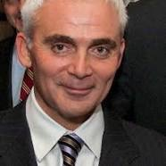

The company he's backed, Vancouver-based Hive Blockchain Technologies Inc., is among the first publicly traded stocks to provide exposure to cryptomining – the vast data crunching needed to verify the blockchain and the volatile currencies they produce, such as bitcoin and ether.
So far, his decision to dig for data servers has paid off. Hive's shares have soared about 633 per cent, giving it a market value of $553-million, since it took over the listing of Leeta Gold Corp. and began trading on Sept. 18. After only three days, the company raised $30-million in a share sale led by GMP Securities LP.
"We're quite lucky to be first out of the gate," said Hive chief executive officer Harry Pokrandt, a former Macquarie Group investment banker who bought his first bitcoin for $100 in a Vancouver coffee shop on his iPad. Speaking from a makeshift office adjoining Mr. Giustra's Fiore Group, which is listed as an adviser to Hive, he said, "We're a unique way to get into the space."
Mr. Giustra helped build the company that would become Goldcorp Inc. then founded film studio Lions Gate Entertainment Corp. He counts Bill Clinton and George Soros
among his close pals. Those connections may position him to grasp a nascent corner of finance and navigate bitcoin's uncertain regulatory waters. Mr. Giustra didn't respond to a request for an interview.
Blockchain is the technology used to verify and record transactions on a public, online ledger. "Miners" use computers to solve complex math problems to verify transactions, earning a reward of a newly issued coin, such as bitcoin or ether. Hive paid Hong Kong-based Genesis Mining Ltd., builder of the world's largest ether mining facility, $9-million and gave it a 30-per-cent stake to acquire a new data centre in Reykjanes, Iceland.
There, Hive plans to mine different cryptocurrencies, depending on which ones offer the best margins and build an inventory of coins on the expectation they'll appreciate.
Hive said it plans to buy a second Genesis data centre next door for $5-million and has the option to buy more in Iceland and Sweden, cold countries which can keep power and cooling costs down.
FOOTNOTE: I believe HIVE works in conjunction with “the KRAKEN” switching it’s mining to another crypto currency just before the Kraken is Released, creating high volatility .

‘Donald of Dubai’
UAE billionaire trading off President Trump’s name is raising fresh conflict-of-interest questions
Hussain Sajwani owns a real estate company whose Trump-branded properties are raising eyebrows among the US President’s critics
Jon Gambrell Tuesday 15 August 2017 08:00 BST0 comments
Hussain Sajwani, has a 70 per cent stake in Damac Properties which this week started selling Trump Estate villas in Dubai.
During recent trips to Croatia and Malta, a Dubai-based billionaire and business partner of the Trump Organisation looked more like a head of state himself, mingling with government dignitaries, receiving a presidential reception and visiting the glittering Mediterranean sea.
Hussain Sajwani met with leaders in the two European nations and addressed local
journalists, many of whom made reference to his ties to President Donald Trump or simply called him “the Donald of Dubai”.
Sajwani’s trips to Europe – as well as a recent deal in Oman – show that Trump’s business partner in Dubai wants to expand his development empire beyond the Middle East, and a tower which is under construction in London.
Enter Sajwani’s Damac Properties. As of this week, it has started selling Trump-branded villas on the Trump golf club estate in Dubai.
“My dream is, as we have put our major, iconic tower in London, that we do repeat that in major gateway cities around the world,” Sajwani said in a July online video. “Tokyo, Toronto, New York, Paris, I don’t know. But that would be a dream – to grow Damac with its iconic brands around the world.”
Sajwani’s dream for a global expansion – as well his growing online presence among social media videos and posts – received a major boost with Trump taking the White House. It also raised the public profile of a billionaire whose fortune grew in part out of contracting work his companies did in supplying US forces during the 1991 Gulf War that expelled Iraqi forces from Kuwait.
Damac Properties declined a request to interview Sajwani made by Associated Press. Damac spokesman Niall McLoughlin said the company is “exploring opportunities in major gateway cities across Europe and the US, hence the numerous and ongoing meetings over the past many years” by Sajwani.

Trump’s conflicts of interest make US seem like a ‘kleptocracy’ (noun, plural kleptocracies. 1. a government or state in which those in power exploit national resources and steal; rule by a thief or thieves.)

Trump’s conflict of interest problem isn’t going away
Sajwani wholeheartedly embraced Trump, even as the US presidential candidate’s campaign saw him call for a “complete shutdown” of Muslims coming to the US. Once reaching office, Trump’s travel ban on six predominantly Muslim countries avoided naming the UAE, a major US ally that hosts some 5,000 American troops and is the US Navy’s busiest foreign port of call.

In February, 2017, Trump’s sons Eric and Donald Jr. opened the Trump International Golf Club in Dubai, the first of two to be built in the kingdom by Sajwani. Damac share prices have nearly doubled from 2.17 dirhams a share on the day of the US election in Then in July, Sajwani visited Croatia and met with president Kolinda Grabar Kitarovic. Sajwani also visited tourist towns along the coast of the Adriatic Sea, according to a Damac statement at the time. The local branch of Colliers International, a commercial real estate firm based in Toronto, said it organised the three-day trip for Sajwani, trying to pitch him on developments on the Istria peninsula and Central and Southern Dalmatia.
Damac “continues to look at the investment opportunities” in Croatia, primarily along the Adriatic, said Vedrana Likan, the managing partner of Colliers’ Croatian arm.

Sajwani then travelled to Malta, an archipelago nation off Italy in the Mediterranean Sea, and met with Prime Minister Joseph Muscat.
Both Croatia and Malta are members of the European Union, which Emirati citizens have been able to travel to without visas since 2015. That can drive business for any possible Damac project in either country, as well as create new European interest in Dubai, where the developer makes its real money, said Issam Kassabieh, an analyst with the UAE-based firm Menacorp Finance.
“It’s a very effective method of branding,” Kassabieh said. “Once foreign investors see the Damac name in Europe, they’ll follow it all the way back to the source, which is Dubai, so they can capitalise on it here.”
This week Damac Properties launched a new set of Trump-branded duplex villas, priced from £624,000, including three years’ golf course membership. The company previously offered standalone villas at priced from around £1m up to just over £3m.
The Trump Organisation, now run by Trump’s sons though the president hasn’t divested from it, also tweeted that the new

villas were for sale. The villas are “not a new project” and represented “our longstanding relationship with Damac Properties.”
If Sajwani “is featuring the Trump name in his marketing materials and if, as one can fairly assume, that’s being furnished to government officials and others, then that would be a not-very-subtle attempt to trade on his business partner’s presence in the White House,” Eisen said.

NOTE: GoldMoney Stock XAU on TSX (Toronto Stock Exchange) as of August 3rd was at $2.35 then along came Hussain Sajwani, Trump’s partner from Dubai to Toronto and guess what, within 45 days, GoldMoney XAU shot up to $6.25
What a great way to pay for their Toronto investment and it is ruled under SHARIA LAW!
For his New Year’s party for 2017, US President Donald Trump announced that Hussain Sajwani, his new billionaire buddy and business partner from Dubai, would be a featured guest at the festivities at Trump’s Mar-a-Lago estate and golf course in Palm Beach, Florida.
This is the same guy Thomas had mentioned many times, as he continued trying to convince Sajwani, the founder and Chairman of global property development company DAMAC Properties, to invest in the 55,500 tons of gold. And I’d met the man three times in Thomas’ office back in 2007-08, including the first time Grace hooked him up to the EPFX Bio-feedback Medical Device in 2007. From there, I was his bio-feedback practitioner on his return visits, and he had another 1-hour session on the bio-feedback device with me in early 2008.

And yes, this is the same Hussain Sajwani who Thomas confirmed had committed to buy over $600 million dollars of the gold and back the entire Gold Heist-Assassination, when he spoke with me in June 2010. So, Trump’s newfound affection for the Saudi billionaire was an attention-getter for me, to say the least.
When Donald Trump made this announcement that Hussain Sajwani was his best friend and business partner and was attending his Mar-Lago New Years Eve Party ringing in 2017, I waited a couple of months before sending a message to Sajwani.
Around the end of March 2017, I googled DAMAC Properties and noticed that the web-site had an automated messaging service, so, I sent the message, “ Please have Hussain Sajwani call Boyd Anderson immediately with my phone number”. I received a reply , “ What is this regarding”? I simply replied , "Dr. Thomas and Dr. Boyd" … Hussain Sajwani would have remembered me as Dr. Boyd as this is how I was introduced to him back in 2007-08.
I never got another reply, but the very next day, Jared Kushner got into a big fight with Steve Bannon and the day after that

Kushner was on a plane to an island in the Indian Ocean to meet with the Crown Princes of Dubai and Abu Dhabi and about a week later Trump dropped the MOAB (Mother of all Bombs) on Afghanistan.
Saudi corruption case spells trouble for Trump

David Andelman
By David A. Andelman
Updated 3:50 PM ET, Sun November 5, 2017 108
GOLDMONEY XAU on TSX (Toronto Stock Exchange) - Follows SHARIA LAW

Sharia Law
Select Language▼
Shariah lawSharia law is the law of Islam. The Sharia (also spelled Shari'a or Shariah) law is cast from Muhammad's words, called "hadith," his actions, called "sunnah," and the Quran, which he dictated. Sharia law itself cannot be altered, but the interpretation of Sharia law, called "fiqh," by muftis (Islamic jurists) is given some latitude.
legal codes, Sharia law also prioritizes punishment over rehabilitation, and the penalties under Sharia law favor corporal and capital punishments over incarceration. Of all legal systems in the world today, Sharia law is deemed the most intrusive and restrictive, especially against women (see below), and is making inroads into Western democracies (see Sharia law in America, Canada, Europe and UK).
According to Sharia law (see links for details):
• Theft is punishable by amputation of the hands (Quran 5:38 - includes graphic image).
• Criticizing or denying any part of the Quran is punishable by death.
• Criticizing Muhammad or denying that he is a prophet is punishable by death.
• Criticizing or denying Allah is punishable by death (see Allah moon god).
• A Muslim who becomes a non-Muslim is punishable by death (See Compulsion).
• A non-Muslim who leads a Muslim away from Islam is punishable by death.
• A non-Muslim man who marries a Muslim woman is punishable by death.
• A woman or girl who has been raped cannot testify in court against her rapist(s).
• Testimonies of 4 male witnesses are required to prove rape of a female (Quran 24:13).
• A woman or girl who alleges rape without producing 4 male witnesses is guilty of adultery.
• A woman or girl found guilty of adultery is punishable by death (see "Islamophobia").
• A male convicted of rape can have his conviction dismissed by marrying his victim.
• Muslim men have sexual rights to any woman/girl not wearing the Hijab (see Taharrush).
• A woman can have 1 husband, who can have up to 4 wives; Muhammad can have more.
• A man can marry an infant girl and consummate the marriage when she is 9 years old.
• Girls' clitoris should be cut (Muhammad's words, Book 41, Kitab Al-Adab, Hadith 5251).
• A man can beat his wife for insubordination (see Quran 4:34 and Religion of Peace).
• A man can unilaterally divorce his wife; a wife needs her husband's consent to divorce.
• A divorced wife loses custody of all children over 6 years of age or when they exceed it.
• A woman's testimony in court, allowed in property cases, carries ó the weight of a man's.
• A female heir inherits half of what a male heir inherits (see Mathematics in Quran).
• A woman cannot drive a car, as it leads to fitnah (upheaval).
• A woman cannot speak alone to a man who is not her husband or relative.
• Meat to eat must come from animals that have been sacrificed to Allah - i.e., be "Halal."
• Muslims are to subjugate the world under Islam (see Quran 9:29 and Palestine Issue).
• Muslims should engage in Taqiyya and lie to non-Muslims to advance Islam.
- The list goes on.

Aga Khan (Kazar) AND CANADA

Google - ASSASSIN and you get:

Order of Assassins or simply Assassins (Arabic: أساسين asāsīn, Persian: حشاشین Hashâshīn) is the common name used to refer to an Islamic sect formally known as the Nizari Ismailis. Based on texts from Alamut, their grand master Hassan-i Sabbah tended to call his disciples Asāsīyūn (أساسيون, meaning "people who are faithful to the foundation [of the faith]"), but some foreign travelers.

Modern works on the Nizaris have elucidated their history and, indoing so, dispelled popular histories from the past as mere legends. In 1933, under the direction of the Imam Sultan Muhammad Shah, “ Aga Khan III “, the Islamic Research Association was developed. Historian Vladimir Ivanov was central to both this institution and the 1946 Ismaili Society of Bombay. Cataloguing a number of Ismaili texts, Ivanov provided the ground for great strides in modern Ismaili scholarship.

The title is made up of the titles agha and khan. The Turkish "agha" is "aqa" ( qā) in Persian. The word "agha" comes from the Old Turkic and Mongolian "aqa", meaning "elder brother”, and "khan" means king, ruler in Turkic and Mongolian languages.

By ALEX BALLINGALLOttawa Bureau
Tues., March 21, 2017
OTTAWA—Prime Minister Justin Trudeau’s controversial Christmas holiday to the Aga Khan’s private island cost Canadian taxpayers at least $127,000, newly released documents show.
Most of the bill is related to security for the prime minister and his family. The RCMP detail that travelled with the Trudeaus cost at least $71,988.87 — including more than $18,000 in overtime wages and $53,000 in per diems for the RCMP members — according to the documents released to Parliament on Tuesday.
There those RCMP (Royal Canadian Mounted Police) again…..???
Further costs included $32,000 for the use of the government’s CC-144 Challenger jet, and roughly $15,000 for the transportation, accommodation and per diems of staff from Global Affairs Canada.
Bardish Chagger, the Government Leader in the House of Commons, responded that it’s normal for police to travel with the prime minister for security
“RCMP have always accompanied prime ministers whether on personal or business travel,” she said.
as mentioned earlier in my book:
Then, as announced at RCMP headquarters in Regina, Saskatchewan in October 2016, Canada’s Royal Canadian Mounted Police offered an apology and a $100 million dollar pay off as compensation for harassment and sexual abuse against female members. What a great way to keep it in the family! 109
In the face of media pressure, it was also later revealed that Trudeau travelled to the island with Liberal party president Anna Gainey and her husband, a former campaign operative and head of an Ottawa think tank. Newfoundland MP Seamus O’Regan and his husband were also on the trip.
Trudeau also admitted that he took the Aga Khan’s helicopter to-and-from the Bahamian capital to Bell Island, prompting accusations that he broke Parliamentary ethics rules by accepting travel on a private aircraft.
The prime minister has repeatedly justified the trip as a family vacation to visit a longtime friend. But the vacation has come under close scrutiny because of the Aga Khan’s foundation in Canada, which has landed more than $300 million in government aid contracts since 2004 and actively lobbies public officers in Ottawa.

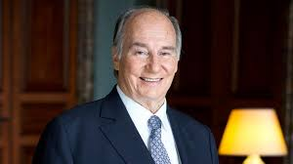
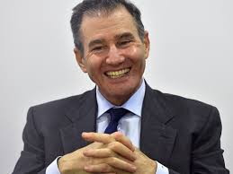
Notice any resemblance ,,,,,, Aga Khan & Ivan Glasenberg

THE BRITISH MONARCHY AND THE COMMITTEE OF 300 (AS OF SEPTEMBER 2016)
CURRENT MONARCH AND SUPREME LEADER OF THE NWO:
Queen Elizabeth II
Abdullah II of Jordan
Kerry, John Forbes
Abramovich, Roman Arkadyevich
King, Mervyn
Ackermann, Josef
Kinnock, Glenys
Adeane, Edward
Kissinger, Henry
Agius, Marcus Ambrose Paul
Knight, Malcolm
Ahtisaari, Martti Oiva Kalevi
Koon, William H. II
Akerson, Daniel
Krugman, Paul
Albert II of Belgium
Kufuor, John
Alexander – Crown Prince of Yugoslavia
Lajolo, Giovanni
Alexandra (Princess) – The Honourable Lady Ogilvy
Lake, Anthony
Alphonse, Louis – Duke of Anjou
480
Lambert, Richard
Amato, Giuliano
Lamy, Pascal
Anderson, Carl A.
Landau, Jean-Pierre
Andreotti, Giulio
Laurence, Timothy James Hamilton
Andrew (Prince) – Duke of York
Leigh-Pemberton, James
Anne – Princess Royal
Leka, Crown Prince of Albania
Anstee, Nick
Leonard, Mark
Ash, Timothy Garton
Levene, Peter – Baron Levene of Portsoken
Astor, William Waldorf – 4th Viscount Astor
Leviev, Lev
August, Ernst – Prince of Hanover
Levitt, Arthur
Aven, Pyotr
Levy, Michael – Baron Levy
Balkenende, Jan Peter
Lieberman, Joe
Ballmer, Steve
Livingston, Ian
Balls, Ed
Loong, Lee Hsien
Barroso, José Manuel
Lorenz (Prince) of Belgium, Archduke of Austria-Este
Beatrix (Queen)
Louis-Dreyfus, Gérard
481
Belka, Marek
Mabel (Princess) of Orange-Nassau
Bergsten, C. Fred
Mandelson, Peter Benjamin
Berlusconi, Silvio
Manning, Sir David Geoffrey
Bernake, Ben
Margherita – Archduchess of Austria-Este
Bernhard (Prince) of Lippe-Biesterfeld
Margrethe II Denmark
Bernstein, Nils
Martínez, Guillermo Ortiz
Berwick, Donald
Mashkevitch, Alexander
Bildt, Carl
Massimo, Stefano (Prince) – Prince of Roccasecca dei Volsci
Bischoff, Sir Winfried Franz Wilhen “Win”
McDonough, William Joseph
Blair, Tony
McLarty, Mack
Blankfein, Lloyd
Mersch, Yves
Blavatnik, Leonard
Michael (Prince) of Kent
Bloomberg, Michael
Michael of Romania
Bolkestein, Frits
Miliband, David
Bolkiah, Hassanal
Miliband, Ed
Bonello, Michael C
482
Mittal, Lakshmi
Bonino, Emma
Moreno, Glen
Boren, David L.
Moritz – Prince and Landgrave of Hesse-Kassel
Borwin – Duke of Mecklenburg
Murdoch, Rupert
Bronfman, Charles Rosner
Napoléon, Charles
Bronfman, Edgar Jr.
Nasser, Jacques
Bruton, John
Niblett, Robin
Brzezinski, Zbigniew
Nichols, Vincent
Budenberg, Robin
Nicolás, Adolfo
Buffet, Warren
Noyer, Christian
Bush, George HW
Ofer, Sammy
Cameron, David William Donald
Ogilvy, David – 13th Earl of Airlie
Camilla – Duchess of Cornwall
Ollila, Jorma Jaakko
Cardoso, Fernando Henrique
Oppenheimer, Nicky
Carington, Peter – 6th Baron Carrington
Osborne, George
Carlos – Duke of Parma
Oudea, Frederic
483
Carlos, Juan – King of Spain
Parker, Sir John
Carney, Mark J.
Patten, Chris
Carroll, Cynthia
Pébereau, Michel
Caruana, Jaime
Penny, Gareth
Castell, Sir William
Peres, Shimon
Chan, Anson
Philip (Prince) – Duke of Edinburgh
Chan, Margaret
Pio, Dom Duarte – Duke of Braganza
Chan, Norman
Pöhl, Karl Otto
Charles – Prince of Wales
Powell, Colin
Chartres, Richard
Prokhorov, Mikhail
Chiaie, Stefano Delle
Quaden, Guy Baron
Chipman, Dr John
Rasmussen, Anders Fogh
Chodiev, Patokh
Ratzinger, Joseph Alois (Pope Benedict XVI)
Christoph, Prince of Schleswig-Holstein
Reuben, David
Cicchitto, Fabrizio
Reuben, Simon
Clark, Wesley Kanne Sr. (General)
Rhodes, William R. “Bill”
484
Clarke, Kenneth
Rice, Susan
Clegg, Nick
Richard (Prince) – Duke of Gloucester
Clinton, Bill
Rifkind, Sir Malcolm Leslie
Cohen, Abby Joseph
Ritblat, Sir John
Cohen, Ronald
Roach, Stephen S.
Cohn, Gary D.
Robinson, Mary
Colonna, Marcantonio (di Paliano) – Prince and Duke of Paliano
Rockefeller, David Jr.
Constantijn (Prince) of the Netherlands
Rockefeller, David Sr.
Constantine II Greece
Rockefeller, Nicholas
Cooksey, David
Rodríguez, Javier Echevarría
Cowen, Brian
Rogoff, Kenneth Saul “Ken”
Craven, Sir John
Roth, Jean-Pierre
Crockett, Andrew
Rothschild, Jacob – 4th Baron Rothschild
Dadush, Uri
Rubenstein, David
D’Aloisio, Tony
Rubin, Robert
Darling, Alistair
485
Ruspoli, Francesco – 10th Prince of Cerveteri
Davies, Sir Howard
Safra, Joseph
Davignon, Étienne
Safra, Moises
Davis, David
Sands, Peter A.
De Rothschild, Benjamin
Sarkozy, Nicolas
De Rothschild, David René James
Sassoon, Isaac S.D.
De Rothschild, Evelyn Robert
Sassoon, James Meyer – Baron Sassoon
De Rothschild, Leopold David
Sawers, Sir Robert John
Deiss, Joseph
Scardino, Marjorie
Deripaska, Oleg
Schwab, Klaus
Dobson, Michael
Schwarzenberg, Karel
Draghi, Mario
Schwarzman, Stephen A.
Du Plessis, Jan
Shapiro, Sidney
Dudley, William C.
Sheinwald, Nigel
Duisenberg, Wim
Sigismund (Archduke) – Grand Duke of Tuscany
Edward (Prince) – Duke of Kent
Simeon of Saxe-Coburg and Gotha
486
Edward (The Prince) – Earl of Wessex
Snowe, Olympia
Elkann, John
Sofía (Queen) of Spain
Emanuele, Vittorio – Prince of Naples, Crown Prince of Italy
Soros, George
Fabrizio (Prince) – Massimo-Brancaccio
Specter, Arlen
Feldstein, Martin Stuart “Marty”
Stern, Ernest
Festing, Matthew
Stevenson, Dennis – Baron Stevenson of Coddenham
Fillon, François
Steyer, Tom
Fischer, Heinz
Stiglitz, Joseph E.
Fischer, Joseph Martin
Strauss-Kahn, Dominique
Fischer, Stanley
Straw, Jack
FitzGerald, Niall
Sutherland, Peter
Franz, Duke of Bavaria
Tanner, Mary
Fridman, Mikhail
Tedeschi, Ettore Gotti
Friedrich, Georg – Prince of Prussia
Thompson, Mark
Friso (Prince) of Orange-Nassau
Thomson, Dr. James A.
487
Gates, Bill
Tietmeyer, Hans
Geidt, Christopher
Trichet, Jean-Claude
Geithner, Timothy
Tucker, Paul
Gibson-Smith, Dr Chris
Van Rompuy, Herman
Gorbachev, Mikhail
Vélez, Álvaro Uribe
Gore, Al
Verplaetse, Alfons Vicomte
Gotlieb, Allan
Villiger, Kaspar
Green, Stephen
Vladimirovna, Maria – Grand Duchess of Russia
Greenspan, Alan
Volcker, Paul
Grosvenor, Gerald – 6th Duke of Westminster
Von Habsburg, Otto
Gurría, José Ángel
Waddaulah, Hassanal Bolkiah Mu’izzaddin
Gustaf, Carl XVI of Sweden
Walker, Sir David Alan
Hague, William
Wallenberg, Jacob
Hampton, Sir Philip Roy
Walsh, John
Hans-Adam II – Prince of Liechtenstein
Warburg, Max
488
Harald V Norway
Weber, Axel Alfred
Harper, Stephen
Weill, Michael David
Heisbourg, François
Wellink, Nout
Henri – Grand Duke of Luxembourg
Whitman, Marina von Neumann
Hildebrand, Philipp
Willem-Alexander – Prince of Orange
Hills, Carla Anderson
William (Prince) of Wales
Holbrooke, Richard
Williams, Dr Rowan
Honohan, Patrick
Williams, Shirley – Baroness Williams of Crosby
Howard, Alan
Wilson, David – Baron Wilson of Tillyorn
Ibragimov, Alijan
Wolfensohn, James David
Ingves, Stefan Nils Magnus
Wolin, Neal S.
Isaacson, Walter
Woolf, Harry – Baron Woolf
Jacobs, Kenneth M.
Woolsey, R. James Jr.
Julius, DeAnne
Worcester, Sir Robert Milton
Juncker, Jean-Claude
Wu, Sarah
Kenen, Peter

Country Population
in 2025 Today

1 China -1,358,640,000 ,,,,,,,,,,, 1,370,000,000
2 India - 1,341,720,000 ,,,,,,,,,,,,1,270,000,000
3 Russia -142,167,300 ,,,,,,,,,,,,,142,350,000
4 Japan - 109,299,040 ,,,,,,,,,,,,, 126,700,000
5 Brazil - 210,686,060,,,,,,,,,,,,,,,, 205,820,000
6 Indonesia - 267,684,400,,,,,,,,, 258,320,000
7 Italy - 45,346,640 ,,,,,,,,,,,,,,,,,,,,,,62,000,000
8 Mexico - 124,108,280 ,,,,,,,,,,,,,,, 123,170,000
9 France - 42,044,920 ,,,,,,,,,,,,,,,,,,, 66,840,000
10 Canada - 26,479,240 ,,,,,,,,,,,,,,,,35,360,000
11 U.S.A - 54,326,300 ,,,,,,,,,,,,,,,,,,, 323,990,000

From Deagal country forecast
http://www.deagel.com/country/forecast.aspx

The key element to understand the process that the USA will enter in the upcoming decade is migration. In the past, specially in the 20th century, the key factor that allowed the USA to rise to its colossus status was immigration with the benefits of a demographic expansion supporting the credit expansion and the brain drain from the rest of the world benefiting the States. The collapse of the Western financial system will wipe out the standard of living of its population while ending ponzi schemes such as the stock exchange and the pension funds. The population will be hit so badly by a full array of bubbles and ponzi schemes that the migration engine will start to work in reverse accelerating itself due to ripple effects thus leading to the demise of the States. This unseen situation for the States will develop itself in a cascade pattern with unprecedented and devastating effects for the economy. Jobs offshoring will surely end with many American Corporations relocating overseas thus becoming foreign Corporations!!!! We see a significant part of the American population migrating to Latin America and Asia while migration to Europe - suffering a similar illness - won't be relevant. Nevertheless the death toll will be horrible. Take into account that the Soviet Union's population was poorer than the Americans nowadays or even then. The ex-Soviets suffered during the following struggle in the 1990s with a significant death toll and the loss of national pride. Might we say "Twice the pride, double the fall"? Nope. The American standard of living is one of the highest, far more than double of the Soviets while having added a services economy that will be gone along with the financial system. When pensioners see their retirement disappear in front of their eyes and there are no servicing jobs you can imagine what is going to happen next. At least younger people can migrate. Never in human history were so many elders among the population. In past centuries people were lucky to get to their 30s or 40s. The American downfall is set to be far worse than the Soviet Union's one. A confluence of crisis with a devastating result.
Jason Goodman with Quinn Michaels: https://www.youtube.com/watch?v=YSn7I…

UW dropout, hailed as internet rock star
NEWS Oct 15, 2017 by Jeff Outhit Waterloo Region Record
Buterin
Ethereum inventor Vitalik Buterin speaks onstage in San Francisco last month. - Steve Jennings,Getty Images

WATERLOO — A skinny 23-year-old who dropped out of the University of Waterloo is at the heart of what could be the next big thing online.
Vitalik Buterin, a Russian-born Canadian, basked in a standing ovation Saturday from computer coders and futurists who came to Waterloo to help change how the internet works.
In 2013, Buterin invented Ethereum, an open software platform to help people reach agreements by cutting out middle parties such as banks.
His new technology has seen setbacks and successes.
And some 400 computer coders came to Waterloo this past weekend to spend 36 hours creating possible software applications that use it. Buterin helped judge the best ideas.
The mostly-male crowd met Buterin with a fan-boy vibe when he participated in a panel discussion. Handlers gave him rock-star treatment, keeping him away from the media.

Buterin quit UW in 2013 after one year. He wore a T-shirt that said Hard Fork Café, an inside joke riffing on a computing term, and was introduced as someone "literally ahead of the technology" who beat out Facebook's Mark Zuckerberg for a global technology prize in 2014.
Ethereum aims to exploit what some predict is the next version of the internet, in which millions of computers work collectively to continuously update ledgers that everyone can inspect but no single user controls.
Futurists argue that decentralizing the internet in this way makes transactions tamper-proof, without a central point for hackers to target, free from censorship or interference. The technical term for this is a blockchain.

SUMMARY:
Now this is quite a story , when one considers that I read about ETHEREUM back in 2008 in the NWO (New World Order) 14 year plan that Thomas handed me.
To prove that I am telling the TRUTH, I will make the announcement that ETC CLASSIC (ETHEREUM CLASSIC) will become the new ‘HERO’ of the crypto-currencies by becoming the 3rd party GOVERNANCE for Ethereum.
There is a FLAW in the BLOCKCHAIN Technology... the SWISS Jews have access to the Blockchain ledger…

The Thomas Fire
Hundreds of homes in Montecito threatened as winds push Thomas fire toward coast; new evacuations
One of the largest wildfires in California history broke out on December 4th — and it’s still raging. The Thomas Fire has been burning Ventura and Santa Barbara counties for 12 days now, and one firefighter has been killed battling it. But how did the Thomas Fire get its name?
The Thomas Fire started in Santa Paula, Ventura County on December 4th. The blaze ignited (Ignatius Layola 1537 founded the JESUIT ORDER) Ignatius means to IGNITE ,,,,, near Thomas Aquinas College, a small, Catholic-affiliated liberal arts college. The fire was named after its proximity to the school. Like the Thomas Fire, most wildfires are often named after nearby landmarks. The group that first begins fighting the fire gets to pick what to call it, but fire dispatchers can decide if the name is too similar to other fires.
Thankfully, the Thomas Fire’s namesake is safe. The college was evacuated after the fire began, and classes were canceled the week of December 5th. But the campus survived the blaze, and although the campus will remain closed until January, students were able to return to collect their belongings as of December 12th.

Plan to Burn up Northern California Disclosed
https://www.youtube.com/watch?v=DHKIBN2my2Y

https://www.youtube.com/watch?v=evWBgNdWNDk
The Future is not Blockchain. It's Hashgraph.

David Icke - "The Fall of Man"
https://www.youtube.com/watch?v=VJorKZEbQsA

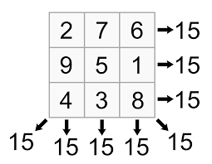

5 Goals in 3 minutes & 7 seconds - 5307 = 15 = 6

1 Goal every 37.4 seconds = 1+3+7+4 = 15 = 6

I was born on my Mother’s Birthday, March 15 = 6 “ 666 “

Also, regarding the # 17

The Number 17
MH370 landed on runway 17 at Iskandar Muda International Airport (formerly called Blangbintang Airport) at Banda Aceh, where it unloaded the 1st 2 tons of gold.

I wore #17 when I scored those 5 goals in 3:07 on Oct. 7th, 1972
(10th month, 7th day: 10 + 7 = 17).
My linemates, Tommy and Lanny, wore #8 and #9 (8 + 9 = 17). 243

Valeri Kharlamov , my Russian hockey player idol, wore #17.

Just as a side note, do you remember how $130 million was spent on MH370 search? Coincidentally, the number 130 is also used 17 times in the Bible.
In 17 places in the New Testament, God is called the God Unique. The verb ‘to pay’ is used 17 times in the NT, as is the word ‘manna’ and the verb ‘to kneel’.
In the Revelation of John, 7 is used 53 times and designates 17 different elements: 7 Churches of Asia, 7 spirits, 7 candelabras, 7 seals, etc.
In the Bible, there are 17 numbers that are multiples of 17.

I dedicated a chapter on the significance of # 555 & # 17 ,,,,,

“5307” - DICTIONARY OF BIBLE THEMES – 5307 ENVOY
“An official representative sent on behalf of a king or government to other kings or nations. Believers are God’s envoys to his world, bearing the good news of salvation on his behalf.”
Incidentally, I’ve had a 5-foot steel statue of ‘Hermes the messenger’ in my home since 2000, and my nickname from my hockey days is ‘Herby’. As details about some of the people I met in Thomas Lilley’s circle of friends and beyond are becoming clearer, I believe that I escaped death, and that I am now ‘the messenger’ to bring these facts to light.

END

Ukraine War: Texas Soldier investigates MH17 crash site, interviews witnesses, English.

Moment Rebels Realised Shot Down MH17 Was Passenger Plane

It’s 5:00 PM
MH17 The Untold story Promo

NewsTeam: Malaysia Airlines MH17 crash site (E32)

BUSTED! Fresh Passports Pulled From Truck at Flight MH17 Crash Site! HD

https://www.google.ca/search?q=malaysian+mh17+bodies+were+not+fresh+dead+for+long+time+smelling+of+rot+decomposing&rlz=1C5CHFA_enCA709CA710&tbm=isch&tbo=u&source=univ&sa=X&ved=0ahUKEwjSu_a96vfbAhX2GDQIHUzDDvIQsAQIJg&biw=1238&bih=715#imgrc=6XQPSyXLxj4EyM:

http://beforeitsnews.com/alternative/2014/07/russian-commander-bodies-dead-for-days-before-flight-took-off-2995572.html

http://www.dailymail.co.uk/news/article-2697895/Now-rebel-commander-blamed-downing-MH17-says-bodies-aren-t-fresh-claims-corpses-dead-days.html

DONALD TRUMP, CHABAD-LUBAVITCH AND THE OLIGARCHS and PUTIN
Submitted by David Livingstone on Sat, 04/08/2017 - 18:55
CHABAD-LUBAVITCH
Global Security has hypothesized that Donald Trump may be a Manchurian Candidate planted by the Russian mafia in collusion with the Russian government.[1] Using a network of hackers and Internet trolls controlled by 291

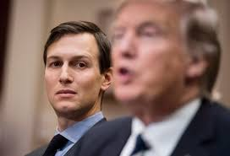
the Russian mob, the Russian government was able to influence the 2016 US Presidential election in favor of Trump. The basis of Trump’s cooperation in the plot has been alluded to in 35-page report, known as the Trump Dossier, first reported by CNN and then published by BuzzFeed on January 11, 2017, which alleges that Russia has gathered damaging intelligence on Trump which it is using to blackmail Trump. In fact, a series of studies by the Financial Times has shown how after he suffered a string of six successive bankruptcies, Trump was bailed out by Russian crime lords.

JARED KUSHNER
In 2015, Trump’s son-in-law and chief adviser Jared Kushner, who has strong ties with the Lubavitchers, purchased the former New York Times Building in Manhattan from Leviev. Kushner, who married to Trump’s daughter Ivanka after she converted to Judaism, had become what the Times described as Trump’s “de facto campaign manager.”[76] He was principal owner in his family’s real estate company Kushner Companies, and of Observer Media, publisher of the weekly, on-line New York Observer. The Kushner’s were friends with Israeli Prime Minister Netanyahu, who stayed at their home in New Jersey, sleeping in Jared’s bedroom.[77] Trump’s foundation has donated thousands of dollars to Chabad institutions, and Haaretz also reported that the foundation of Jared’s parents gave $342,500 to Chabad institutions and projects over a 10-year period.[78] “Israel wasn’t a political discussion for him; it was his family, his life, his people,” said Hirschy Zarchi, rabbi at the Chabad House at Harvard, where Jared was a member.[79] 322

May 27th,2017
Russian ambassador told Moscow that Kushner wanted secret communications channel with Kremlin
Russian ambassador told Moscow that Kushner wanted secret channel with Kremlin
Sergey Kislyak reported to his superiors in December that Jared Kushner, President Trump’s son-in-law and adviser, asked him about setting up a communications channel between the transition team and the Kremlin using Russian facilities in the United States. JARED KUSHNER
In 2015, Trump’s son-in-law and chief adviser Jared Kushner, who has strong ties with the Lubavitchers, purchased the former New York Times Building in Manhattan from Leviev. Kushner, who married to Trump’s daughter Ivanka after she converted to Judaism, had become what the Times described as Trump’s “de facto campaign manager.”[76] He was principal owner in his family’s real estate company Kushner Companies, and of Observer Media, publisher of the weekly, on-line New York Observer. The Kushner’s were friends with Israeli Prime Minister Netanyahu, who stayed at their home in New Jersey, sleeping in Jared’s bedroom.[77] Trump’s foundation has donated thousands of dollars to Chabad institutions, and Haaretz also reported that the foundation of Jared’s parents gave $342,500 to Chabad institutions and projects over a 10-year period.[78] “Israel wasn’t a political discussion for him; it was his family, his life, his people,” said Hirschy Zarchi, rabbi at the Chabad House at Harvard, where Jared was a member.[79] 322

May 27th,2017
Russian ambassador told Moscow that Kushner wanted secret communications channel with Kremlin
Russian ambassador told Moscow that Kushner wanted secret channel with Kremlin
Sergey Kislyak reported to his superiors in December that Jared Kushner, President Trump’s son-in-law and adviser, asked him about setting up a communications channel between the transition team and the Kremlin using Russian facilities in the United States.
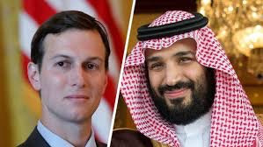
Harper returns! The former prime minister finally delivers a public speech ... in Las Vegas
Harper has vanished from public life following his October election defeat. Until, that is, he showed up to give 'unite the right' tips to Republicans

THE CANADIAN PRESS/Sean Kilpatrick

After virtually dropping off the map following the October federal election, former prime minister Stephen Harper has finally emerged at a public engagement — in Las Vegas.

Last week, Harper spoke to an intimate gathering of top Republicans during the spring meeting of the Republican Jewish Coalition, according to Politico.

While the meeting itself was held at The Venetian casino and resort, on Thursday Harper spoke to a small circle of Republicans at the 44,000-square-foot mansion of casino magnate Sheldon Adelson, a prominent Republican donor.

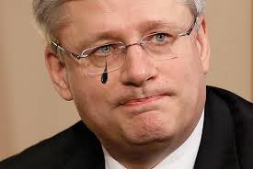

12 Russians indicted in Mueller investigation

(CNN)The Justice Department's indictment of 12 Russian military intelligence agents on Friday was jaw-dropping in its scope and level of details into attempts to influence the 2016 US presidential election.

The Russian government really, really wanted to beat Clinton

Fake names, stolen passwords and BITCOIN

Early in July 2014, I got a call from the mayor of Maple Creek, Saskatchewan, asking me to drive the 4.5 hours to do a LED lighting audit for the Old Armoury. The mayor and town council were impressed with the new Arena lighting, and now they wanted to do the Armoury.
Maple Creek is located in South Western Saskatchewan, situated on the Battle River on the foothills of the Cypress Hills. The area is known for the Cypress Hills Massacre, a mass murder that occurred on June 1, 1873, in the Cypress Hills region of Battle Creek, North-West Territories (now in Saskatchewan). An estimated twenty or more Natives and one American wolf hunter died during the conflict.
As a result, the Cypress Hills Massacre prompted the Canadian government to accelerate recruitment and deployment of the newly formed North-West Mounted Police (today’s RCMP, the Royal Canadian Mounted Police) to prevent further conflict.

So after I did a walk-thru and an audit count at the Armoury with the mayor, I had an urge to drive south, up to Fort Walsh. As I was heading upwards into the Cypress Hills, I had an eery feeling of nostalgia… just thinking about the massacre. I stood on top of a hill overlooking the fort, reading the monument and visualizing the slaughter back in 1873.
On my drive back through the rolling hills of the ranch lands to Saskatoon about an hour later, my mind was rolling too. I was thinking about MH370 and Thomas, the Cypress Hills Massacre, the creation of the North West Mounted Police , Bitcoin…
I glanced out my side window and saw a baby calf lying on the grass, on the other side of the barbed wire fence from its mother. I had an urge to stop and try to help this little calf get back with its mother.
So I stopped the car and got out, I walked about 300 meters to where the calf was. I tried, but the calf took off running. So I got back into my car, turned on the ignition key and glanced at the clock.
It read ‘5:37’. Then I looked at the odometer, it read ’53,070’ kilometres. I decided to clock the distance to the nearest farm to let the farmer know about the calf. It was ‘5.37’ kilometers to his front door.
Weird or what? It sent shivers down my spine….
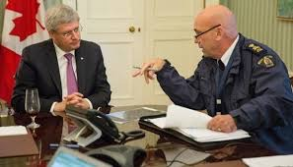
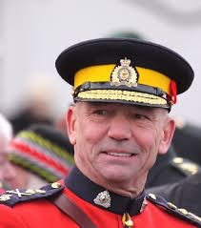
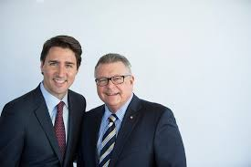

RCMP apology, $100 million compensation fund comes without harassers held accountable
Some call the fund hush money: 'How can you be validated when the RCMP lets them walk?'

RCMP faces $1.1B lawsuit over bullying, harassment claims dating back decades

Ivan Glasenberg (GLENCORE) - Vladimir Putin meeting with business representatives.

https://www.youtube.com/watch?v=aK77o4hamjU

Glencore Makes Takeover Approach to Bunge
By Dana Mattioli, Jacob Bunge and Scott Patterson

Glencore PLC has made a takeover approach to grain trader Bunge Ltd., people familiar with the matter said, a move that would make the Swiss mining giant a major player in the U.S. agriculture market.

It isn’t clear where any discussions between the companies stand and there may not be any deal, but if there is one it would be substantial: Bunge had a market value Tuesday of nearly $10 billion; including debt; its so-called enterprise value was about $15 billion.

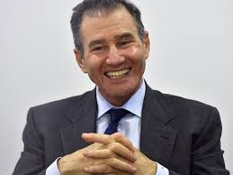
Glencore is a mining and commodity-trading powerhouse with a market value of GBP42.3 billion ($55 billion). An acquisition of Bunge, one of the world’s largest traders and processors of commodities like soybeans and corn, would give Glencore a major presence in the U.S., a long-held goal of Chief Executive Ivan Glasenberg.
https://www.youtube.com/watch?v=u6rSBifsvwg

“From an ADM perspective, Glencore absorbing Bunge would create a dangerous competitor for them. So they may be trying to deter Glencore,” said Jean-Francois Lambert, founding partner of consultancy Lambert Commodities and a former HSBC banker.

According to sources, Glencore is subject to a standstill agreement with Bunge that prevents it from making a fresh approach following its unsuccessful move last year. However, this lapses in February or in the case of a rival bid.

HUGE OVERLAPS
A battle for Bunge is only one of several scenarios. The likelihood of U.S. regulatory hurdles means ADM could agree with Glencore to divide Bunge’s assets, notably in the United States where the Swiss-based firm is known to be interested in expanding its relatively small presence.

This would also make more business sense. Glencore, which spun off its agriculture division a year ago after selling half of the business to two Canadian pension funds, appears better suited to acquiring Bunge.

“Glencore and ADM may bid against each other or they may find a nice way to split it up. But the synergies between Glencore and Bunge are much bigger than between ADM and Bunge, where there are huge overlaps,” a senior banker said.

ADM already has experience of a difficult acquisition with Toepfer, a century-old German merchant over which it took full ownership in 2014. Traders say integrating Toepfer has brought internal headaches and limited benefits in trading.

“One of questions that ADM will have to answer is how do they avoid this becoming a costly exercise with no certainty that they can avoid the same mistakes that were made with the acquisition of Toepfer,” a source familiar with ADM said.

Glencore’s credentials as a dealmaker seem stronger. It bought Canada’s Viterra in 2012 in one of the biggest grain deals of recent years, fending off interest from ADM, although moves on three or four smaller targets in the grain sector last year were unsuccessful.

Archer Daniels Midland Co
47.57
ADM.NNEW YORK STOCK EXCHANGE
-0.33(-0.69%)
ADM.N
ADM.NBG.NGLEN.LNOBG.SI
It has been open about its preference for upstream assets where it sees greater scope for economies of scale.

Trucker charged in Humboldt Broncos crash released on $1,000 bail

Russell and Raelene Herold of Montmartre, Sask.
Lost their son in Humboldt Broncos crash.

Below pictures are of the huge ‘BUNGE’ Site located on the Intersection of Highways 35 & 335 where the Crash happened on April 6th 2018.

Another Coincident ????????
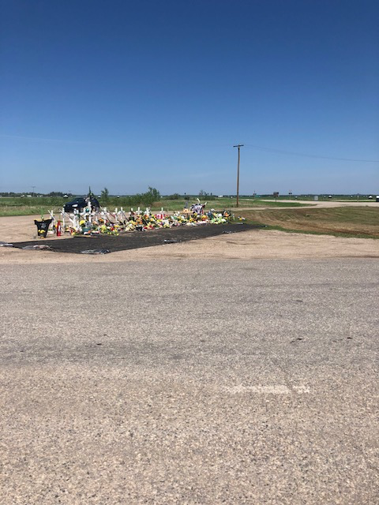

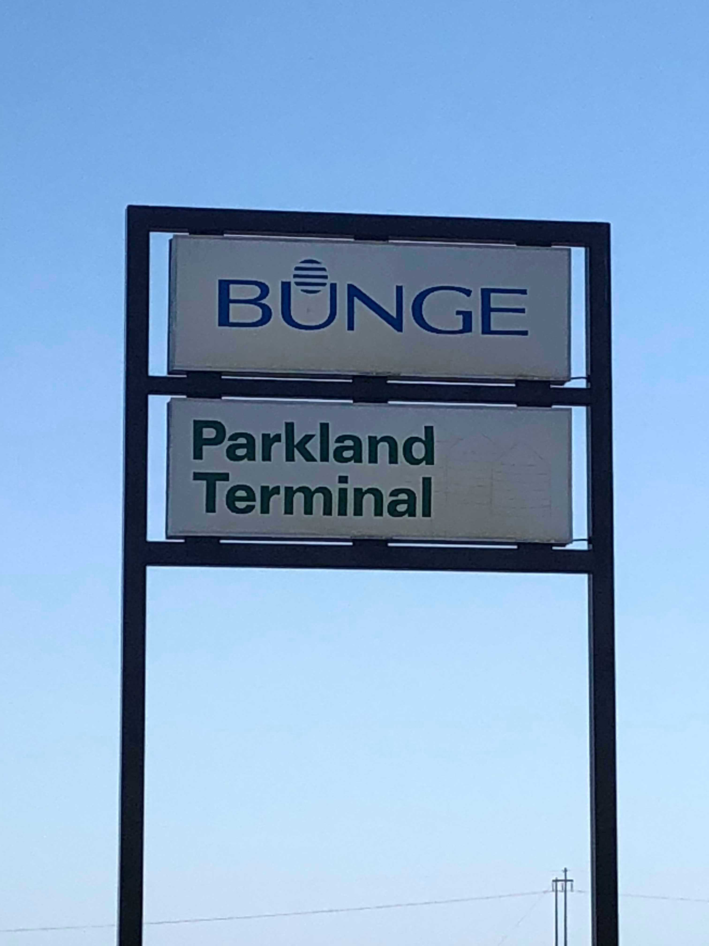

CHINA CONTENDER
COFCO International, the overseas arm of Chinese state-owned food group COFCO, is also a possible contender for some of Bunge’s assets. Like ADM, it has struggled with integrating purchases - in its case Rotterdam-based grain trader Nidera and the agribusiness of Singapore-listed Noble Group (NOBG.SI) for a total of more than $3 billion.

This threw up financial losses and led to a management reshuffle and heavy job losses last year. However, some sources with knowledge of the Geneva-based company have said the worst is now over. Yu Xubo, president of the Beijing-based parent, has said COFCO Group aims to become the largest international food trader by 2020.

COFCO International would seem an unlikely bidder for Bunge’s U.S. assets as any suggestion of a Chinese state-controlled organization running parts of the American agricultural supply chain would provoke political resistance, particularly under the Trump administration.

But COFCO could chase Bunge’s South American assets, given a need to safeguard China’s supply of protein feed and edible oil from soybeans. “Bunge’s Brazil assets have the greatest value for COFCO,” an investment fund manager said. “If it’s deemed to be critical enough, I don’t think financing and timing are so important for China.”

A COFCO International spokesman declined to comment.

ABCD END-GAME?

Some analysts see merit in ADM taking the initiative and betting on rising global food demand, for which soybean crops produced in the Americas will play a vital role.

But if it were to buy Bunge and then try to sell the U.S. assets it acquired to avoid overlap, an absence of COFCO International would probably narrow its options to Glencore.

Barry Silbert #1 is the brother of Allan Silbert who was the guy who ran or owned the Bitcoin exchange back in 2014 that purchased the Villa in Bali with Bitcoin for the MH370 Pilot and is doing well...
Below is a recent article... fast forward!
MAY 30, 2017
BITCOIN
“3” People Set to Make a Killing from the Bitcoin Boom, by Jeff John Roberts
#1
Barry Silbert, Venture Capitalist
Fortune Brainstorm TECH 2014
Barry Silbert is another long-time player in the bitcoin scene, who made big bets when most people laughed that the currency was 284

for kooks. One of his bets saw him obtain 48,000 bitcoins in a second auction held by the U.S. Marshals Service in 2014. At that time, bitcoin prices had fallen to around $350, which means Silbert's stake could now be worth around $110 million.
Silbert is currently focused on building a rival financial product to the Winklevoss ETF, and likely owns a lot more than the 48,000 bitcoins he won at auction.
REMEMBER BARRY SILBERT !!!!!!
$500,000 Bali Villa is Biggest Bitcoin Purchase Ever (this is where they put the pilot of MH370)
March 20, 2014 12:00 GMT is the largest purchase ever made with cryptocurrency. (The new home for MH370 Pilot)
Sold through the bitcoin-only BitPremier luxury marketplace, the fully-managed property in the delMango Villa Estate sold for in excess of $500,000 though the exact price and identity of the buyer involved remain unknown.
BitPremier was founded by Alan Silbert, who is the brother of Barry Silbert, a major bitcoin investor and founder of the Bitcoin 285

Investment Trust. Barry Silbert is also the founder of SecondMarket and has invested in his brother's BitPremier venture.
Alan Silbert told CoinDesk that the purchaser of the property in Bali was an early bitcoin adopter from the US and that the sale represented "by far the largest" sale to date on the marketplace, which launched 10 months ago.
#2
Satoshi Nakamoto, Bitcoin Inventor - Richard
Since his 2008 white paper, which described a new type of software tied to a digital currency, the man known as Satoshi has stood as the soul of bitcoin.
But no one can say for sure he is.
Satoshi has not spoken publicly for years, but he is believed to control large numbers of bitcoin wallets from the currency's early days. Some reports say he controls more than 5% of all bitcoin in circulation, which means his net worth could be in the billions.
It remains to be seen if Satoshi will emerge one day and distribute that wealth (maybe by endowing a bitcoin university?) or if Satoshi and his riches will remain invisible and out of reach forever.
#3

Uncle Sam - Rothchilds
The early idealists of bitcoin saw it as an anarchy-currency free of the control of national governments. Alas, the U.S. government didn't get the memo. Since 2016, the Internal Revenue Service has been stepping up a campaign to identify bitcoin investors and slap them with capital gains tax.
Right now, the agency is locked in a legal fight with the popular cryptocurrency exchange Coinbase, and is demanding information about millions of customer accounts. The IRS is annoyed because it says only 802 people declared bitcoin income in 2015—even though the value of the currency has increased dramatically from its 2013 value of $13. 86
Putin was involved from the beginning of the 7 year plan ,,, after all, he ordered MH370 to fly to and be stored at the cosmodrome in Kazakhstan...
June 6, 2017, 11:16 AM CST
ETHEREUM - RUSSIA
A Vast Blockchain Experiment Could Change Russia
By Leonid Bershidsky
June 6, 2017, 11:16 AM CST
Russian President Vladimir Putin and his economic team have long been under the 287

impression that, to wean the country off its oil dependence, they needed a major leap in some specific area of technology that wasn't yet dominated by Western, Chinese or Japanese tech giants. Their latest hopes are being pegged to the Ethereum blockchain platform.

Crypto Valley Zug:
Canton of Zug – Home of Innovation

Ivan Glasenberg keen to tell the world he is back on top (from http://on.ft.com/2mhYvkm)

Well, after Thomas and the Swiss Jews pulled off the biggest Gold Heist - Assassination in the History of the World and created Bitcoin, Ethereum, Monero, ETC Classic etc... 279

“Ivan says he’s back on top!"
Just like Kazakhstan being the big winner when Brexit took place, they all look like HEROES... WOW! Not difficult when the cards are completely stacked in their favour.

MESSAGE FROM MOSCOW... 2016
Thomas used to say this sentence all the time... "I don’t have an AXE to Grind with You!"
When I first listened to Gabe Zolna, I believed Thomas was the one who sent this message below...
This message from MOSCOW was recently emailed to Gabor Zolna on YouTube: 343

October 20th, 2016
I’m afraid “The Race for the Whitehouse” this is the very last one for the USA as a sovereign country if you ask me. It’s factually over with two opposing candidates who have both been maneuvered, yes! Maneuvered because to me, it looks perfectly orchestrated by the higher ups who have, “AN AXE TO GRIND AGAINST THE PEOPLE.”
This from Google definitions... this is more to do with the destruction of America which is taking place... this is only to make the public aware that Trump and Pence are totally controlled by the Jesuits... Because Trump’s partner is Sajwani and Trump obviously got to know Thomas as he probably helped connect the two... and also I believe Trumpence defines the two fraudsters very well... moving in the direction of the Jesuits...
Trumpence - Definition
(derived from the names Donald Trump and Mike Pence)
The punishment or fate a society deserves to receive, e.g. "The American people received their trumpence when they decided hate and ignorance was more affective and important than love and understanding."

Trump - Pence
Trumpence - (Meaning, Definition)
The amount of return on investment on a con job, e.g. "I knew it was too good to be true, but I thought it was worth trumpence."
1.) Something that is fallaciously splendid.
2.) Falsehood, empty talk.

CHAPTER #13 – The first Jesuit pope & the Dead Pools
This is the first time in the history of the world that we have a Jesuit pope!
And based on their hidden agenda, as well as their own history, that fact alone should strike fear in the hearts of millions. So to begin, let’s look a little closer into the background of the Jesuit “Society of Jesus”.
Who are the Jesuits?
The Jesuits call their group ‘the Society of Jesus’, a Roman Catholic order of priests and brothers founded half a millennium ago by the soldier-turned-mystic Ignatius Loyola. On the surface, their claimed intention is to seek and "find God in all things," dedicating themselves to the “greater glory of God" and the good of all humanity 348

In fact, with 17,000-plus priests, brothers, scholastics and novices worldwide, the Jesuits are the largest male religious order in the Catholic Church, comprised of pastors, teachers, and chaplains, plus doctors, lawyers, and astronomers, among many other roles in Church and society. In their varied ministries, they seek to care for the whole person: body, mind, and soul, and to nurture "men and women for others." 90
On the whole, it sounds like noble intentions for a generous benefactor. But the first clue to the potential for diabolical implementation of those good intentions shows up when you look at the four vows every Jesuit must agree to when they join the order. I’ve highlighted the suspicious part in the clip below, taken directly from the Jesuit website at http://jesuits.org/aboutus...
Four Vows Of A Jesuit
“As members of a religious order, Jesuits take three vows — of poverty, chastity and obedience — and a fourth vow of obedience specifically in regards to the worldwide mission. In other words, Jesuits must be ready to accept whatever mission the Pope requires, a vow that is reflective of our broader dedication to the universal Church, and to the greater 349

good of all people from all faiths and cultures.”
The problem here is that the Jesuits are not genuinely supporting the goals they’ve identified for themselves. They’re actually ‘crypto-Jews’, masking their real identity (and their real purposes) behind a publicly acceptable front!
In case you need a refresher, here’s a quick definition to describe ‘crypto-Jews’…
Crypto-Judaism is the secret adherence to Judaism while publicly professing to be of another faith; practitioners are referred to as "crypto-Jews" (origin from Greek kryptos - κρυπτός, 'hidden'). 92
For example, the Dönmeh (Turkish: Dönme) were a group of crypto-Jews in the Ottoman Empire who converted publicly to Islam, but were said to have retained their beliefs.
“Before the Lord does anything, He tells his plans to His servants the Prophets’.-Amos 3:7 94
To push this example over the tipping point, I’ll mention the Shemitah phenomenon, along with the biblical notion known as the recurring Jubilee Year in this ancient Judaic

practice. The previous Jubilee began on September 23, 2015 and ended on October 2, 2016.
You should know that it has been proven that the Shemitah has governed the timing of cataclysmic events on Earth during the past century. There have been several periodic economic collapses and financial crashes during that time, which have aligned perfectly with the Shemitah cycle.95
As a clue to understanding why the passengers of MH370 were never coming back, Thomas had prompted me by saying “You need to know where money originates from, that’s the key.”
And while goldsmiths in England had been craftsmen, bullion merchants, money changers and money lenders since the 16th century, they were not the first to act as financial intermediates. In the early 17th century, the scriveners were the first to keep deposits, for the express purpose of re-lending them.96
Fast-forward to this year, and you can see how centuries of Shemitah-scheduled economic events have culminated in the 2017 world-wide bank crisis happening right now! Countries are printing money everywhere at 351

alarming rates, which has never happened before on this scale in world history
The trouble is, history also shows us that when a country attempts to print its way out of debt, the country fails and collapses. What happens when the whole world does it instead?
Today, in 2017, the US national debt is pegged at close to 18 trillion dollars (the greatest level of national debt in world history), but the total debt of all liabilities is actually more than ten times greater. In fact, it is greater than the amount of all goods and services on the entire the planet.
We have been set up to fail!
In the Middle East, ISIS is beheading Christians -- just as the Bible predicted. As the Russians are move into the Middle East, USA forces are pulled out, giving the Russians what they’ve been trying to achieve for a hundred years -- control of the world’s oil supply.
America has signed a peace treaty with Iran, a country that vows to destroy Israel and America. In this treaty, our bankrupt nation is giving our enemy 160 billion dollars. Nothing in this treaty stops Iran from 352

building a bomb, or developing ICBMs that can strike Israel and America! It seems the US is giving aid and comfort to it’s own enemies, supplying them with means to destroy the country.
This chaotic assortment of world events could be setting the stage for World War III.

222
Kazakhstan and the Middle East. Incidentally, notice the number of Catholic communities in Kazakhstan as of February 2013…
Pope Welcomes Kazakhstan’s Efforts to Promote Inter-Religious Understanding
Pope Benedict XVI welcomed the efforts of President Nursultan Nazarbayev to promote inter-religious and inter-cultural understanding on Feb. 6 and gave his apostolic blessing to Kazakhstan’s initiatives in this field.
“By a twist of fate Kazakhstan became the second home for thousands of Catholics. Today, 79 Catholic communities operate in the country,” Mami said.

While it may seem encouraging to see Kazakhstan developing an “inter-religious understanding”, there’s more going on than meets the eye of casual observers. Check out the observations I found in this article (I’ve edited some of the outdated references, since it was originally posted in 2009). This is also well worth looking into today, to see further results from Nazarbayev’s line of thinking!

Is Kazakhstan the “Seat of Satan”?
Kazakhstan has good relations with Israel. President Nazarbayev presides over what has been called one of the most corrupt satanic regimes in central Asia. Known to have rubbed elbows with Bill Clinton, George W. Bush, and even Dick Cheney, Nazarbayev made international headlines in 2009 when he proposed a single world currency.
Astana (SATAAN), the first capital of New World Order, is being built in the 21st century, and as Kazakhstan’s president, Nursultan Nazarbayev’s vision, it perfectly represents where the world is headed. The city, being built from scratch in a remote and deserted area of the Asian steppes, is astonishing. It’s a futuristic occult capital, embracing the New World Order while celebrating Sun Worship, the most ancient religion known to man.
Conceived by Britain’s most prolific architect, Lord Norman Forster, this giant pyramid is dedicated to “the renunciation of violence” and “to bring together the world’s religions”. Norman Foster has said that the building has no recognizable religious symbols, to permit the harmonious reunification of confessions. In reality, the pyramid is a temple for the occultist’s only ‘true’ religion: Sun worship.
The Republic of Kazakhstan in Central Asia is in the process of building the world’s first “Alien Embassy” according to some local media reports. Apparently, the authorities have already allocated a large plot of land in the city of Almaty for this ambitious project.
Kazakhstan’s government believes open contact with aliens is imminent, and by being the first nation to specifically create such facilities, they are convinced they will reap enormous financial and economic rewards. The Kazakhstan government also sees this as a chance to demonstrate their nation’s forward thinking policies.
I guess even with the mindset and beliefs of Kazakhstan’s president, the country may serve a strategic purpose for some global powers… but to what ends?
A U.S. partnership with Kazakhstan can keep Chinese and Russian ambitions in check
The November 30, 2016 telephone call between President-elect Donald J. Trump and President Nursultan Nazarbayev of Kazakhstan was a shocker, concentrates on building relationships with key countries in key regions. Kazakhstan is in the heart of Eurasia, bordering both Russia and China: the two main headaches of American foreign policy.

Trump’s Space Force Will Guard the U.S. From Above, NASA Chief Says
By Eric Roston
July 12, 2018, 2:00 AM CST
Agency is part of a broad retooling of U.S. space strategy
Bridenstine priming NASA to return permanently to the moon
NASA’s administrator is a strong defender of President Donald Trump’s proposals for space -- including an armed force and a permanent presence on the moon -- and says he wants Americans to realize how much their well-being depends on what happens far above Earth.

“Every banking transaction requires a GPS signal for timing,” Jim Bridenstine said in an interview. “You lose the GPS signal and guess what you lose? You lose banking.”

“If you look at what space is, it’s not that much different than the ocean,” added Bridenstine, who made 333 aircraft-carrier landings as a Navy pilot. “It’s an international domain that has commerce that needs to be protected.”

Bridenstine was in his third term representing a congressional district in Oklahoma when Trump nominated him to lead the $21 billion space agency. He was confirmed in the spring despite criticism over his lack of scientific or engineering experience and his previous statements questioning climate change science -- though he said in hearings that human activity was the chief cause of global warming.

Chabad Libovitch

https://www.youtube.com/watch?v=LkxTrMYVAQA&feature=share

Vaccinations Gardisil destroys womanhood

http://vaccineimpact.com/2018/japan-leading-the-world-in-exposing-fraud-with-gardasil-hpv-vaccine-injuries-and-deaths/

Humboldt Broncos ,Crash German coincidences

https://extra-capsa.com/2018/04/09/humboldt-broncos-bus-crash-part-iii-the-munster-attack-synchronicity/

greatawakening

Welcome to the Great Awakening
Qanon or Q, is an apparent member of the American Military Intelligence that serves at the pleasure of the President.

This is a community for pro-Q supporters. Please read and respect our rules below before contributing.

Q

OpinionQ+ President Trump and the Frequency of the Number 17 in the News (Q=17th Letter of the English Alphabet) self.greatawakening

Submitted 1 month ago * by CENSORED_ENOUGHPromises made. Promises kept. - Q

I think it is pretty well established that Trump and the Number 17 are associated at least with regard to Q. But I think it has some more relevance beyond the Q anon phenom.

Over the last six months, I keep seeing the number 17 all related to POTUS. These are news reports that he could not have directly affected at all and so what is the reason for the strange association of this number with POTUS. I also believe that he has some association with this number over his life. I don't know what it is, but it intrigues me and I just think there is something to this association than has not been discovered.

Theory: I would even venture a guess, that since POTUS has been associated as Q+ in the posts, that there might be 17 members of "Q" working as a special unit. I would not be surprised to learn that this "collective" will be known someday and it will comprise 17 operatives assigned to POTUS. (SS?)

Below are some rather bizarre coincidences that came up on a quick search seemly associated with Trump and the number 17 found in the news. More than coincidental...

Trump Beat Out 17 Major Candidates for the Republican Nomination

Trump owns 17 golf courses

Trump negotiated the release of 17 Americans From Overseas Prisons

Trump announces 2017 Fake News Award Winners on January 17, 2018

17 States Sue Trump Administration on Green House Gas

Trump Dossier Comprised From 17 Memos by Christopher Steele

Trump Wants to Kill 17 Agencies and Shrink Government

Trump Took a 17 Day Vacation to New Jersey Golf Resort

Trump Attacked LGBTQ Community 17 Times in 2017

Protests Rage In Orange County, Trump Rally, 17 Arrested

Trump Meets Apollo 17 Astronaut, Signs Space Policy Directive

17 Republicans Join Fight Against Trump’s Stand of Global Warming

17 Of the Most Absurd Things Donald Trump has Said About Marriage

Trump Holds 17 Press Conferences In 2016

Trump Budget Plan: 17 Charts

Trump Grants Ethics Waivers to 17 Top White House Staffers

Black Activists Credit Trump Policies to Create 17 Low for Black Unemployment

17 Times Trump Urged America Not to Go to War In Syria

Trump: 17 Reasons Why American Christians Celebrated In 2017

Trump Hotels CEO Says 17 Deals In the Works

17 Congressman Nominate Trump for Nobel Prize

Trump’s $17M Caribbean Home Pummeled By Hurricane Irma

17 Things Trump Said About Michael Flynn

17 Women Come Forward During Trump Campaign to Accuse Him

Trump Accidentally Refers to 17 Years of Obamacare

Astros Present #17 Jersey to President Trump

Report: Netanyahu, Trump to meet on Sept. 17 - Israel News …

Trump, QAnon & the Number ’17’: Q Followers Think He’s Speaking in Code

QAnon’s followers have a particular affection for the number 17. The believe that every time Donald Trump references it, he’s really referencing them. It comes from the fact that Q is the 17th letter of the alphabet. QAnon members were notable in the crowd during Donald Trump’s rally in Tampa on July 31.

Trump repeatedly saying he had only been to DC 17 times before he became President... what’s the 17th letter of the alphabet? #QAnon #AskTheQ

Trump Said the Number 17 Multiple Times in Tampa
According to the Tampa Bay Times transcript of the event, Trump used the letter Q, four times. The president is quoted as saying, per the Times transcript:

You know, I told the story the other day, I was probably in Washington in my entire life 17 times. True, 17 times. I don’t think I ever stayed overnight… Again, I’ve only been here about 17 times. And probably seven of those times was to check out the hotel I’m building on Pennsylvania Avenue and then I hop on the plane and I go back. So I’ve been there 17 times, never stayed there at night. I don’t believe.

During the event, dozens of people could be seen in the crowd making reference to QAnon with signs and t-shirts. The QAnon conspiracy began on 4Chan in October 2017. It began with a mysterious poster named “Q.” That person claimed to be a government agent with ultra top-secret information. That person also said that he or she was on a mission to take down the so-called “deep state.” The official line from Press Secretary Sarah Sanders after the rally in Tampa was, “The president condemns and denounces any group that would incite violence against any individual.”

Trump Also Tweeted About ’17 Angry Democrats’ After the Tampa Rally

The day after the rally in Tampa, Trump again made reference to the number 17 in a Twitter post about the Russia investigation. The message read, “This is a terrible situation and Attorney General Jeff Sessions should stop this Rigged Witch Hunt right now, before it continues to stain our country any further. Bob Mueller is totally conflicted, and his 17 Angry Democrats that are doing his dirty work are a disgrace to USA!” The 17 Democrats was originally 13 Democrats. On July 29, Trump explained that he had expanded the number to 17 to included “an Obama White House lawyer.”

The University of Alabama Football Team Gave Trump a Number 17 Jersey in 2018

In April 2018, when the University of Alabama football team visited the White House on the back of their national championship winning season, Coach Nick Saban presented Trump with a number 17 jersey. A Reddit thread on the Great Awakening/QAnon subreddit was dedicated to it. The thread was titled, “Why does he keep picking #17 for jerseys? Shouldn’t he pick #45? Is he making it that obvious?” Some argued on the thread about whether or not the 17 was in reference to the conspiracy theory, to Alabama’s 17th national championship or the fact they won it playing in the 2017 season.

Cannabis facility size of 21 football fields planned for Medicine Hat.
High-tech facility will boost Aurora's total capacity to more than 430,000 kg per year
The Canadian Press · Posted: Apr 17, 2018 8:48 AM MT | Last Updated: April 17

Aurora Cannabis is acquiring about 29 hectares of land in Medicine Hat, Alta., to build a huge new cannabis facility. (Jim Mone/Associated Press)
Aurora Cannabis Inc. says it is acquiring about 29 hectares of land in Medicine Hat, Alta., to build a new high-tech cannabis facility.
The company says a memorandum of understanding with the city includes a prospective 10-year, 42 megawatt energy supply agreement.

Aurora says the new facility, to be named "Aurora Sun," will be the size of 21 football fields and 50 per cent larger than its "Aurora Sky" operation at Edmonton International Airport.
- Aurora Cannabis buys CanniMed in Canada's biggest deal
The first planting in Medicine Hat is expected in the first half of 2019, with completion slated for the second half of the year.
Once in operation, Auror|a says the new facility will boost its total capacity to more than 430,000 kilograms per year.
The company currently operates facilities in Mountain View County, Alta., and in Pointe-Claire on Montreal's West Island. It is also completing a facility in Lachute, Que.

Hut 8 Adds 16 Bitcoin Mining BlockBoxes to Medicine Hat Facility
September 07, 2018 08:13 ET | Source: HUT 8 Mining Corp.

TORONTO, Sept. 07, 2018 (GLOBE NEWSWIRE) -- Hut 8 Mining Corp. (“Hut 8” or the “Company”) (TSXV: HUT) (OTCQX: HUTMF), one of the world’s largest public cryptocurrency mining companies, announces the purchase of an additional 16 BlockBox datacentres which have been installed at its bitcoin mining facility in the City of Medicine Hat, Alberta, Canada (the “CMH Facility”).
The additional 16 BlockBoxes, installed in August 2018, increases Hut 8’s bitcoin mining capacity by 19.2 MW and approximately 144 petahashes per second (PH/s). When combined with its operations in Drumheller, Alberta, the Company now operates a total of 73 BlockBoxes, representing an aggregate capacity of 85.9 MWs of fully-funded operating power representing approximately 632 PH/s.
“Hut 8 is working alongside city officials in Medicine Hat to ramp up to full electrical capacity for the additional 16 Blockboxes through the coming weeks,” said Andrew Kiguel, President and Chief Executive Officer of Hut 8. “We prioritize the electrical requirements of the citizens of Medicine Hat and are committed to ramping up our operations without impacting their power needs.”
“The City of Medicine Hat is pleased that Hut 8 is moving forward with the next phase of development,” said the City of Medicine Hat’s Mayor Ted Clugston. “We continue to operate with our City’s best interests in mind, and Hut 8 supports our efforts. They have shown tremendous value to our community, not only by employing nearly 40 local residents, but also by engaging over 30 local contractors in developing their operation.”
The new BlockBoxes, at a cost of US$950,000 per BlockBox, will be financed through a secured loan from Galaxy Digital Lending (“Galaxy”) in the amount of US$16 million (the “Loan Financing”) and a vendor-take-back from Bitfury for 40 percent of the purchase price of the BlockBoxes at $3.75 per Hut 8 common share. Terms of the Loan Financing are LIBOR + 9%. The coupon is payable in USD or bitcoin and has a 30-month term with a bullet repayment. The Loan Financing is scheduled to close on or about September 7, 2018.
As part of the Loan Financing, Galaxy will receive 2.2 million Hut 8 purchase warrants which can be exercised to acquire common shares at a price of $4.50 (the “Warrants”). The Warrants will be subject to customary restrictions on resale. Both the Loan Financing and the issuance of the Warrants remain subject to approval by the TSXV.
“The loan from Galaxy enables Hut 8 to grow its capacity by 28% by issuing less than 3% new shares, resulting in substantial accretion to common shareholders. Hut 8 is now the largest public cryptocurrency mining company in the world with 85.9 MWs of capacity. This transaction also affirms the commitment from our strategic partners at Bitfury and Galaxy to our business model,” said Andrew Kiguel.
Hut 8’s current capital structure, prior to effecting the impact of the transaction above, consists of 83,094,000 common shares outstanding, 660,000 warrants with a $5.00 conversion price and 670,000 options with a $5.00 strike price. To date, Hut 8 has mined more than 3,000 bitcoin and retains more than 2,500 in bitcoin inventory.
Pursuant to its continuous disclosure obligations, Hut 8 is also announcing the grant of 115,000 stock options under the Company’s Omnibus Long-Term Incentive Plan (the “Option Plan”) to a director, Joseph Flinn, at an exercise price of $5.00 per share, which options shall vest in accordance with the Option Plan and the policies of the TSXV. The options grant remains subject to the approval of the TSXV.
ABOUT HUT 8 MINING CORP.
Hut 8 Mining Corp., headquartered in Toronto, Canada, is a cryptocurrency mining and blockchain infrastructure company established through an exclusive arrangement with the Bitfury Group, the world’s leading full-service blockchain technology company. Through the Bitfury Group, Hut 8 has access to a world-leading proprietary mix of hardware, software and operational expertise to construct, optimize and manage datacentres in low-cost and attractive jurisdictions. Hut 8 is led by a team of industry experts and intends to provide investors with exposure to blockchain processing infrastructure and technology along with underlying cryptocurrency rewards and transaction fees.
Hut 8 provides investors with direct exposure to bitcoin, without the technical complexity or constraints of purchasing the underlying cryptocurrency. Investors avoid the need to create online wallets, wire money offshore and safely store their bitcoins. Hut 8 provides a secure and simple way to invest.
JUST AS BEFORE, NOW THAT I HAVE MY VIDEO AND WEB-SITE , TRUMP FLEES TO FRANCE TO DISCUSS WITH MACRON ,,, ANOTHER ROTHSCHILD PUPPET ,,, JUST WATCH,, THEY WILL ANNOUNCE SOME FANTASTIC ‘FALSE FLAG’ REGARDING MH370
Trump jets to Paris, leaving political tumult behind
By Kevin Liptak, CNN

Updated 1:37 AM ET, Fri November 9, 2018

The President confirmed his attendance at the centenary event after determining in August that the $90 million price tag for the military parade he had commissioned in Washington was too steep. He said then that he would "go to the Paris parade" instead.
Trump had originally ordered his own military parade after being wowed by a Bastille Day procession in Paris last year. The Armistice Day ceremony is expected to be far more solemn, without an overly military bent. It is, after all, intended to observe the end of war, not the practice of it.

GLOBAL RESET ! Beware The 11th Of November

https://www.youtube.com/watch?v=5-VqJwNzwog

Black Ops Operator Comes Forward And Tells All:Cody Snodgres

https://www.youtube.com/watch?v=e0C_qG5U7pE

